- Definiraj logaritemsko funkcijo! Nariši graf osnovne logaritemske funkcije! Opiši logaritemsko funkcijo! Kako osnova vpliva na graf? Ali je lahko osnova poljubno realno število? Definicijo in lastnosti poišči v učbeniku ali v zvezku.

- Nariši grafe danih funkcij!
Ob svaki napiši definicijsko območje, ničlo in začetno vrednost!
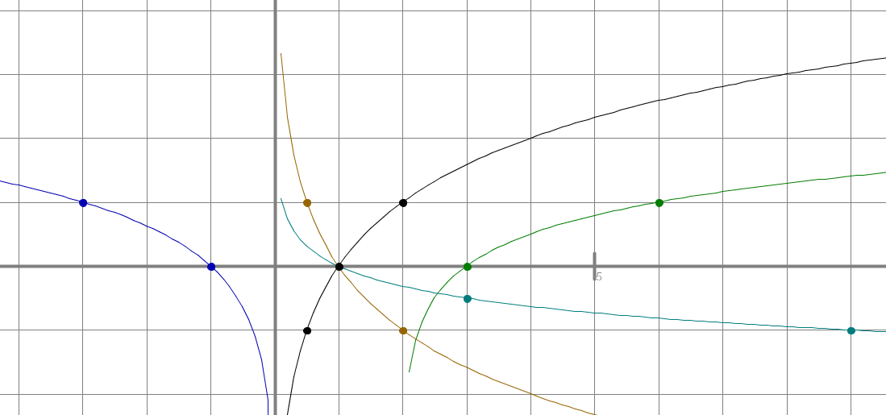
$f(x)={\text{log}}_{2}x$$f(x)={\text{log}}_{4}(x−2)$$f(x)={\text{log}}_{3}(−x)$$f(x)={\text{log}}_{1/2}x$$f(x)={−1}/2{\text{log}}_{3}x$$1$$$\begin{aligned}f(x)={\text{log}}_{2}x \\ f(x)= {\text{log}}_{4}(x−2) \\ f(x)={\text{log}}_{3}(−x) \\ f(x)={\text{log}}_{1/2}x \\ f(x)= |2{\text{log}}_{4}x| \\ f(x)= −1/2 {\text{log}}_{3}x \\ f(x)= \text{ln} x+1 \\ f(x)= \text{log}(x+1)\end{aligned}$$

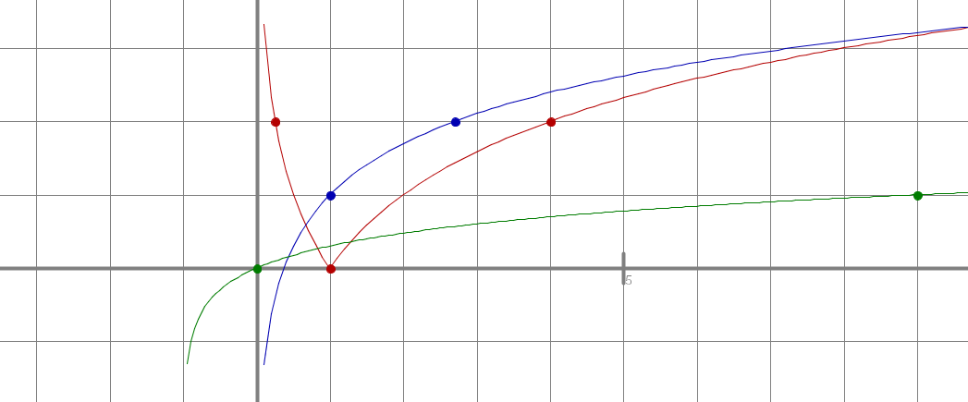$f(x)=\text{log}(x+1)$$f(x)=|2{\text{log}}_{4}x|$$f(x)=\text{ln}x+1$$1$

- Logaritmiraj dane izraze:
$$\begin{aligned}\text{log}4x^{5}y^{2}=2\text{log}2+5\text{log}x+2\text{log}y \\ \text{log}\frac{3 \sqrt{{\text{xy}}^{3}}}{x^{7}}=\text{log}3+\frac{1}{2}\text{log}x+\frac{3}{2}\text{log}y−7\text{log}x \\ \text{log}\sqrt[4]{({\text{xy}}^{−2})^{7}x^{3}}=\frac{1}{4}\left(7\text{log}x−\text{14}\text{log}y+3\text{log}x\right)=\frac{5}{2}\text{log}x−\frac{7}{2}\text{log}y\end{aligned}$$

- Antilogaritmiraj dane izraze:
$\begin{aligned}\text{log}x+3\text{log}y−\text{log}5=\text{log}A⇒A=\frac{{\text{xy}}^{3}}{5} \\ \text{log}2+2\text{log}x−\frac{3}{2}(\text{log}y−\text{log}x)=\text{log}A⇒A=\frac{2x^{2}}{\sqrt{(y/x)^{3}}} \\ 0,\text{25}\text{log}x−2(\text{log}x+\text{log}3)=\text{log}A⇒A=\frac{\sqrt[4]{x}}{9x^{2}}\end{aligned}$ ali $A=\frac{2x^{2}⋅\sqrt{x^{3}}}{\sqrt{y^{3}}}$

- Poenostavi izraze:
$\begin{aligned}{\text{log}}_{x}x^{\text{15}}−\text{log}\text{100000}=\text{15}−5=\text{10} \\ {\text{log}}_{2}x^{9}−{\text{log}}_{2}x^{7}=2{\text{log}}_{2}x \\ \text{log}a^{5}+\text{log}a^{−3}=2\text{log}a \\ \text{log}(x^{2}−3x−4)−\text{log}(x−4)=\text{log}\frac{x^{2}−3x−4}{x−4}=\text{log}\frac{(x−4)(x+1)}{x−4}=\text{log}(x+1) \\ \text{log}(a^{2}−b^{2})−\text{log}(b−a)=\text{.}\text{.}\text{.}=\text{log}(a+b) \\ {\text{log}}_{5}\text{300}−{\text{log}}_{5}\text{12}={\text{log}}_{5}\text{25}=2 \\ \text{log}5+\text{log}\text{200}=\text{log}\text{1000}=3 \\ {\text{log}}_{3}6⋅{\text{log}}_{6}9=\frac{\text{log}6}{\text{log}3}⋅\frac{\text{log}9}{\text{log}6}=\frac{\text{log}6}{\text{log}3}⋅\frac{2\text{log}3}{\text{log}6}=2 \\ {\text{log}}_{2}\text{81}⋅{\text{log}}_{3}8=\frac{\text{log}3^{4}}{\text{log}2}⋅\frac{\text{log}2^{3}}{\text{log}3}=\text{12}\end{aligned}$
- Reši enačbe:

$$\begin{aligned}{\text{log}}_{x}\text{32}=5⇒R=\left\{2\right\} \\ {\text{log}}_{x}8=\frac{3}{2}⇒R=\left\{4\right\} \\ {\text{log}}_{4}\text{64}=x⇒R=\left\{3\right\} \\ {\text{log}}_{9}\text{27}=x⇒R=\left\{3/2\right\} \\ {\text{log}}_{0,\text{25}}8=x⇒R=\left\{{−3}/2\right\} \\ {\text{log}}_{3}x=−2⇒R=\left\{1/9\right\} \\ {\text{log}}_{5}x=3⇒R=\left\{\text{125}\right\} \\ {\text{log}}_{4}x=0,5⇒R=\left\{2\right\} \\ {\text{log}}_{\text{125}}x=−\frac{1}{3}⇒R=\left\{1/5\right\}\end{aligned}$$
$$\begin{aligned}\text{log}(x+2)+\text{log}(x+4)=\text{log}3⇒R=\left\{−1\right\} \\ \text{log}(−x)+\text{log}(x+5)=\text{log}(x+8)⇒R=\left\{−2, −4\right\} \\ \text{log}(2x−1)+\text{log}3=\text{log}(5x+1)⇒R=\left\{4\right\} \\ \text{log}x−\text{log}(x−4)=\text{log}5⇒R=\left\{5\right\} \\ \text{log}(x+2)−\text{loglog}(x+7)=−\text{log}6⇒R=\left\{−1\right\} \\ \text{log}(x+5)−\text{log}(x−1)=\text{log}(x+1)⇒R=\left\{3\right\}\end{aligned}$$
x = -2 ni rešitev!

