SEZNAM KNJIG ZA ANGLEŠKO BRALNO ZNAČKO

4.-5. RAZRED

Charlie and the Chocolate Factory
Bill Hatches an Egg
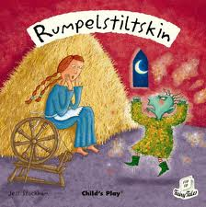
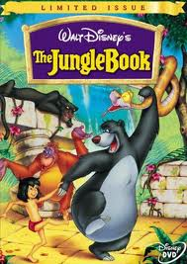
The Jungle Book
The Little Mermaid
Words in the City
Words at Home
Words in Action
In the Sky
The Enormous Turnip
Where's My Baby?
The Little Red Hen
The Magic Cooking Pot
Tinkers Farm
The Leopard and the Lighthouse
The Fire Boy
Blue Moon Valley
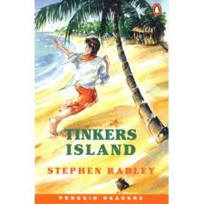
Who wants to be a Star?
The White Oryx
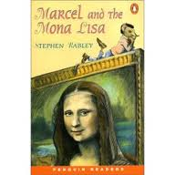
Marcel and the Mona Lisa
Flying Home
Between Two Worlds
Hannah and the Hurricane
Marcel and the White Star
The Ghost House
Girl Meets Boy
The Phone Rings
The Winner
Tinkers Island
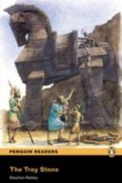
Billy and the Queen
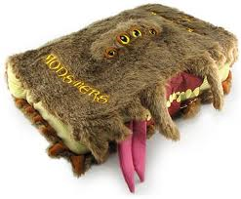
Simon and the Spy
The Troy Stone
Dino's Day in London
The Last Photo
Aladdin and the Lamp
Muzzy and the Mystery Plant
The Cup in the Forest
Rumplestiltskin

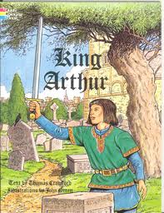
6.-7. RAZRED

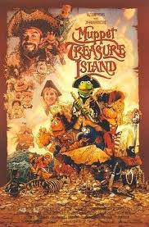
King Arthur
New York Cafe
Brothers in Egypt
Rosa Raye, Crime Reporter
My Family and Other Animals
Apollo 13
Fly Away Home
Treasure Island
A Christmas Carol
The Cay
White Fang
Sweet Valley High
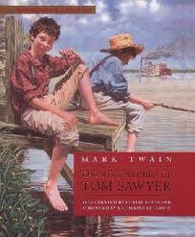
The Secret Garden
Money to Burn
Dragon Heart
The Crane's Gift
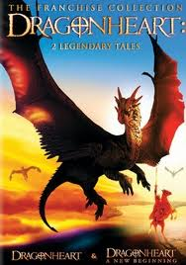
Falling for you
Freckles
The Adventures of Tom Sawyer
The Storm
Robin Hood
Mike's Lucky Day
Sally's Phone
Orca

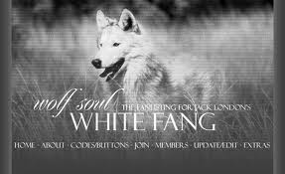

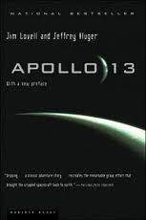

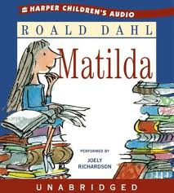
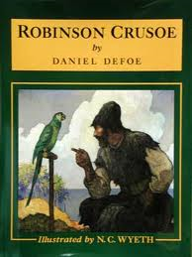
8.-9. RAZRED

The Climb
Matilda
Under the Greenwood Tree
Love Story
Goldfish
Dracula
The Year of Sharing
Love among the Haystacks
Robinson Crusoe
Pocahontas
Wizard of Oz
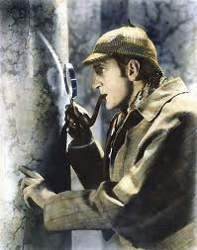
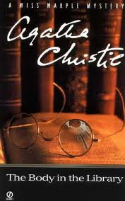
Sherlock Holmes – Two Plays
A Ghost in Love
The Butler did it
Tom Sawyer
Down the River
Cries from the Heart
Goodbye Mr. Hollywood
Go, Lovely Rose
Stories from the five Towns
Return to Earth
Agatha Christie
One Way Ticket
