Immigrants http://en.wikipedia.org/wiki/History_of_New_York#Prehistory
NYC http://www.history.com/topics/new-york-city
LEGENDS OF London http://www.chr.org.uk/legends.htm
Origin NYC name apple http://www.infoplease.com/askeds/big-apple.html
Fun weather act http://edition.englishclub.com/esl-activities/misc/activities-weather-vocabulary/

BBC weather http://efllecturer.blogspot.com/2011/09/bbc-weather-forecast.html
Embed <iframe src="http://www.slideshare.net/slideshow/embed_code/1394207" width="427" height="356" frameborder="0" marginwidth="0" marginheight="0" scrolling="no" style="border:1px solid #CCC; border-width:1px 1px 0; margin-bottom:5px; max-width: 100%;" allowfullscreen> </iframe> <div style="margin-bottom:5px"> <strong> <a href="https://www.slideshare.net/mod83/toms-tefl-weather" title="Tom&#x27;s TEFL - Weather" target="_blank">Tom&#x27;s TEFL - Weather</a> </strong> from <strong><a href="http://www.slideshare.net/mod83" target="_blank">Hong Kong Primary School</a></strong> </div>
WeTHER QU http://teflpedia.com/Weather_conversation_questions
VIDEO WHATžS THE WEATHER LIKE http://www.totalesl.com/ESL-TEFL-TESOL-Conversation-Weather.php
GAME WEATHER PIRATES http://www.eslgamesplus.com/weather-vocabulary-esl-interactive-board-game/ !!!!
CROCCDILE GAME http://www.eslgamesplus.com/weather-vocabulary-esl-interactive-crocodile-board-game/

http://www.acapela-group.com/voices/demo/ snemanje povedi

podcast US EN forecast http://www.eslpod.com/website/show_podcast.php?issue_id=12180377#BBC weather http://www.youtube.com/watch?v=fYmt2amuUps

bbc http://efllecturer.blogspot.com/2011/09/bbc-weather-forecast.html
http://efllecturer.blogspot.com/2011/09/bbc-weather-forecast.html

video nat geo embed code <embed src="http://video.nationalgeographic.com/video/player/flash/syndicatedVideoPlayer.swf" flashvars="vid=weather-101-sci" name="flashObj" width="400" height="334" type="application/x-shockwave-flash" pluginspage="http://www.macromedia.com/shockwave/download/index.cgi?P1_Prod_Version=ShockwaveFlash" allowscriptaccess="never"></embed>

BBB CCCCC!!!! http://www.bbc.co.uk/worldservice/learningenglish/grammar/ask_about_english/081007/

Wea5ther video US shangai
http://www.youtube.com/watch?v=PScGbLBOvKo#t=24
British and weather video http://www.youtube.com/watch?v=H40_t-ysQ7E
Embed <iframe src="http://www.slideshare.net/slideshow/embed_code/1394207" width="427" height="356" frameborder="0" marginwidth="0" marginheight="0" scrolling="no" style="border:1px solid #CCC; border-width:1px 1px 0; margin-bottom:5px; max-width: 100%;" allowfullscreen> </iframe> <div style="margin-bottom:5px"> <strong> <a href="https://www.slideshare.net/mod83/toms-tefl-weather" title="Tom&#x27;s TEFL - Weather" target="_blank">Tom&#x27;s TEFL - Weather</a> </strong> from <strong><a href="http://www.slideshare.net/mod83" target="_blank">Hong Kong Primary School</a></strong> </div>
!!!!

http://www.acapela-group.com/voices/demo/ snemanje povedi

podcast US EN forecast http://www.eslpod.com/website/show_podcast.php?issue_id=12180377#BBC weather http://www.youtube.com/watch?v=fYmt2amuUps

bbc http://efllecturer.blogspot.com/2011/09/bbc-weather-forecast.html
http://efllecturer.blogspot.com/2011/09/bbc-weather-forecast.html

video nat geo embed code <embed src="http://video.nationalgeographic.com/video/player/flash/syndicatedVideoPlayer.swf" flashvars="vid=weather-101-sci" name="flashObj" width="400" height="334" type="application/x-shockwave-flash" pluginspage="http://www.macromedia.com/shockwave/download/index.cgi?P1_Prod_Version=ShockwaveFlash" allowscriptaccess="never"></embed>

BBB CCCCC!!!! http://www.bbc.co.uk/worldservice/learningenglish/grammar/ask_about_english/081007/

Wea5ther video US shangai
http://www.youtube.com/watch?v=PScGbLBOvKo#t=24
British and weather video http://www.youtube.com/watch?v=H40_t-ysQ7E
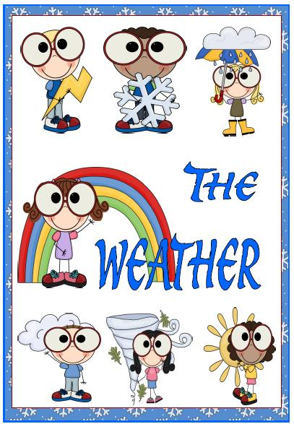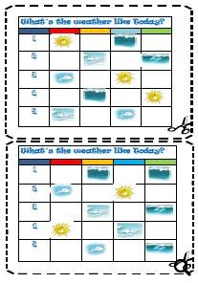
Some activities to do in the classroom when talking about weather. And they work!

- Weather forecast

- Divide students into pairs or groups, depending on how many computers are available.
- Have the students check the following web page:
http://www.weatheronline.co.uk
- Each pair or group has to check the weather in one of the countries or continents.
- They compare the weather forecasts and decide where the weather is going to be the best, the worst, the hottest, the coldest, the rainiest,...
- They can produce a TV World Weather Report and present it.

- Planning a holiday

- Divide students into pairs or groups, depending on how many computers are available.
- Have the students check the following web pages:

http://www.netscape.co.uk travel map

http://www.mapquest.co.uk maps enter country city
http://www.virtualtourist.com/ map world europe country
- Have them find a holiday destination. It can be a country, a city, a region,...

- The pairs or groups prepare the presentation, the other pairs or groups have to guess which country they are talking about.

It's a country in western Europe, the climate is quite cold and it usually rains a lot.
If you want to get there you need to travel by...
The best way to get there is by....
The journey takes about....
The country is known for...
You can visit ....
You can do/ make/ organise/......
The weather forecast says that....

- They can further discuss which clothes to take, what activities to do,...

- Interactive exercises

- Divide students into pairs or groups
- Have them do the interactive exercises and report the results

Weather forecast
http://webschool.wash.k12.ut.us/science/sequential/18forecasting.html

Scrambled words
http://www.aitech.ac.jp/~iteslj/quizzes/ck/sw-weather.html

Weather
http://www2.arnes.si/~oskplucija4/weather2.htm
http://www2.arnes.si/~oskplucija4/adjectives1.htm

Weather
http://www.aitech.ac.jp/~iteslj/quizzes/mc-we.html

Weather quiz (higher level)
http://weathercenter.com/quiz/

If the above urls are not active any more, you will easily find others, there are lots of them on the internet.

How s the weather today
http://www.bbc.co.uk/worldservice/learningenglish/grammar/ask_about_english/081007/

BBC DOBRO http://www.bbc.co.uk/worldservice/learningenglish/grammar/ask_about_english/081007/

