PREDLOGA PRIPRAVE NA TEMATSKI OZ. UČNI SKLOP

Osnovni podatki:
Ime in priimek, šola:
Program:
Razred:
Predmet:
Časovno obdobje, obseg ur: 17.3-26.3. 2014. 6

 | Cilji sklopa/teme | Vsebinski sklop/tema | Št. ur | Dejavnosti učencev (opis z razvidno vodilno metodo in obliko dela) -> podčrtane dejavnosti z IKT | Potrebna IKT znanja in uporaba orodij + viri  (e-vsebine in e-storitve) | Samostojno domače delo z IKT  (e-vsebine in e-storitve)
 | -Spoznavanje kulture, običajev in zgodovine v angleško govorečih deželah  GEO/HIST  -Ponovitev in utrjevanje geografskih pojmov  - Spoznavanje zanimivih dogodkov iz zgodovine obeh mest  -strani neba  -Primerjava med državama in mestoma  - primerjava kulture | Culture  History | 6 | - Poiščejo izvor imen za London in New York (spletni naslov, video, podcast,)  - Poiščejo videoposnetke o zgodovini NY in Londona(prihod imigrantov, kuga , prisvajanje zemlje Ameriških Indijancev)  - Heroji (Little Big Horn/Man, Wounded Knee, nakup Mahattna, Statue of Liberty  - Učenci posnamejo vprašanja/ poročilo, intervju z junaki/ heroji  - Na spletni strani google maps poimenujejo geografske pojme  - Del zemljevida shranijjo kot sliko, označijo z geo. Pojmi, smeri neba,  - PRIMERJAJO OBE DRŽAVI ( uk zda)> SESTAVIJO KVIZ IN GA REŠUJEJO | - VPRAŠAMO UČENCE, V ČEM SO VEŠČI (tablice, aurasma, audacity,  - podcast,  - glogster, wallwisher, quizlet, interaktivni vprašalniki, če se znajo posneti-slušno in video) | - Snemanje  - Sestava vprašalnika  - raziskovanje po internetu  - sodelovalno delo
 | CULTURE/GEO  - najbolj priljubljena tema pogovorov -VREME  -Ponovitev in utrjevanje pridevnikov in besedišča za opis  Vremena  - uporaba going to / will future za napoved vremena  -spoznavanje in uporaba besednih zvez za opis vremenskih pojavov in značilnosti ter primerjava z enakimi frazami v slovenskem jeziku  - uporaba izrazov in besednih zvez za poročanje o vemenu in vremenski napovedi |  |  | - Vreme- interaktivne vaje J. priskrbi naslov,primerjava vremena med različnimi državami na isti dan, napoved vremena z going to /will weatheronline. co.uk  - E - vsebine za interaktivno tablo in interaktivne vaje – frazemi, opis vremena (igrice)  - Interaktvni vprašalnik - google drive (primerjava frazemov v ang.-slo)  - Sestava kviza ali vprašalnika z quizlet

- Poslušaj podcast

Immigrants http://en.wikipedia.org/wiki/History_of_New_York#Prehistory
NYC http://www.history.com/topics/new-york-city
LEGENDS OF London http://www.chr.org.uk/legends.htm
Origin NYC name apple http://www.infoplease.com/askeds/big-apple.html
Fun weather act http://edition.englishclub.com/esl-activities/misc/activities-weather-vocabulary/ BESEDILO, ideje

BBC weather http://efllecturer.blogspot.com/2011/09/bbc-weather-forecast.html
Embed <iframe src="http://www.slideshare.net/slideshow/embed_code/1394207" width="427" height="356" frameborder="0" marginwidth="0" marginheight="0" scrolling="no" style="border:1px solid #CCC; border-width:1px 1px 0; margin-bottom:5px; max-width: 100%;" allowfullscreen> </iframe> <div style="margin-bottom:5px"> <strong> <a href="https://www.slideshare.net/mod83/toms-tefl-weather" title="Tom&#x27;s TEFL - Weather" target="_blank">Tom&#x27;s TEFL - Weather</a> </strong> from <strong><a href="http://www.slideshare.net/mod83" target="_blank">Hong Kong Primary School</a></strong> </div>
WeTHER QU http://teflpedia.com/Weather_conversation_questions
VIDEO WHATžS THE WEATHER LIKE http://www.totalesl.com/ESL-TEFL-TESOL-Conversation-Weather.php
GAME WEATHER PIRATES http://www.eslgamesplus.com/weather-vocabulary-esl-interactive-board-game/ !!!!
CROCCDILE GAME http://www.eslgamesplus.com/weather-vocabulary-esl-interactive-crocodile-board-game/

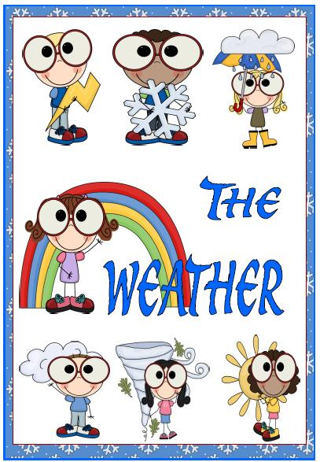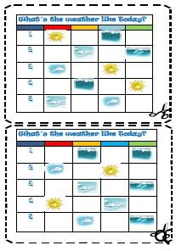
Some activities to do in the classroom when talking about weather. And they work!

- Weather forecast

- Divide students into pairs or groups, depending on how many computers are available.
- Have the students check the following web page:
http://www.weatheronline.co.uk
- Each pair or group has to check the weather in one of the countries or continents.
- They compare the weather forecasts and decide where the weather is going to be the best, the worst, the hottest, the coldest, the rainiest,...
- They can produce a TV World Weather Report and present it.

- Planning a holiday

- Divide students into pairs or groups, depending on how many computers are available.
- Have the students check the following web pages:

http://www.netscape.co.uk travel map

http://www.mapquest.co.uk maps enter country city
http://www.virtualtourist.com/ map world europe country
- Have them find a holiday destination. It can be a country, a city, a region,...

- The pairs or groups prepare the presentation, the other pairs or groups have to guess which country they are talking about.

It's a country in western Europe, the climate is quite cold and it usually rains a lot.
If you want to get there you need to travel by...
The best way to get there is by....
The journey takes about....
The country is known for...
You can visit ....
You can do/ make/ organise/......
The weather forecast says that....

- They can further discuss which clothes to take, what activities to do,...

- Interactive exercises

- Divide students into pairs or groups
- Have them do the interactive exercises and report the results

Weather forecast
http://webschool.wash.k12.ut.us/science/sequential/18forecasting.html

Scrambled words
http://www.aitech.ac.jp/~iteslj/quizzes/ck/sw-weather.html

Weather
http://www2.arnes.si/~oskplucija4/weather2.htm
http://www2.arnes.si/~oskplucija4/adjectives1.htm

Weather
http://www.aitech.ac.jp/~iteslj/quizzes/mc-we.html

Weather quiz (higher level)
http://weathercenter.com/quiz/

If the above urls are not active any more, you will easily find others, there are lots of them on the internet.

- Create your own wordsearch puzzles, quizzes,..
- Have the students go to the following url: http://school.discovery.com/students/
- Create you own username and password. Log in.
- Have them create their own crossword puzzles, mazes, wordsearch puzzles
- Print their creations
- Have them exchange their puzzles and try to find solutions
- Weather Idioms
In the same way you can look for idioms and discuss them with your students.

- Weather proverbs

- Divide students into pairs or groups
- Cut & mix the two halves of the proverbs.
- They try to match the two halves.
- They compare the English proverbs with the ones in their own language.
- They can think of other weather proverbs in their mother tongue and translate them into English.
- Of course, you will choose the right proverbs according to the level of students' performance in English.

Ring around the moon, | brings a storm soon.
Rain before seven, | stops before eleven.
Rainbow at night, | sailor's delight.
Lightning never strikes twice | in the same place
One swallow | does not make a summer.
If the bull leads the cows to pasture, expect rain; | if the cows precede the bull, the weather will be uncertain.
Pigs gather leaves | and straw before a storm.
Flowers close up | before a storm.
Horses run fast before | a violent storm and windy conditions
Expect rain and maybe severe weather | when dogs eat grass.
Wolves always | howl more before a storm.
When the rooster goes crowing to bed, | he will rise with a watery head.
Evening red and morning gray | are sure signs of a fine day.
Evening gray and morning red, | put on your hat or you'll wet your head.
When small clouds join and thicknen, | expect rain.
Dandelion blossoms | close before a storm.
If autumn leaves are slow to fall, | prepare for a cold winter..
If wasps build their nests high, | the winter will be long and harsh.
Redbirds or Blubirds chatter | when it's going to rain
Birds on a telephone wire | indicate the coming of rain.
Before a storm, cows will | lie down and refuse to go out to pasture.
When spiders weave their webs by noon, | fine weather is coming soon.
Haste | makes waste.

Remember!
Students should know
why they are doing
what they are doing
and
why the teacher is doing
what he / she is doing.

( I don't know the author of this quote, but I like it.)

Podcast to listen to idioms http://podbay.fm/show/120830753/e/1125277200?autostart=1

