Field of diversity: | 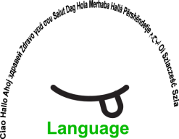 |  | L,LV,M |  | Group size:  
Title | Mi se imamo radi-We all love each other
Content | There is a Slovenian song about friendship, that can be easily translated even by the learners and sung in many different languages. The lyrics are: We all love each other, …why shouldn't we love each other, we'll always love each other… we're all still very young… |  |  |  |   Time: 45 min
Goals (Skills/Competences) | - To talk about the importance of friendship  - To build good relationship between all the students,  - To build social skills and bonds,  - To learn and perform the song in various languages
Material | The song Mi se imamo radi  Lyrics: Mi se imamo radi, radi radi radi 3x, mi se imamo radi, radi prav zares  We all love each other, love love each other 3x, we all love each other, we really really do
Procedure: | - The students listen to the Slovenian version of the song.  - With the help of the English version, they try to translate it in all the languages spoken in the class.  - The learners help each other, the teacher helps, moderates.  - The learners sing the song in all the languages simultaneously or as they choose.  - The non-singing learners can choose another activity: drawing friends, using an instrument to accompany, dance, act,……  + links The song
Modifications
Comments
Success factors   | Positive motivation, having fun  From experience, it is a very well accepted challenge The same can be done with the song Frere Jacques, sung in all the languages | Pitfalls   |  | Unable to translate, un-willing to participate
The activity is flexible and depends on the local context. Feel free to adapt!
THE SONG: LYRICS
SLOVENIAN: Mi se imamo radi | ENGLISH: We all love each other | GERMAN: Wier sind gutte freunde…
Mi se imamo radi,  radi, radi, radi,  mi se imamo radi,  radi, radi, radi,  Mi se imamo radi,  radi, radi, radi,  mi se imamo radi,  radi prav zares.  Zakaj se ne bi imeli  radi, radi, radi, 3x  zakaj se ne bi imeli  radi prav zares.  Še se bomo imeli  radi, radi, radi,3x  še se bomo imeli  radi prav zares.  Saj smo sami mladi  mladi, mladi, mladi,3x  saj smo sami mladi  mladi prav zares. | We all love each other,  love love each other  We all love each other,  love love each other  We all love each other,  love love each other  We all love each other,  Oh we really do  Why shouldn't we love each other,  love love each other 3x  Why shouldn't we love each other,  Oh we really should  We'll always love each other,  love love each other 3x  We'll always love each other,  we promise that we will  We are all still young  very very young 3x  We are all still young ,  Oh we really are
ITALIAN:  Noi ci vogliamo bene, tanto tanto bene…  OR  Siamo buoni amici, molto buoni amici | FRENCH:  Nous sommes de bons amis, de tres bons amis  OR  Nous on s'aime très fort, très très fo-ort | CZECH
DUTCH | ??? | ???
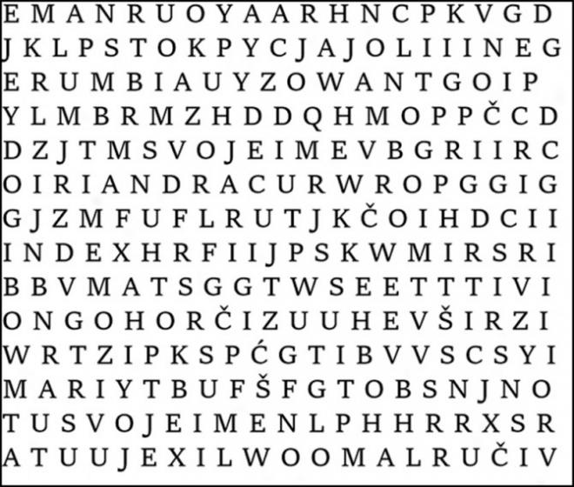

©
UDEL 21

