Field of diversity: | 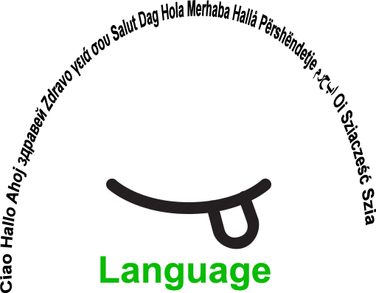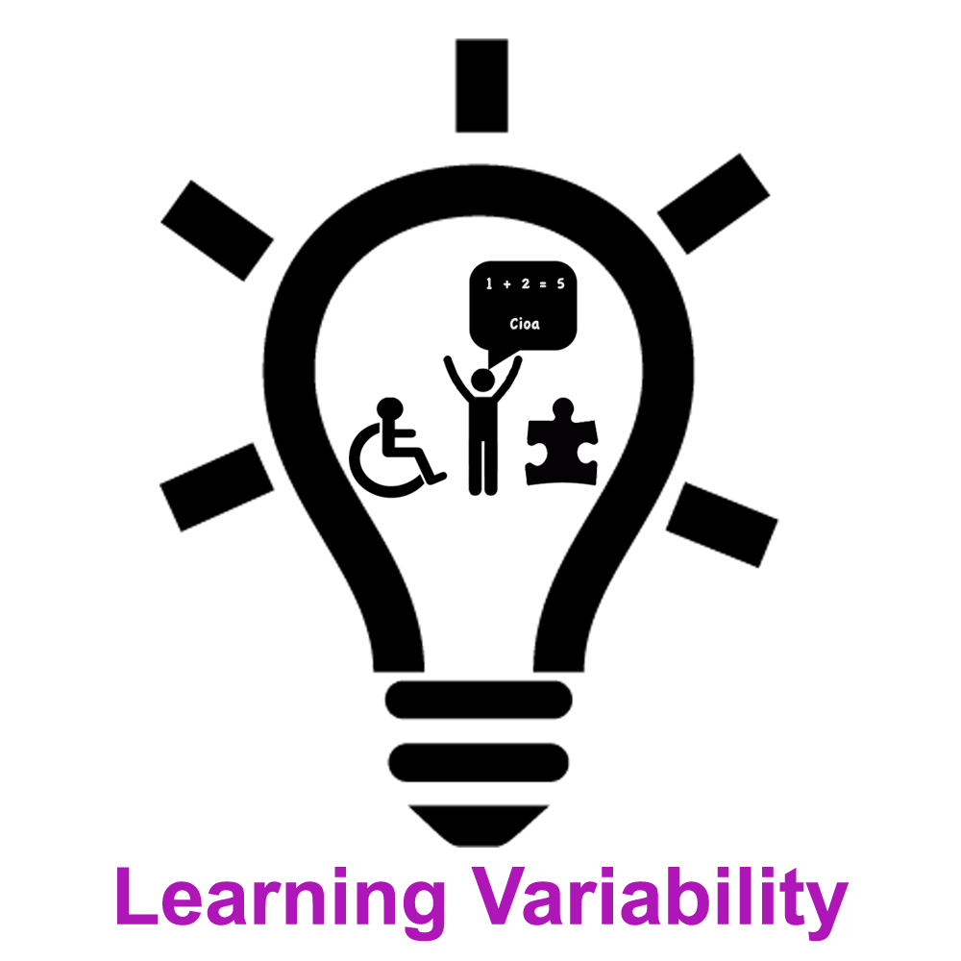 |  | LLV2 |  | Group size: 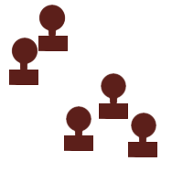
Title | Language detectives
Content | It is said that one image tells you more than a thousand words.  By using images/pictograms, learning of a new language becomes much easier and less stressful. Language detectives have proved the saying is true. |  |  |  | Time: 2-3 lessons of 45 min
Goals (Skills/Competences) | To learn new vocabulary in the language/languages spoken in the new country, to develop social and communication competences,  to learn about habits and rules in the new school.
Material | A camera or mobile phone or notebook ( ipad or similar)  Cardboard, scissors, glue  A4 sheets of paper  Pictograms  Computer-to create ppt presentation
Procedure: | - New comers (migrants, students from other parts of the countries or refugees) are put in groups with three native speakers or students, that speak the languages spoken in the new country very well (in this case students, who speak Slovenian, English and Italian - languages spoken and learnt in the coastal region of Slovenia, where Slovenian and Italian are taught from grade 1 on, and English from grade 2 on).  - A new student is accompanied by three school mates, they visit all the places at school from the courtyard, gym, classrooms, canteen to the principal’s office take photographs and name the places.  -Back in class they prepare a ppt and label the places with their names in three languages spoken at school. They can also add their own languages.  -The names are recorded and with the help of the teacher a link is created to the names of the places in the powerpoint presentation.  -The students then create labels in the three languages and put them on all the entrances to the places at school.  -Newcomers are helped by the peers and by the teacher. All the material is used to learn the expression in the language-s of the country.  + links – Examples at the bottom ***
Modifications
Comments
Success    factors | Socialising, getting new friends, learning by doing | Pitfalls   |  | /
The activity is flexible and depends on the local context. Feel free to adapt!

*** Examples
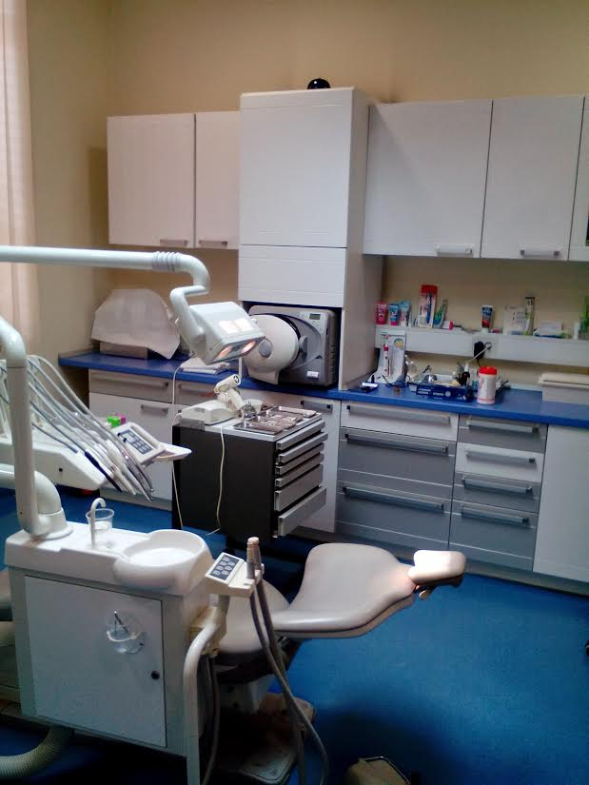  Šolski zobozdravnik  School dentist  Il dentista | 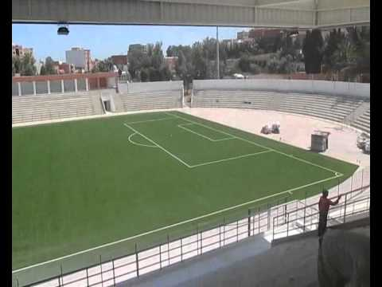  Stadion  Stadium  Stadio | 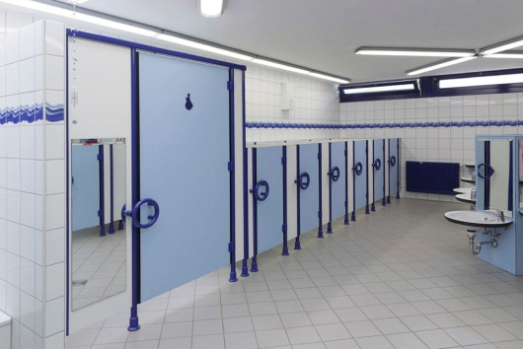  Sanitarije – WC  Toilets  Servizi igienici
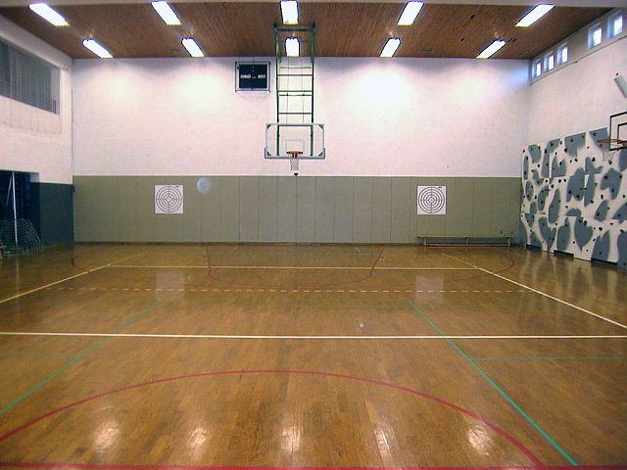  Telovadnica  Gym  Palestra | 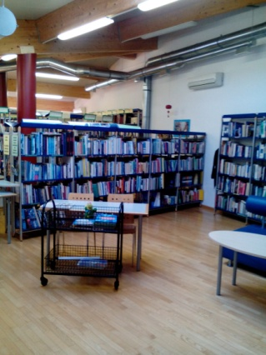  Šolska knjižnica  School library  Biblioteca | 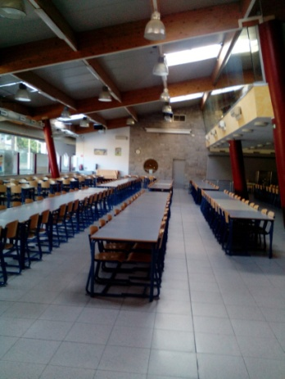  Jedilnica  Canteen  Sala ristorazione

©
UDEL 21

