Title: | Celebrating the day of the languages |  | L2 |  | Group size:  
Field of diversity: | 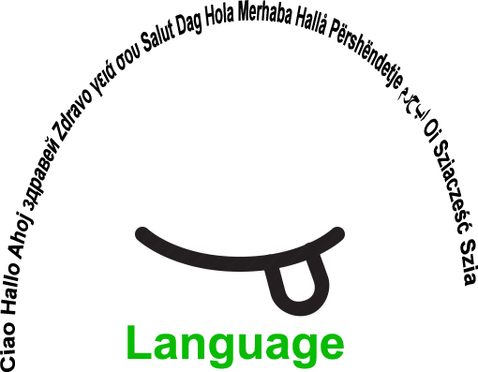
Content  Material | School and students provide different material (e.g. for costumes, ....) one week before the activity.  Camera to record |  |  |  | Time: whole day activity (5 hours)  
Goals (Skills/Competences): | Improvement of communication skills and performing skills in different languages that are learned at school.  To create, act, taste, show the specialities of the different languages and countries.
Procedure: | - The teacher explains the goals of the lesson: verbal and visual.  - Students form groups, according to their interest in the languages that are learnt in the school and in which they feel safe.  - Newcomers/migrant students can form their own group. Visual aids are present, e.g. pictograms.  - The group chooses between a number of activities, e.g. creating masks, creating costumes, preparing national sweets, creating cartoons/skits… The students can propose other options. Visual aids are present, e.g. pictograms.  - There is a mentor/teacher present in each group to moderate the activity. A student can be appointed as leader.  - One teacher or student records the activities and makes a short video.  - At the end of the day, the groups present (their own choice) the outcome for all students.  - All students watch the video.  - Evaluation of the activity: students have different options within a structured choice (the teacher decides the different options), e.g. by discussion, a questionnaire, a graph …
Modifications
Comments
Success    factors | The migrant group of students already  know each other.  The students are motivated to do the tasks and to reach the goals |   Pitfalls
The activity is flexible and depends on the local context. Feel free to adapt!
©
UDEL 21

