Field of diversity: | 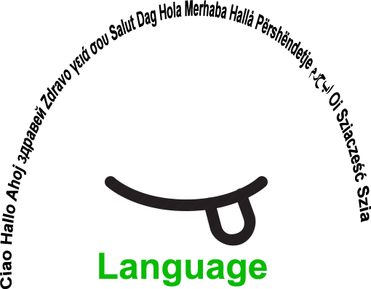 |  |  |  | Group size:  
Title | Why not involve students to create interactive quizzes and games?
Content | Students love doing online interactive exercises to improve language or other competences. This time they become the authors of interactive quizzes, they share them with their peers. |  |  |  |   Time: 3x45 minutes
Goals (Skills/Competences) | To develop social skills, language or other competences
Material | Computer classroom  Links: kahoot.it, quizlet.com,
Procedure: | Procedure  The students are given the instructions on how to create online quizzes and games (the teachers has to try them first)  They each choose a different topic for creating the quizzes/games  They work in the computer classroom and are supervised/supported and motivated by the teacher  Each student thus creates his/her own game  The links of the games created are sent to the teacher, the teacher corrects the mistakes and publishes the students’ work online.  The students then choose which topic they are going to practise and which games/quizzes created by them, they are going to do. They can work at school or at home, at their own pace and at the time they want.  + links: kahoot.it, quizlet.com  Link: Article by JB
Modifications
Comments
Success    factors | The students are always highly motivated to create their own »tests« for other students to do.  Enough computers for everyone. | Pitfalls   |  | Not being able to do the games at home
The activity is flexible and depends on the local context. Feel free to adapt!
©
UDEL 21

