Field of diversity: | 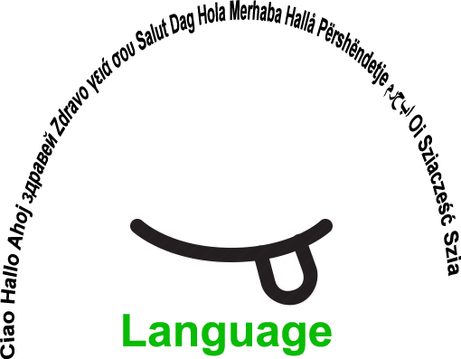 |  |  |  | Group size:  
Title | What about sketches in different languages?
Content | Creating sketches based on a traditional story in the language of the students’ choice |  |  |  |   Time: 3 hours
Goals (Skills/Competences) | To improve speaking and social skills by creating scenarios and acting.
Material | Circles with the name of the languages.  Handouts with a story from a national legend.
Procedure: | - The students are invited to join heterogeneous groups, according to the language they are going to use.  - The students have a story of the national literature (legend, fairy tale, crime story, ….) in the language of instruction.  - The students read the story and create a scenario with dialogues for a short sketch that matches the story.  - The students prepare to act the story in the language the group has chosen to use.  - The students act the story in the language of the group.  - The students give each other feedback about the preparation they did, the procedure and the feelings they had while preparing the sketch and performing it.  - The performance can be recorded if the students agree.  (Example: Slovenian story “Butalci” - the most stupid people living on earth. Students choose the characters, create dialogues, can use masks and costumes and perform the story in their own way)  Link: www.steinbacher.si/udel21 Username: yeye Password:1Geniji
Modifications
Comments
Success    factors | A set of rules that have to be respected.  The story-line needs to be followed. | Pitfalls   |  | Not encountered so far.
The activity is flexible and depends on the local context. Feel free to adapt!
©
UDEL 21

