Title: | Celebrating the day of the languages |  | L2 |  | Group size:  
Field of diversity: | 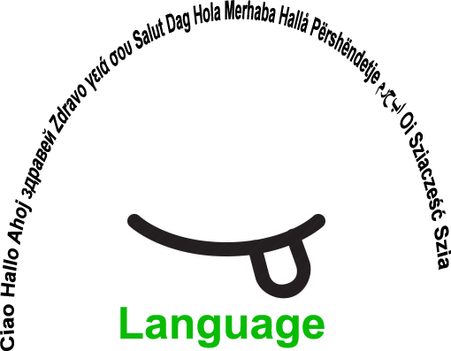
Content  Material | Creation, acting, tasting, showing the specialities of the different languages and countries.  School and students provide different material (e.g. masks, costumes, ....) one week before the activity.  Camera to record. |  |  |  | Time: whole day activity (5 hours)  
Goals (Skills/Competences): | Improvement of communication skills and performing skills in different languages that are learnt in the school.
Procedure: | - The teacher explains the goals of the lesson: verbal and visual.  - Students form groups, according to their interest in the languages that are learned in the school and in which they feel safe.  - Newcomers/migrant students can form their own group. Visual aids are present, e.g. pictograms.  - The group chooses between a number of activities, e.g. creating masks, creating costumes, preparing national sweets, creating cartoons  or sketches, ….. The students can propose other options. Visual aids are present, e.g. pictograms.  - There is a mentor/teacher present in each group to moderate the activity. A student can be appointed as leader.  - One teacher or student records the activities and makes a short video.  - At the end of the day the groups present (own choice) the outcomes for all students.  - All students watch the video.  - Evaluation of the activity: students have different options within a structured choice (the teacher decides the different options), e.g.  by discussion, a questionnaire, a graph, …. Link:Videos
Modifications
Comments
Success    factors | The migrant group already did prior activities so they know each other. | Pitfalls  
The activity is flexible and depends on the local context. Feel free to adapt!

©
UDEL 21

