Title: | What about sketches in different languages? |  |  | Group size:
Field of diversity: | Learning Variability  Language 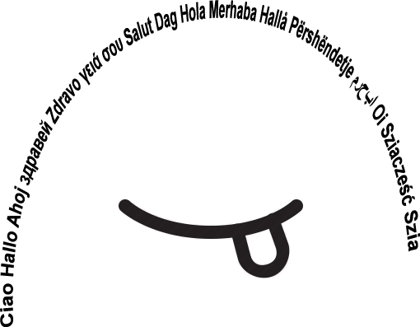
Content  Material | Groups create sketches in a chosen language based on a story  Circles with the name of the languages.  Handouts with a story from a national legend. |  |  | Time: 3 hours  
Goals: | To improve speaking and social skills by acting.
Procedure: | - Students are divided into heterogeneous groups, according to the language they are going to use.  - The students have a story of the national literature (legend, fairy tale, crime story, ….) in Slovenian (instruction language)  - The students read the story and they create a scenario with dialogues for a short sketch that matches the story.  - The students prepare to act the story in the language of the group  - The students act the story in the language of the group  - The students give each other feedback about the preparation they did, the procedure and the feelings they had.  (Example: Slovenian story “Butalci” (the most stupid people living on earth. Students choose the characters, create dialogues, can use masks and costumes)  Link: www.steinbacher.si/udel21 Username: yeye Password:1Geniji
Modifications
Comments
Success    factors | A set of rules that have to be respected.  The story-line needs to be followed. |   Pitfalls
The activity is flexible and depends on the local context
©
UDEL 21

