Field of diversity: | 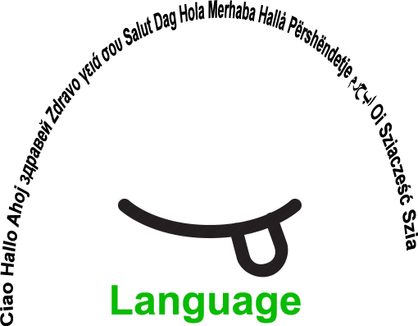 |  | LLV |  | Group size:  
Title | Narrating a story with the help of images
Content | With Rory's Story Cubes, anyone can become a great storyteller and there are no wrong answers. Simply roll the cubes and let the pictures spark your imagination. |  |  |  |   Time: 5min -10min per student up to  30 min
Goals (Skills/Competences) | - to develop speaking and listening skills,  - to develop creative inspiration and imagination  - to broaden vocabulary,  - to develop the ability for narrating short stories
Material | Rory's Story Cubes
Procedure: | - Each learner is asked to throw 3-9 cubes  - The learner is given 1-2 min time to form the story in his/her mind  - The learner arranges the cubes in such a way that they represent the story  - The learner narrates the story to the teacher.  - In a smaller group the learners listen to the stories of each other and narrate their own  - The learners exchange information about their feelings and thoughts while creating the stories, narrating and listening to  other stories.  + links
Modifications  Comments | - The game can be played with fewer cubes and later increase the number, depending on the age of learners and language skills not to forget the ability to listen  - It is possiblle to retell the story several times and develop listening skill  - The story can be created in group, each learner telling one sentence, the others continuing the activity
Success    factors | Everybody is successful  There are no wrong answers | Pitfalls   |  | Difficulties in understanding symbols.  A larner can have difficulties in following the thread /the content of the story
The activity is flexible and depends on the local context. Feel free to adapt!
©
UDEL 21

