Field of diversity: | 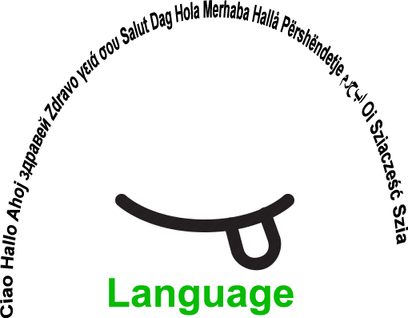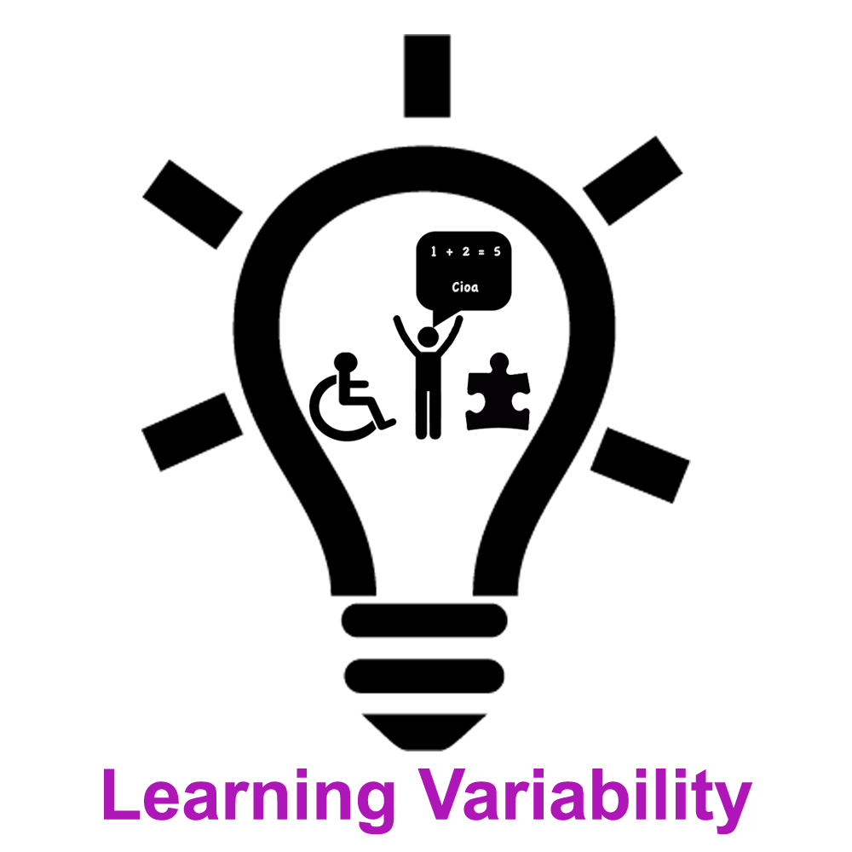 |  | LM |  | Group size:  
Title | Preparation lessons for migrants
Content | Some days before starting the new school year, extra preparation classes are offered to new students, after that more intense week, there is a preparation lesson once a week for the whole year. Besides learning the languages spoken in the new country, they are offered various interesting and motivating activities, such as playing games and singing songs.. |  |  |  |   Time:  First school week and later once a week
Goals (Skills/Competences) | - to facilitate their transition into the new school or a new environment with an unknown language for them  - to translate useful and usable words from Slovenian into their mother language  - to strengthen self-esteem in the new environment  - to improve reading, writing and understanding new vocabulary/alphabet,  - to develop social skills (life perspective, self-esteem), presentation of yourself in a new language
Material | Song Are you sleeping Brother John in Slovenian, Italian, and the languages of the students  Material created by teachers  Ppictures or objects of concrete reality and practical level (numbers, colors, food, clothes …)
Procedure: | Some activities for the first week at school:  - students need to visit the school (gym, library, classrooms …) and get to know the teachers - if possible, before attending the classes, the students complete a quick language course or extracurricular activity in order to learn Slovenian alphabet, understand large/small printed and written letters, to learn useful vocabulary to present themselves, greetings,.. – Students learn the multicultural song Are you sleeping Brother John, and if the students are willing to, with a simple dance choreography At the end of the preparatory week, a short event for the parents is organized, so that the students migrants can show what they have learnt so far.  + links Are you sleeping Fra Martino Mojster Jaka Mojster Jaka Various languages
Modifications
Comments
Success    factors | With the help of the teachers, migrants can adapt much faster, easier and in a positive way into new language environment and also to the new life | Pitfalls  
The activity is flexible and depends on the local context. Feel free to adapt!

©
UDEL 21

