Field of diversity: | 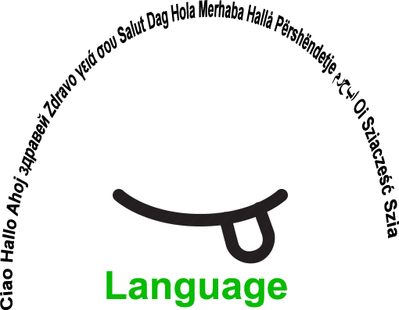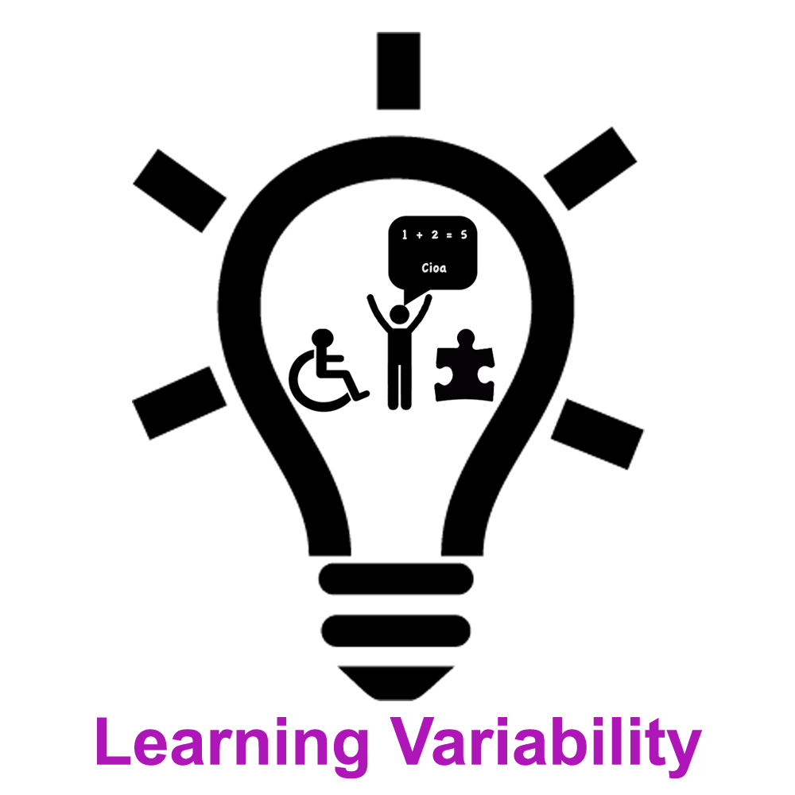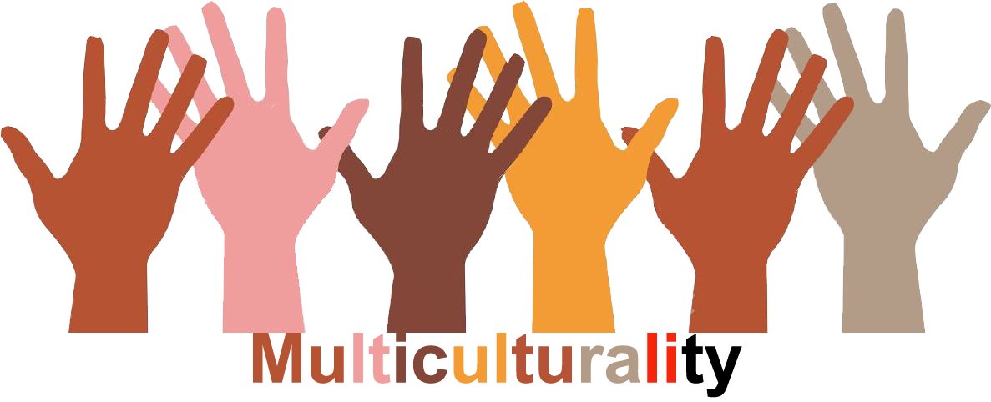 |  | LLV 3 |  | Group size:  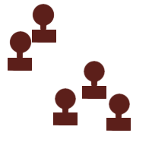
Title | Learning assistance by classmates
Content | VOLUNTARY WORK AS A TOOL FOR DEVELOPING SOCIAL SKILLS AND LEARNING STRATEGIES |  |  |  |   Time: whole school year
Goals (Skills/Competences) | TO IMPROVE SOCIAL SKILLS (EMPATHY, COLLABORATION, TEAM WORK) AND LEARNING STRATEGIES (TO EXPLORE A VARIETY OF DIFFERENT LEARNING POSSIBILITES)  TO SHARE SKILLS AND TALENTS BETWEEN THE STUDENTS. TO HELP EACH OTHER IN DEVELOPING LEARNING STRATEGIES.
Material | Teaching aids, coursebooks, games,..
Procedure: | - Meetings with peers and an assistant teacher 5 times a week for an hour  - By helping the younger students, the older students share their knowledge and experience with the younger students and take the key role as models, mentors, motivators and friends  - The tasks they do together are: doing homework, studying, talking about life in general, cultivating and sharing hobbies, interests, playing games, drawing pictures, and making posters about various humanitarian issues and in that case raising awareness of the problems around us.  - Activities, such as collecting paper, food and blankets for animals, food for homeless, plastic bottle taps for helping disabled people in obtaining wheelchairs etc , visiting the old people’s institutions, and visiting other centres where people are in need of help and a little attention.  +Link: http://www.oslucija.si/www/prostovoljci/
Modifications
Comments
Success    factors | Willingness to help those in need  Being ready to offer help to slower students | Pitfalls   |  | /
The activity is flexible and depends on the local context. Feel free to adapt!
©
UDEL 21

