Field of diversity: | 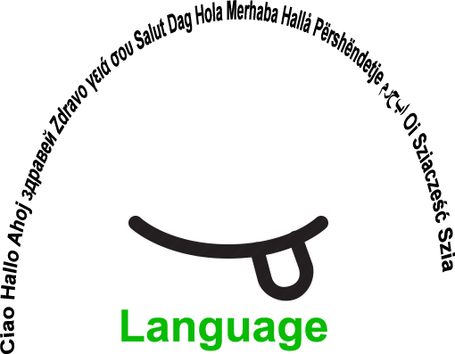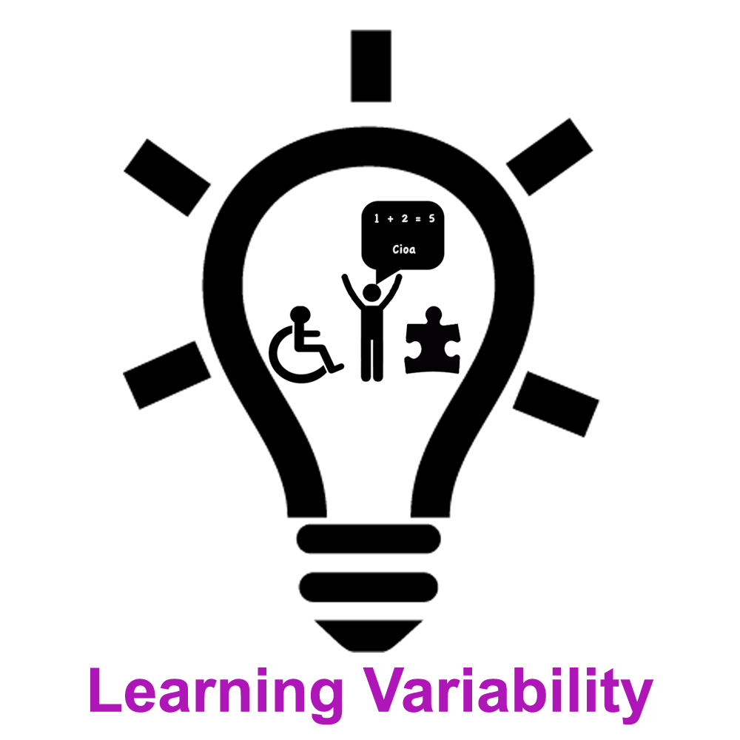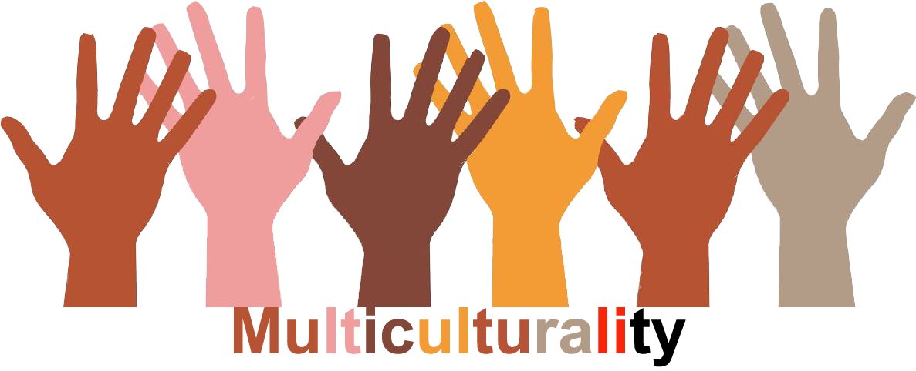 |  | Lv |  | Group size:  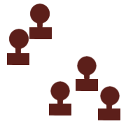
Title | Location and natural geographical characteristics of Slovenia
Content | Slovenia in Europe – A multisensory geography lesson |  |  |  | Time: 1:30
Goals (Skills/Competences) | - To evaluate the meaning of membership in the EU , economically and politically  - To raise awareness of the importance of knowledge and languages for getting jobs in the EU  - To make a SWOT analysis regarding membership of Slovenia in the EU in comparison with non-EU countries
Material | Interactive whiteboard( IWB) , tablets, lap top, folders with instructions, worksheets
Procedure: | Introductory motivation:  Music – My homeland. The learners write down what their country means to them, analysis of the responses, setting goals  Procedure:  Group work – learning stations (learners circulate every 5 minutes):  - Republic of Slovenia – the formationh of the country  - Slovenia in numbers– analysis of statistical data  - Visiting Slovenia – learning about landmarks of Slovenia (computer game)  - Slovenian landmarks – defining natural and societal sights (tablets)  - Slovenia in the EU– analysis of the advantages and drawbacks of being a member of the EU – IWB  - Travelling around Europe –describing the characteristics of European states by using visual source  - Feedback about group work  - Self assessment: Quiz about Slovenia  Links: song
Modifications
Comments
Success    factors | Technology functioning  The same activities can be done for all possible countries | Pitfalls  
The activity is flexible and depends on the local context. Feel free to adapt!
©
UDEL 21

