Field of diversity: | 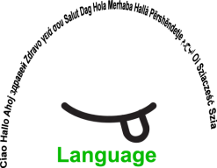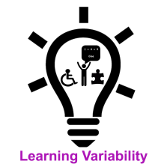 |  |  |  | Group size:  
Title | In the Magic world of Hocus and Lotus
Content | Learning a second or a foreign language by using mimics, creative gestures and a magic object |  |  |  |   Time: 45min+45min
Goals (Skills/Competences) | Enriching vocabulary and improving memorising  - The learners imitate the teacher's gestures, mimics and speech  - They learn new vocabulary and memorize gestures  - They choose or create their own magic object
Material | A magic T-shirt/ a magic object
Procedure: | - The teacher puts on his/her Magic T-shirt and thus enters into the world in which, in this case, only Italian is spoken.  - The teacher starts telling the story by using gestures to explain new vocabulary and facial expression to present different feelings and/or moods. A different tone of the voice is used by the teacher to represent a different character in the story.  - The learners repeat the gestures after the teacher and try to use the same facial expressions.  - The learners then retell the story autonomously, without the teacher's support.  - Each learner presents his/her magic object (they had to bring it to school) and uses the object to tell his/her own story  - The other learners repeat after the learner  - The next lesson all other learners are invited to present their own stories. SEN students, migrants and learners who do not want to expose themselves in such activities may be assigned other tasks, like using musical instruments to accompany stories, creating masks or magic objects or other tasks of their choice.
Modifications
Comments
Success  factors | All learners are active, even those who do not like to expose themselves, which increases their self esteem.  A very motivating activity for the learners to memorize vocabulary, characters, actions, the story and act the story | Pitfalls   |  | Students with special needs and new students might have difficulties in remembering the new vocabulary.  Some learners might not be willing top participate in the activities.
The activity is flexible and depends on the local context. Feel free to adapt!

©
UDEL 21

