Field of diversity: | 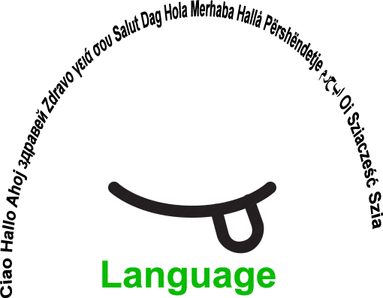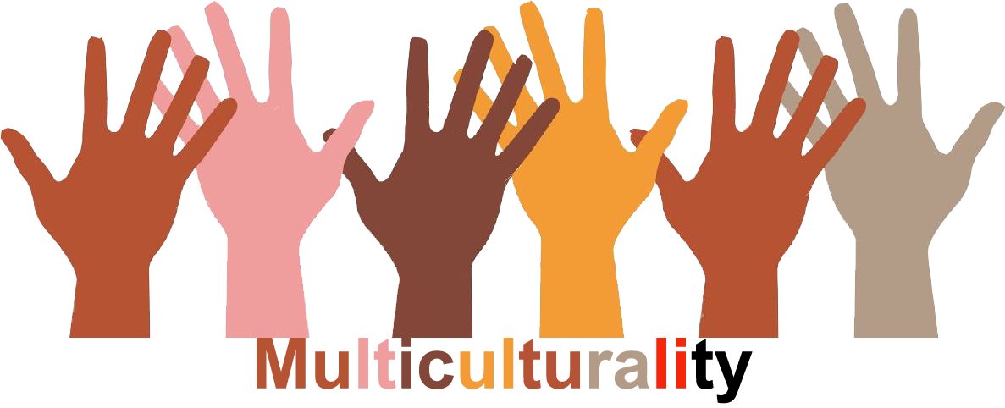 |  | L3 |  | Group size: 
Title | Our Ideal Country
Content | The students create their own ideal country, by using vocabulary dealing with: geographical terms, culture, nationalities, languages, habits, politics, rules etc |  |  |  |   Time: 3-5 lessons x 45 minutes
Goals (Skills/Competences) | To improve speaking competence and to develop social skills
Material | A very big white paper basis on the wall ( can be format A1)  An envelope with small leaflets with gographical terms  A4 sheets of paper/per student  Coloured pencils or similar
Procedure: | - The students draw an ideal country on the white paper basis on the wall (each student part of the drawing).  - Each student draws one leaflet with a geographical name out of the envelope (see attachement)  - The students draw their geographical names on the A4 sheet of paper, colour it and give it a special name  - Each student glues his/her picture on the chosen space on the big white paper basis  -When all the pictures are glued, the country is formed  OPTIONS:  -The students can choose the name of the country, the bordering countries, the languages spoken, the area, the habits, national costumes, culture, population, …and talk about them.  -They set up rules for safety, communication, behaviour, education …(their choice)  - The students may run elections, talk about religious issues, politics  - Evaluation of the activities: What have we learnt?  + LINK: WORKSHEETS
Modifications
Comments
Success    factors | Involving all the students | Pitfalls  
The activity is flexible and depends on the local context. Feel free to adapt!

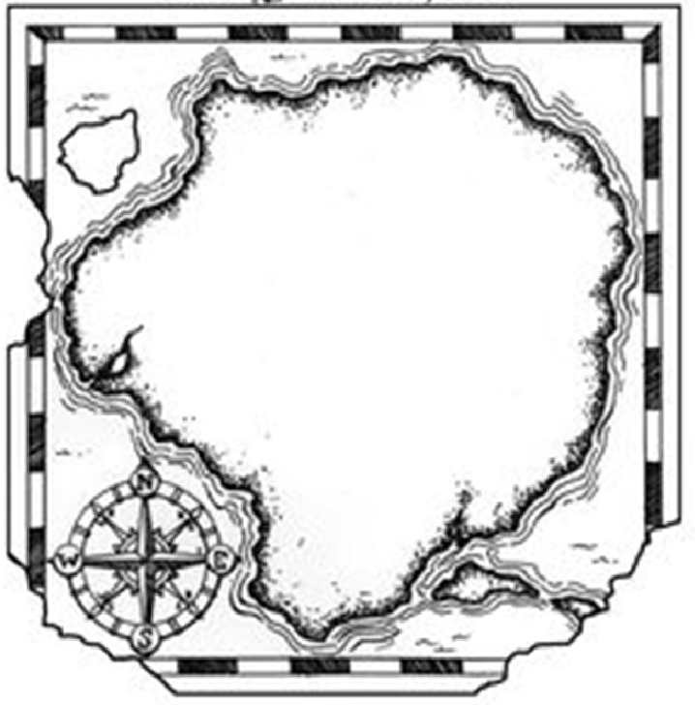 | SLOVENIAN INSTRUCTIONS: NAVODILA  IDEAL COUNTRY (JB)  - NA STENO PRITRDIŠ VELIK ŠELESHAMER ALI ŠE VEČJO BELO PODLAGO  - NA PODLAGI UČENCI NARIŠEJO OBRISE IDEALNE DRŽAVE ( PRIMER LEVO)  - V KUVERTI NA LISTIH SHRANIŠ GEOGRAFSKA IMENA V 3 JEZIKIH  - VSAK UČENEC IZŽREBA EN LISTEK  - NA DRUGI LIST, POLOVICA FORMATA A4, NARIŠE , KAR IMA NA SLIKI IN PRILEPI NEKAM NA BELO PODLAGO  - SVOJO GEOGRAFSKO ENOTO POIMENUJE, KOT ŽELI, LAHKO PO SEBI ALI SI IME IZMISLI  - ENAKO SI IZMISLIJO DRŽAVE, KI MEJIJO NA NAŠO IDEALNO DRŽAVO  - PONIVIMO SMERI NEBA  - UČENCI OPIŠEJO, KJE SE NJIHOVA GEO. ENOTA NAHAJA  - (OPCIJE: OPIŠEJO VELIKOST ENOT, DRŽAVE, JEZIK, PREBIVALSTVO, INDUSTRIJA, KMETIJSTVO, GLAVNO MESTO, POMEMBNI SPOMENIKI ITD ITD…)  - SPROTI, URO ZA URO, SE ZEMLJEVID IN PODATKI DOPOLNJUJEJO,…  - EVALVACIJA UČENCEV IN UČITELJA

REKA  RIVER  FIUME | ZALIV  BAY  BAIA | KANAL  CANAL  CANALE
GORA  MOUNTAIN  MONTAGNA | MESTO  CITY  CITTA | DOLINA  VALLEY  VALLE
JEZERO  LAKE  LAGO | VAS  VILLAGE  VILLAGGIO | GOROVJE  MOUNTAIN RANGE  CATENA MONTUOSA
MORJE  SEA  MARE | VULKAN  VOLCANO  VULCANO | JAMA  CAVE  GROTTA
POTOK  CREEK  RUSCELLO | SLAP  WATERFALL  CASCATA | OBALA  COAST  COSTA
OTOK  ISLAND  ISOLA | POLOTOK  PENINSULA  PENISOLA | HRIB/GRIČ  HILL  COLLINA
KLIF  CLIFF  CLIFF/SCOGLIERA | MEJA  BORDER  CONFINE | OCEAN  OCEAN  OCEANO
GOZD  FOREST  FORESTA | TRAVNIK  MEADOW  PRATO | DŽUNGLA  JUNGLE  GIUNGLA
LETALIŠČE  AIRPORT  AEROPORTO | LUKA  PORT  PORTO | ŽELEZNICA  RAILWAY  FERROVIA
?
©
UDEL 21

