Field of diversity: | 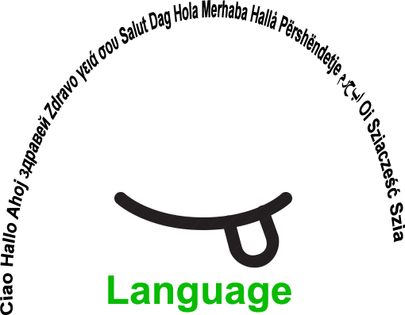 |  |  |  | Group size:  
Title | Narrating a story with the help of images
Content | With Rory's Story Cubes, anyone can become a great storyteller and there are no wrong answers. Simply roll the cubes and let the pictures spark your imagination. |  |  |  |   Time: 5 min to 10 min per student up to  30 min
Goals (Skills/Competences) | - to develop speaking and listening skills,  - to develop creative inspiration and imagination,  - to broaden vocabulary,  - to develop the ability for narrating short stories.
Material | Rory's Story Cubes
Procedure: | - Each learner is asked to throw 3-9 cubes  - The learner is given 1-2 min time to form the story in his/her mind  - The learner arranges the cubes in such a way that they represent the story  - The learner narrates the story to the teacher.  - In a smaller group the learners listen to the stories of each other and narrate their own  - The learners exchange information about their feelings and thoughts while creating the stories, narrating and listening to other stories.  + links
Modifications  Comments | The game can be played with fewer cubes and later increase the number, depending on the age of learners and language skills not to forget the ability to listen.  It is possible to retell the story several times and develop listening skill.  The story can be created in group, each learner telling one sentence, the others continuing the activity.
Success    factors | Everybody is successful  There are no wrong answers | Pitfalls   |  | Difficulties in understanding symbols.  A learner can have difficulties in following the thread /the content of the story  Not being able to purchase the game
The activity is flexible and depends on the local context. Feel free to adapt!
©
UDEL 21

