Field of diversity: | 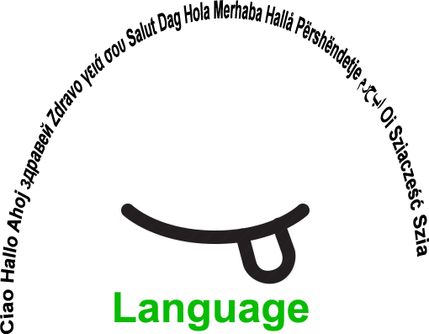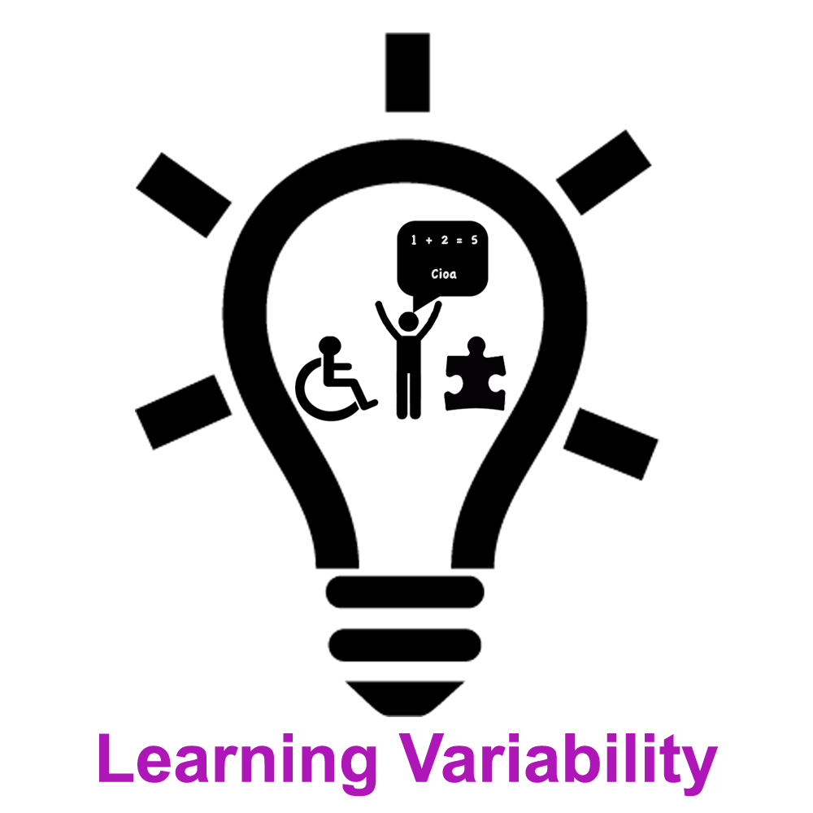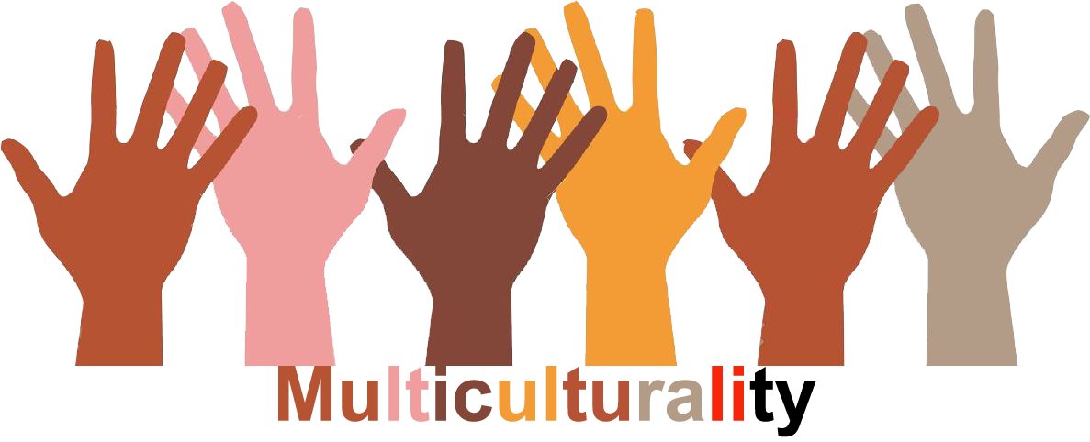 |  | L, LV. M |  | Group size:  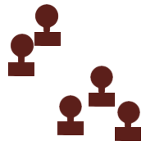
Title | MY WORLD
Content | Presentation of my own world is the presentation of myself |  |  |  |   Time: from 10-15 min per person
Goals (Skills/Competences) | - to get to know each other, to make contact with one another  - to present one's interests, what he/she likes or not, personal characteristics  - to develop identity, to be able to present one-self, to strengther self-esteem  - to develop creativity  - to develop the sense of belonging to a group
Material | - Felt tip pens, crayons, pencils, pictures from amgazines,A4 or largeer sheets of paper
Procedure: | - The teacher presents the activities and goals: looking for materials and preparation of the product ( drawing, cutting up, gluing, …).  The teacher can produce his/her own presentation, so the students might get to know the teacher better.  - The students present their work in smaller groups (in a circle) or in front of the whole class if they choose to do so  - Discussion about the experience and the feelings continues. The students choose whether to participate in the discussion or do  another task they like  - The questions are e.g. What did/didn’t you like? Was the task easy/difficilt? Is there anything new that you have learnt about yourself/  the others? What would you like to do with the products? Would it be a good idea to connect them and make our own common world?
Modifications  Comments | -
Success    factors | - Students like to talk about themselves, they have to be able to choose the way of how to do the task according to the learning styles, individuality has to be respected. | Pitfalls  
The activity is flexible and depends on the local context. Feel free to adapt!
©
UDEL 21

