Field of diversity: | 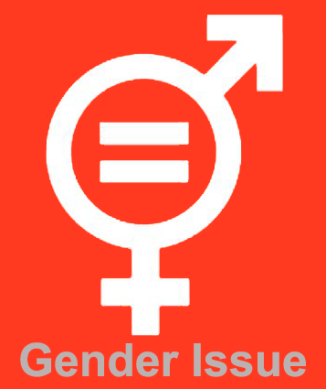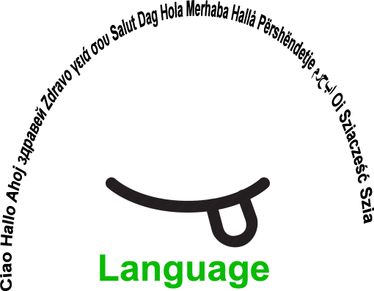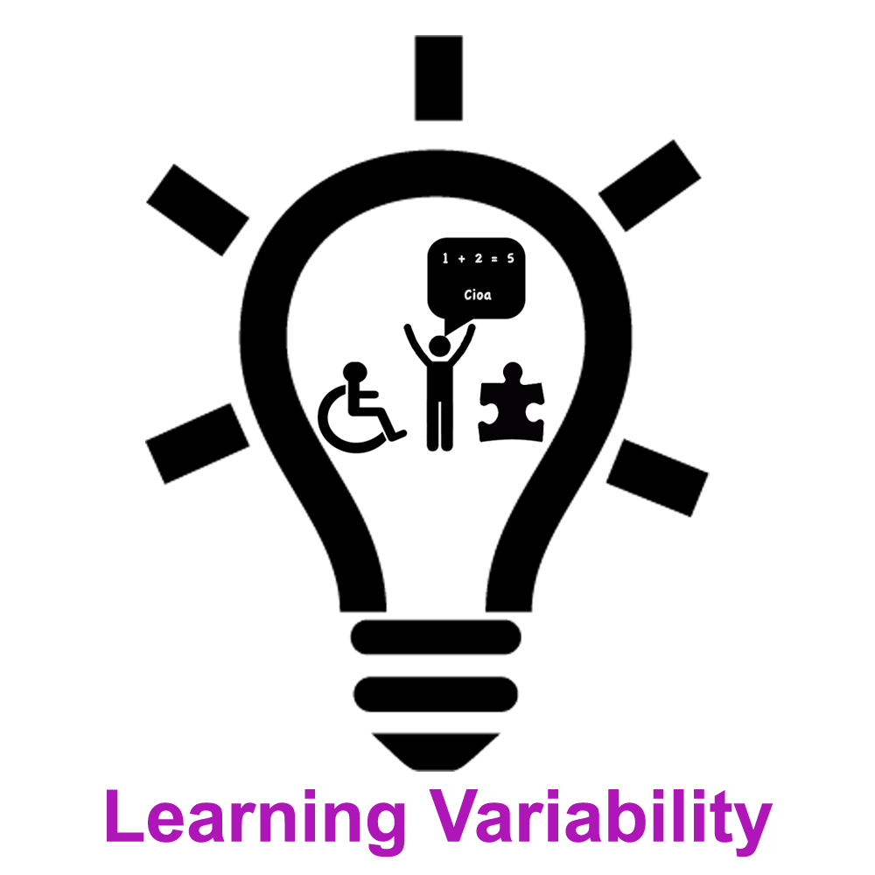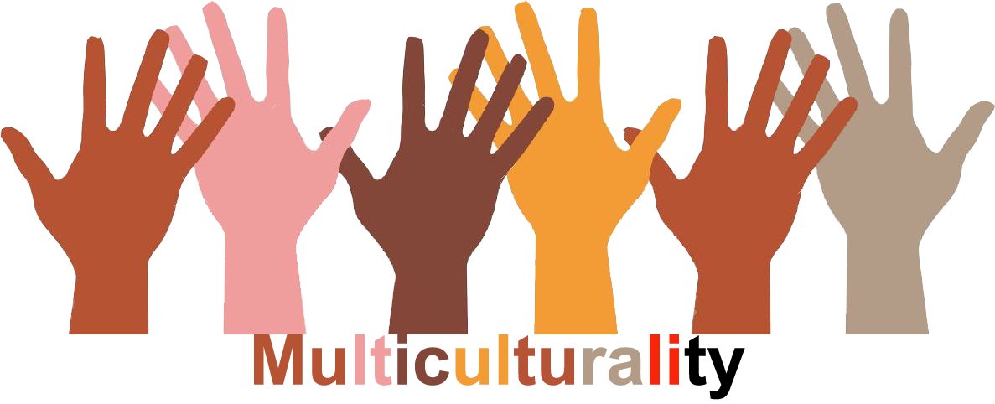 |  |  |  | Group size: 
Title | Our Ideal Country
Content | The students create their own ideal country, by using vocabulary dealing with: geographical terms, culture, nationalities, languages, habits, politics, rules etc |  |  |  |   Time: 3-5 lessons x 45 minutes
Goals (Skills/Competences) | To improve speaking competence and to develop social skills
Material | A very big white paper basis on the wall ( can be format A1)  An envelope with small leaflets with gographical terms  A4 sheets of paper/per student  Coloured pencils or similar
Procedure: | - The students draw an ideal country on the white paper basis on the wall (each student part of the drawing).  - Each student draws one leaflet with a geographical name out of the envelope (see attachment)  - The students draw their geographical names on the A4 sheet of paper, colour it and give it a special name  - Each student glues his/her picture on the chosen space on the big white paper basis  -When all the pictures are glued, the country is formed  OPTIONS:  -The students can choose the name of the country, the bordering countries, the languages spoken, the area, the habits, national costumes, culture, population … and talk about them.  -They set up rules for safety, communication, behaviour, education …(their choice)  - The students may run elections, talk about religious issues, politics  - Evaluation of the activities: What have we learnt?  + LOOK AT IDEAL COUNTRY ANNEX 1 AND ANNEX 2
Modifications
Comments
Success    factors | Involving all the students | Pitfalls  
The activity is flexible and depends on the local context. Feel free to adapt!

©
UDEL 21

