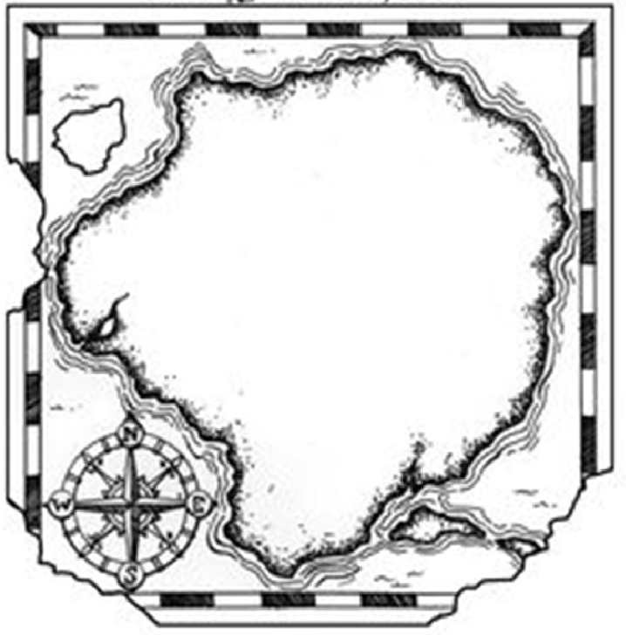 | IDEAL COUNTRY – IDEALNA DRŽAVA INSTRUCTIONS- NAVODILA  - On an appropriate wall, fix or stick a large cardboard or a stronger sheet of paper (A2 or A1) or use whatever white background.  - The students use crayons or felt tip pens and draw the outlines of their ideal country (example on the left).  - Put small cards with geographical terms in three languages in an envelope (example annex 2)  - Each student chooses one card, draws the geographical term on a ½ A4 sheet of paper and sticks it on the chosen place somewhere on the big white background.  - The geographical terms on images are named according to the student’s choice ( the student’s name, an imaginary name, an invented name...)  - The students invent the names of the bordering countries, the sea, the ocean,...  - The revision of the compass is done ( N, S, W, E) by showing different places on the map created.  - The pupils then describe where their geographical unit is.  - Optional task: description of the size of the unit, country, language, population, industry, agriculture, the capital city, important monuments etc, etc)  - Continuously, lesson by lesson the map is improved/upgraded with new information, maps, data,...  The students and the teacher regularly talk about their ideal country, express their feelings about it, and evaluate the work done so far.  - NA STENO PRITRDIŠ VELIK ŠELESHAMER ALI ŠE VEČJO BELO PODLAGO  - NA PODLAGI UČENCI NARIŠEJO OBRISE IDEALNE DRŽAVE ( PRIMER LEVO)  - V KUVERTI NA LISTIH SHRANIŠ GEOGRAFSKA IMENA V 3 JEZIKIH  - VSAK UČENEC IZŽREBA EN LISTEK  - NA DRUGI LIST, POLOVICA FORMATA A4, NARIŠE , KAR IMA NA SLIKI IN PRILEPI NEKAM NA BELO PODLAGO  - SVOJO GEOGRAFSKO ENOTO POIMENUJE, KOT ŽELI, LAHKO PO SEBI ALI SI IME IZMISLI  - ENAKO SI IZMISLIJO DRŽAVE, KI MEJIJO NA NAŠO IDEALNO DRŽAVO  - PONOVIMO SMERI NEBA  - UČENCI OPIŠEJO, KJE SE NJIHOVA GEO. ENOTA NAHAJA  - (OPCIJE: OPIŠEJO VELIKOST ENOT, DRŽAVE, JEZIK, PREBIVALSTVO, INDUSTRIJA, KMETIJSTVO, GLAVNO MESTO, POMEMBNI SPOMENIKI ITD ITD…)  - SPROTI, URO ZA URO, SE ZEMLJEVID IN PODATKI DOPOLNJUJEJO,…  - EVALVACIJA UČENCEV IN UČITELJA  C by JB

