Field of diversity: | 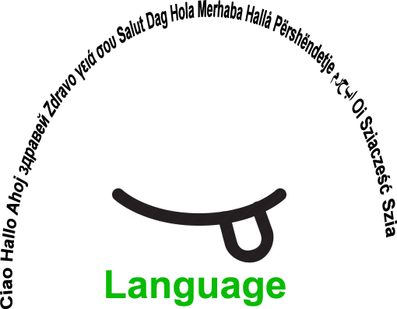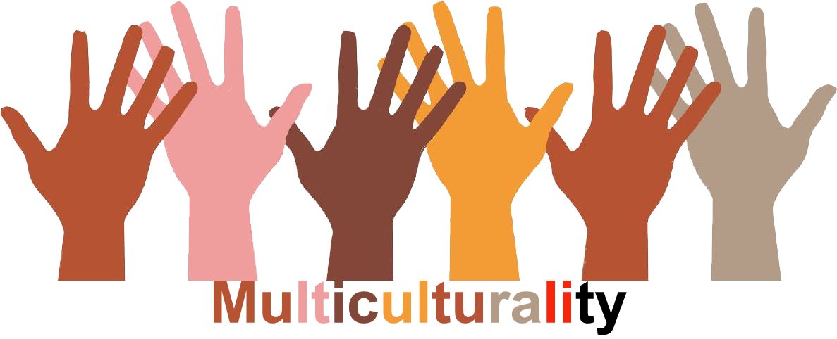 |  |  |  | Group size:  
Title | December festivities in our countries
Content | -Characteristics of December holidays in the countries of birth of students migrants  -Discovering and exploring the particularities of December holidays of the new country, discovering the historic origin of three good men in December (St. Nicholas, Santa Claus, Father Frost)  -Making a poster and expressing wishes for the new Year |  |  |  |   Time: 2 hours
Goals (Skills/Competences) | - talking about December holidays in the language of instruction  - gaining knowledge about the history and traditions of the new environment  - creating a group atmosphere  - exploring, comparing and summarizing data from a text  - learning about cultural differences
Material | - Text in the language of instruction about characteristics of December holidays ( in this case Slovenian)  - Worksheet with different questions (how, who, where, when, what …)  - Poster, markers, glue, scissors  - Photos of December holidays (food, Santa Claus, Christmas …)
Procedure: | - The students migrants are given a worksheet with different questions for help (e.g. how, who, where, when,what …).  - They present orally in the language of instruction (as well as they are able to) to the others in the group how their family celebrate Christmas and New Year.  - With the help of a table with more information, they discover what holidays and special celebrations are celebrated in December, in the new country and abroad (e.g. World AIDS Day, Christmas …).  - The students choose the material and the texts on topics they are interested in and they write about them.  - For each December festivity, they create a new poster, where they write, paint and stick on it the photos about the most interesting findings.  - They can choose from traditional food, Christmas holidays, New Year, old religious practices in the new country (in this case Slovenia) , Christmas tree and nativity scene, superstitions (ex. Horseshoe brings good luck), three good men in December (St. Nicholas, Santa Claus, Father Frost), This Merry Day of Culture (birth of the famous Slovenian poet France Prešeren), World AIDS Day, World Human Rights Day, Independence and Unity Day of Slovenia, Day of St. Nicholas.  - As conclusion the students write on a sheet of paper, in their native language, their Christmas wishes and stick them on the Christmas tree.
Modifications  Comments | The activity was interesting, students migrants tried a relaxed oral performance with the new language and vocabulary they learned till now (Slovenian). Even I, as a teacher, discovered new facts about the history of my country and countries my students.
Success    factors | Ability to use the students' mother tongue  Possibility to talk about their own festivities and share  experiences | Pitfalls   |  | Texts ans activities that are too demanding
The activity is flexible and depends on the local context. Feel free to adapt!
©
UDEL 21

