Field of diversity: | 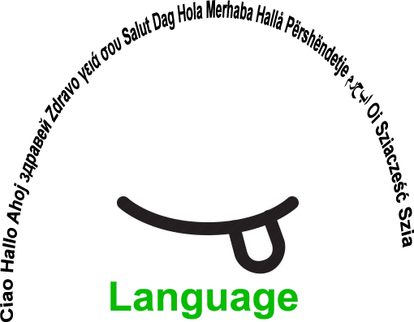 |  | L1 |  | Group size:  
Title | December festivities (today and in the past)
Content | - students present characteristics of December holidays about their country of birth  - discover and explore the particularities of December holidays of the country, where students migrant live in the present  - making a poster  - discover the historic origin of three good men in December (St. Nicholas, Santa Claus, Father Frost) |  |  |  |   Time: 2 hours
Goals (Skills/Competences) | - oral presentation and relaxed speech in Slovene  - gaining knowledge of the history and traditions of the new environment  - creating a group atmosphere  - explore, compare and summarize data from a text  - learn about cultural differences
Material | - Text in Slovene about characteristics of December holidays  - Worksheet with different questions (how, who, where, when …)  - Poster, markers, glue, scissors  - Photos of December holidays (food, Santa Claus, Christmas …)
Procedure: | - The students migrants receive a worksheet with different questions for help (ex. how, who, where, when …).  - They present orally in Slovene to the others in the group how their family celebrate Christmas and New Year.  - Then they discover in a table, what holidays and special celebrations is celebrated in Slovenia and abroad in December (ex. World AIDS Day, Christmas …).  - They choose material and texts on topics about which they prefer and then they write about it.  - For each December festivity they create a new poster, where they write, paint and stick photos about what they find most interesting.  - They can choose from traditional food, Christmas holidays, New Year, old religious practices in the Slovene country, Christmas tree and nativity scene, superstition (ex. Horseshoe brings good luck), three good men in December (St. Nicholas, Santa Claus, Father Frost), This Merry Day of Culture (birth of famous Slovene poet France Prešeren), World AIDS Day, World Human Rights Day, Independence and Unity Day of Slovenia, Day of St. Nicholas.  - As conclusion the students write on a paper in their native language / writing their Christmas wishes and stick it on a tree.
Modifications  Comments | The activity was interesting, students migrants tried a relaxed oral performance with the new language and vocabulary they learned till now (Slovene). Even I, as a teacher, discovered new facts about the history of my country and countries my students.
Success    factors | The students liked to discover new aspects of the tradition and history of the new country they live in. They enjoyed present to the others in Slovene, how they celebrate Christmas and New Year. They liked to independently choose a theme to write about. | Pitfalls   |  | There was not enought time to review all the proposed topics. Some text were a little difficult to understand for the student because written in Slovene, so they needed the help of the teacher.
The activity is flexible and depends on the local context. Feel free to adapt!
©
UDEL 21

