Field of diversity: | 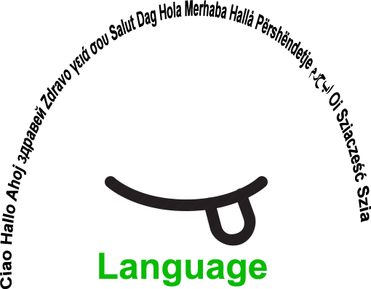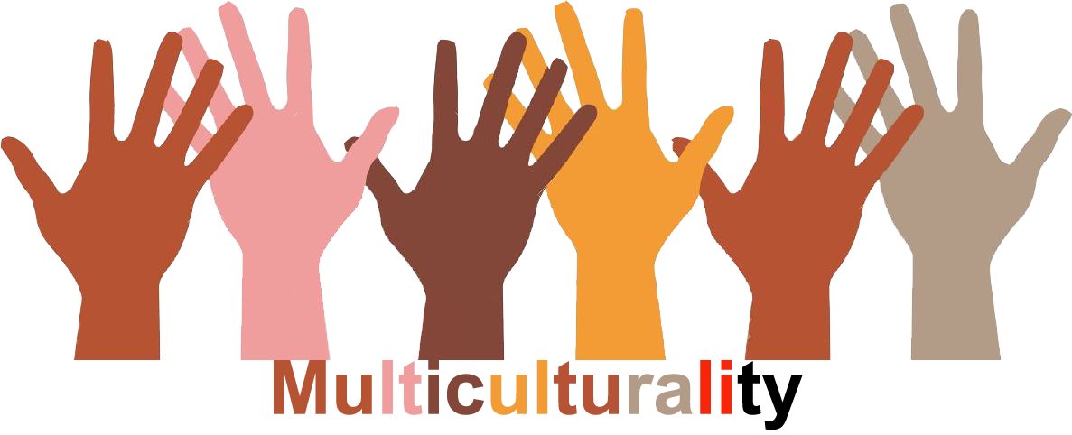 |  |  |  | Group size:  
Title | Celebrating the day of the languages
Content | Creation, acting, tasting, showing the specialities of the different languages and countries. |  |  |  |   Time:
Goals (Skills/Competences) | Improvement of communication skills and performing skills in different languages that are learnt in the school.
Material | School and students provide different material (e.g. masks, costumes …) one week before the activity.  Camera to record.
Procedure: | - The teacher explains the goals of the lesson: verbal and visual.  - Students form groups, according to their interest in the languages that are learned in the school and in which they feel safe.  - Newcomers/migrant students can form their own group. Visual aids are present, e.g. pictograms.  - The group chooses between a number of activities, e.g. creating masks, creating costumes, preparing national sweets, creating cartoons  or short stories … The students can propose other options. Visual aids are present, e.g. pictograms.  - There is a mentor/teacher present in each group to moderate the activity. A student can be appointed as leader.  - One teacher or student records the activities and makes a short video.  - At the end of the day the groups present (own choice) the outcomes for all students.  - All students watch the video.  - Evaluation of the activity: students have different options within a structured choice (the teacher decides the different options), e.g.  by discussion, a questionnaire, a graph, ….  Link: Videos www.steinbacher.si/udel21 Username: yeye Password:1Geniji
Modifications
Comments
Success    factors | The students have to know each other at least a little.  The students have the right to choose what activity to do. | Pitfalls   |  | Not wanting to be filmed/photographed. In that case, they can choose another role.
The activity is flexible and depends on the local context. Feel free to adapt!
©
UDEL 21

