Field of diversity: | 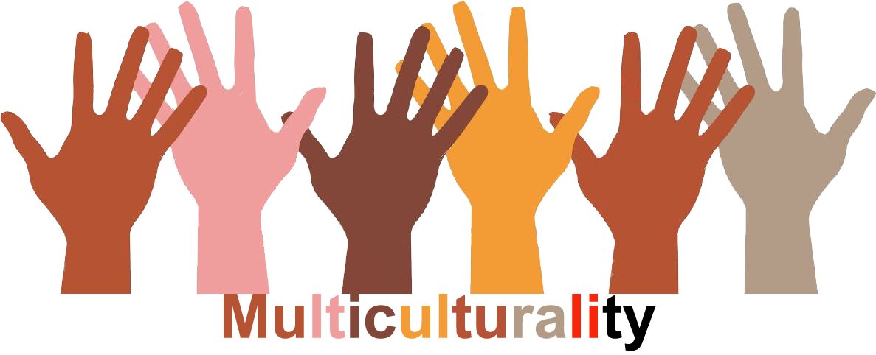 |  | L1 |  | Group size:  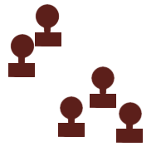
Title | External - Internal
Content | To recognize differences in the external appearance and to find internal similarities |  |  |  |   Time: 1 UE
Goals (Skills/Competences) | The students should realize that differences in the appearance don't mean that you can't have internal similarities.
Material | two eggs (one white, one brown), two plastic bowls  two apples (one red, one green), a knife, a cutting board  questionnaire or/and large piece of paper (A3)
Procedure: | - divide the class in two groups  - one group gets the eggs, the other gets the apples  - each group gets the questionnaire  - each group does the questionnaire, collects ideas and works with the eggs/apples  - after that the two groups present their answers to each other  - reflection with the whole class  - is one egg/apple better than the other?  - can you allocate/transfer your studies to peolpe?  - where in your daily life could you face something similar?
Modifications  Comments | with older students you can use a »placemat« (˃□˂) instead of the questionnaire  you can use peppers, pears,...
Success    factors | It's helpful that each group is supported by a teacher | Pitfalls   |  | Motor abilities of the students are too weak to crack the eggs or use a knife properly  Difficulties to make the abstraction from egg/apple to a person
The activity is flexible and depends on the local context. Feel free to adapt!
©
UDEL 21

