Field of diversity: | 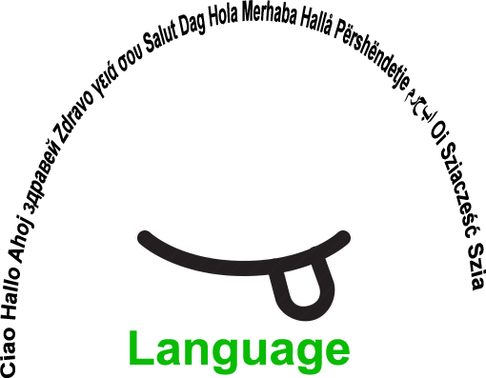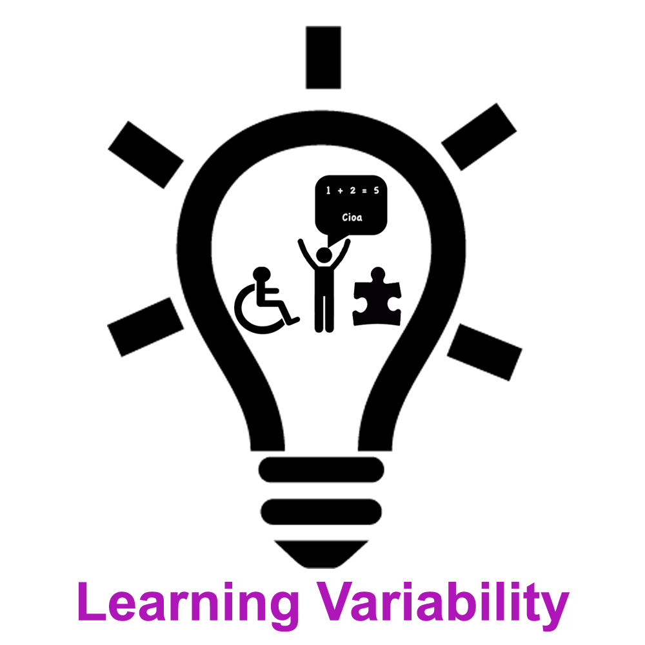 |  | L1 |  | Group size:  
Title | December festivities (today and in the past)
Content | - students present characteristics of December holidays about their country of birth  - discover and explore the particularities of December holidays of the country, where students migrant live in the present  - making a poster  - discover the historic origin of three good men in December (St. Nicholas, Santa Claus, Father Frost) |  |  |  |   Time: 2 hours
Goals (Skills/Competences) | - oral presentation and relaxed speech in Slovene  - gaining knowledge of the history and traditions of the new environment  - creating a group atmosphere  - explore, compare and summarize data from a text  - learn about cultural differences
Material | - Text in Slovene about characteristics of December holidays  - Worksheet with different questions (how, who, where, when …)  - Poster, markers, glue, scissors  - Photos of December holidays (food, Santa Claus, Christmas …)
Procedure: | - The students migrants receive a worksheet with different questions for help (ex. how, who, where, when …).  - They present orally in Slovene to the others in the group how their family celebrate Christmas and New Year.  - Then they discover in a table, what holidays and special celebrations is celebrated in Slovenia and abroad in December (ex. World AIDS Day, Christmas …).  - They choose material and texts on topics about which they prefer and then they write about it.  - For each December festivity they create a new poster, where they write, paint and stick photos about what they find most interesting.  - They can choose from traditional food, Christmas holidays, New Year, old religious practices in the Slovene country, Christmas tree and nativity scene, superstition (ex. Horseshoe brings good luck), three good men in December (St. Nicholas, Santa Claus, Father Frost), This Merry Day of Culture (birth of famous Slovene poet France Prešeren), World AIDS Day, World Human Rights Day, Independence and Unity Day of Slovenia, Day of St. Nicholas.  - As conclusion the students write on a paper in their native language / writing their Christmas wishes and stick it on a tree.  LINK: photos at the bottom of the page
Modifications  Comments | The activity was interesting, students migrants tried a relaxed oral performance with the new language and vocabulary they learned till now (Slovene). Even I, as a teacher, discovered new facts about the history of my country and countries my students.
Success    factors | The students liked to discover new aspects of the tradition and history of the new country they live in. They enjoyed present to the others in Slovene, how they celebrate Christmas and New Year. They liked to independently choose a theme to write about. | Pitfalls   |  | There was not enough time to review all the proposed topics. Some texts were a little difficult to understand for the student because written in Slovene, so they needed the help of the teacher.
The activity is flexible and depends on the local context. Feel free to adapt!

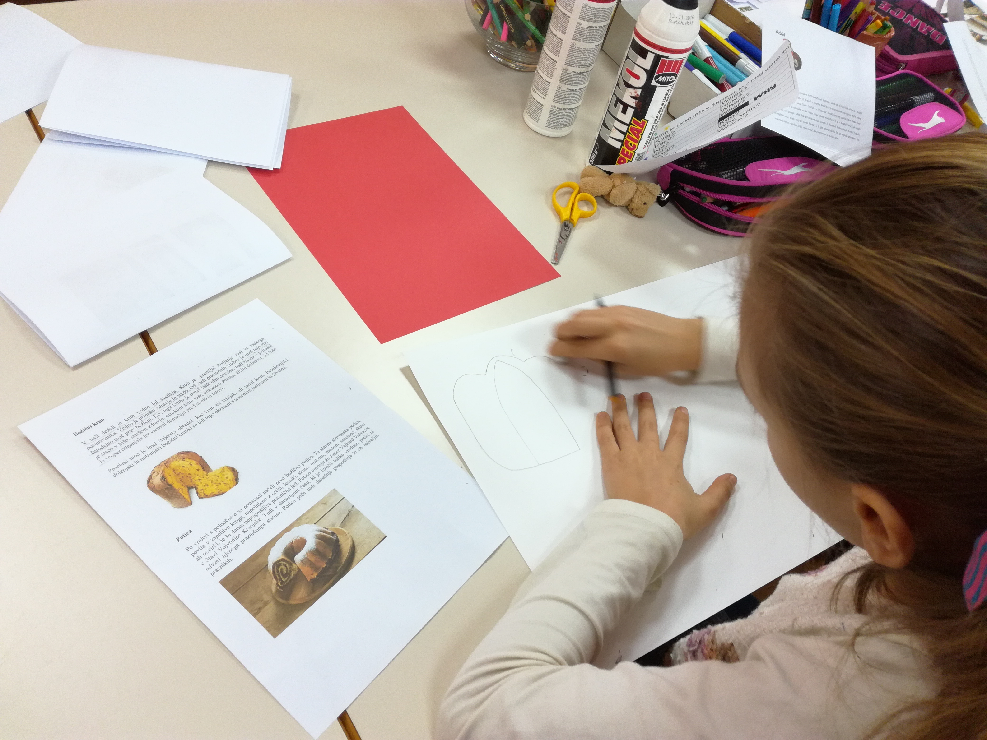 | 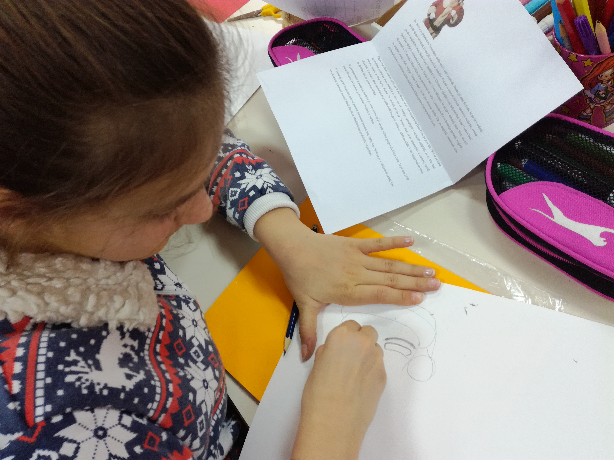 | 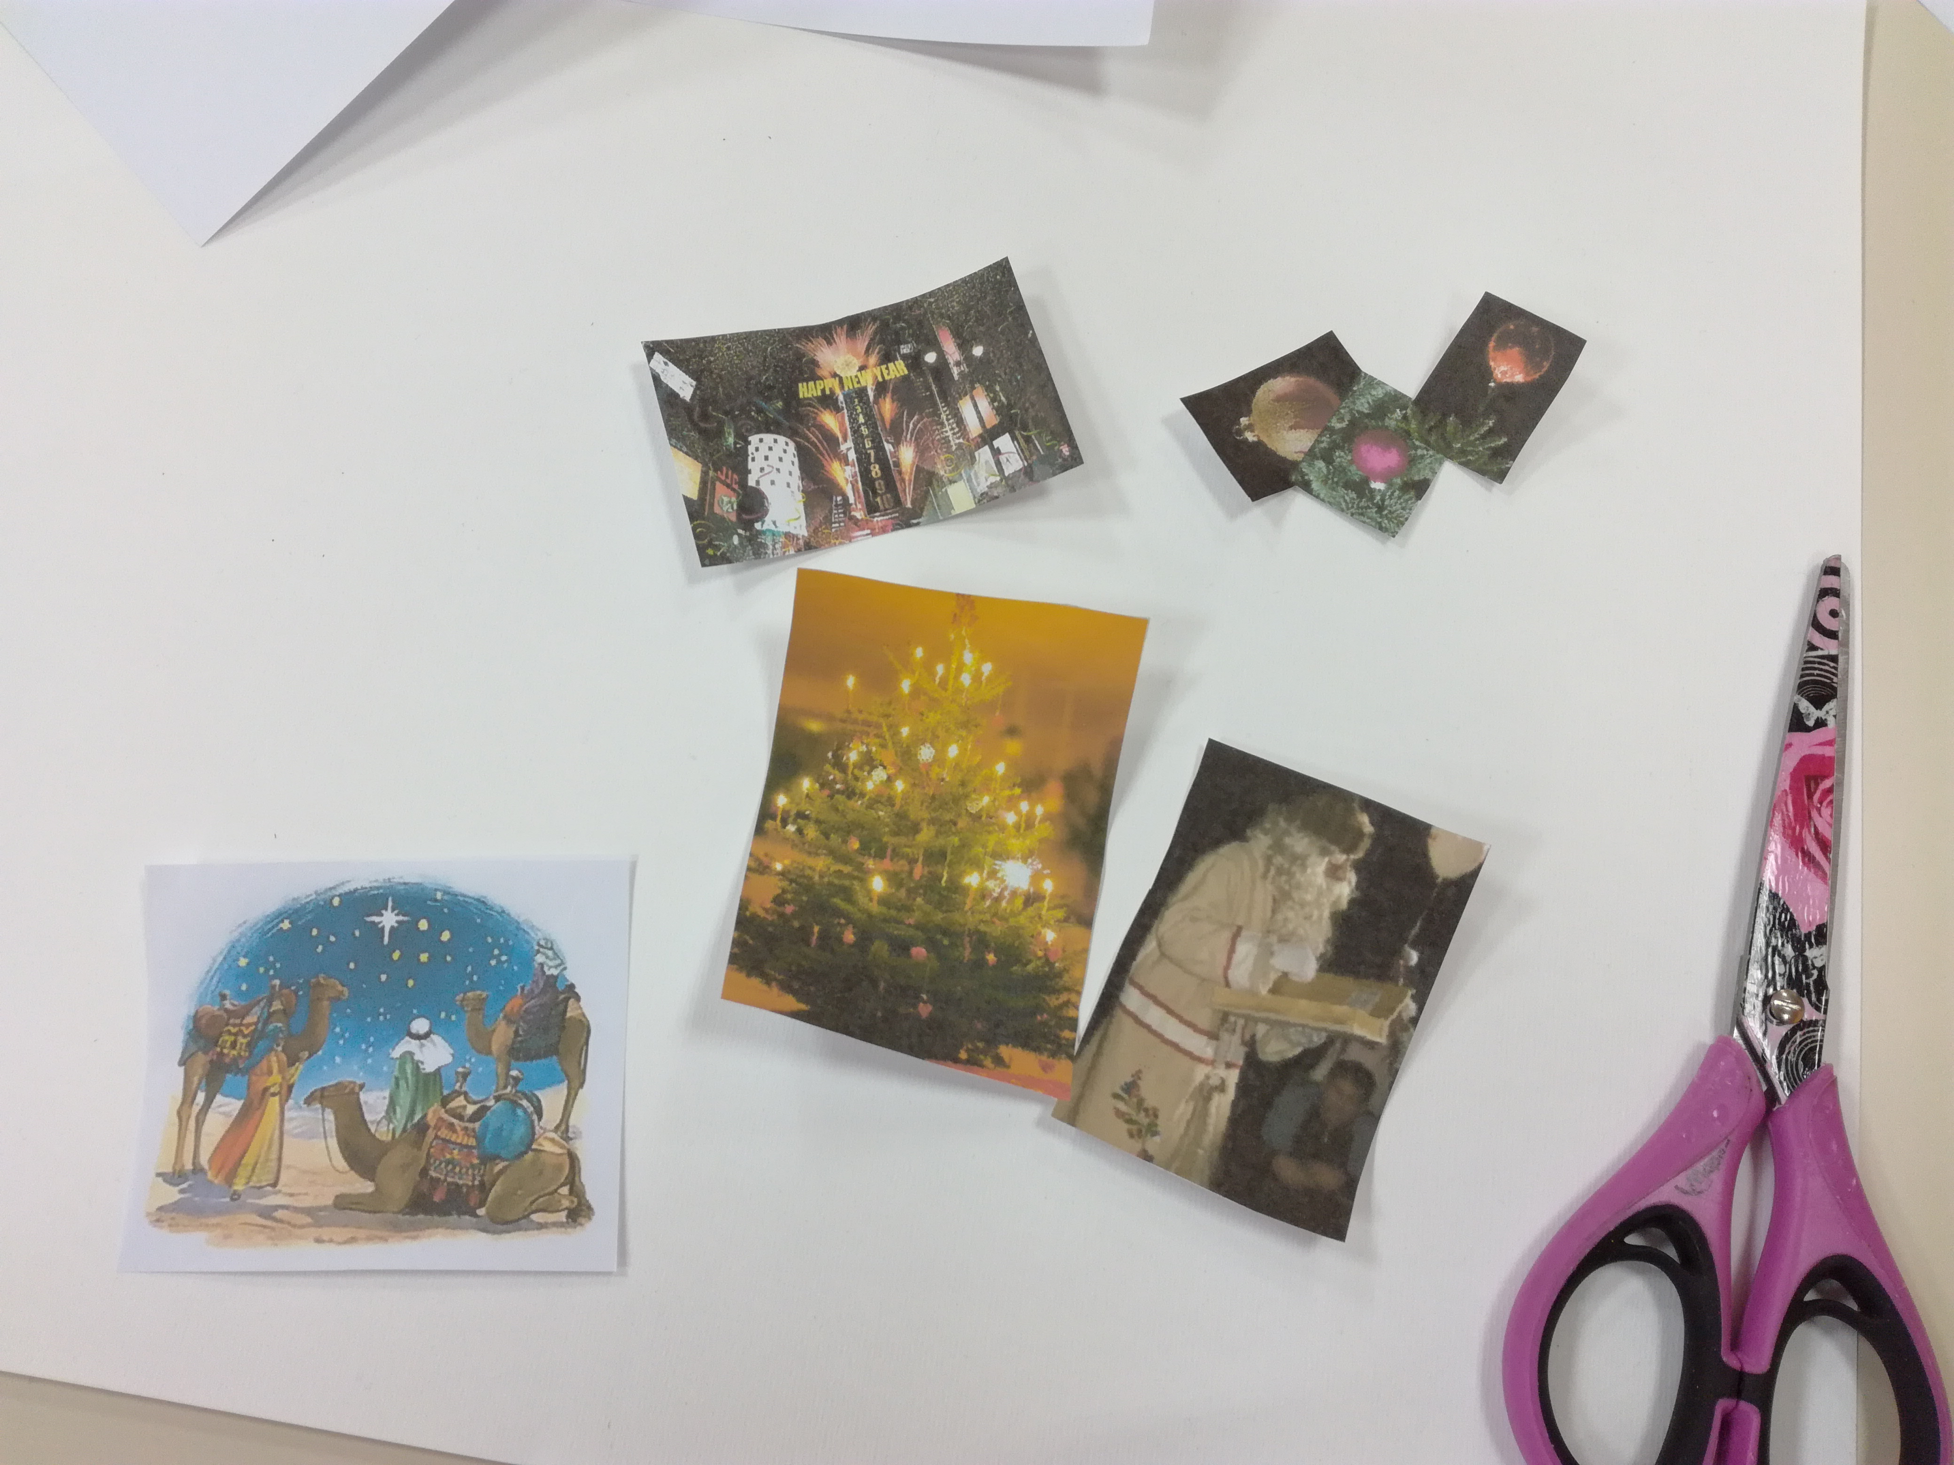
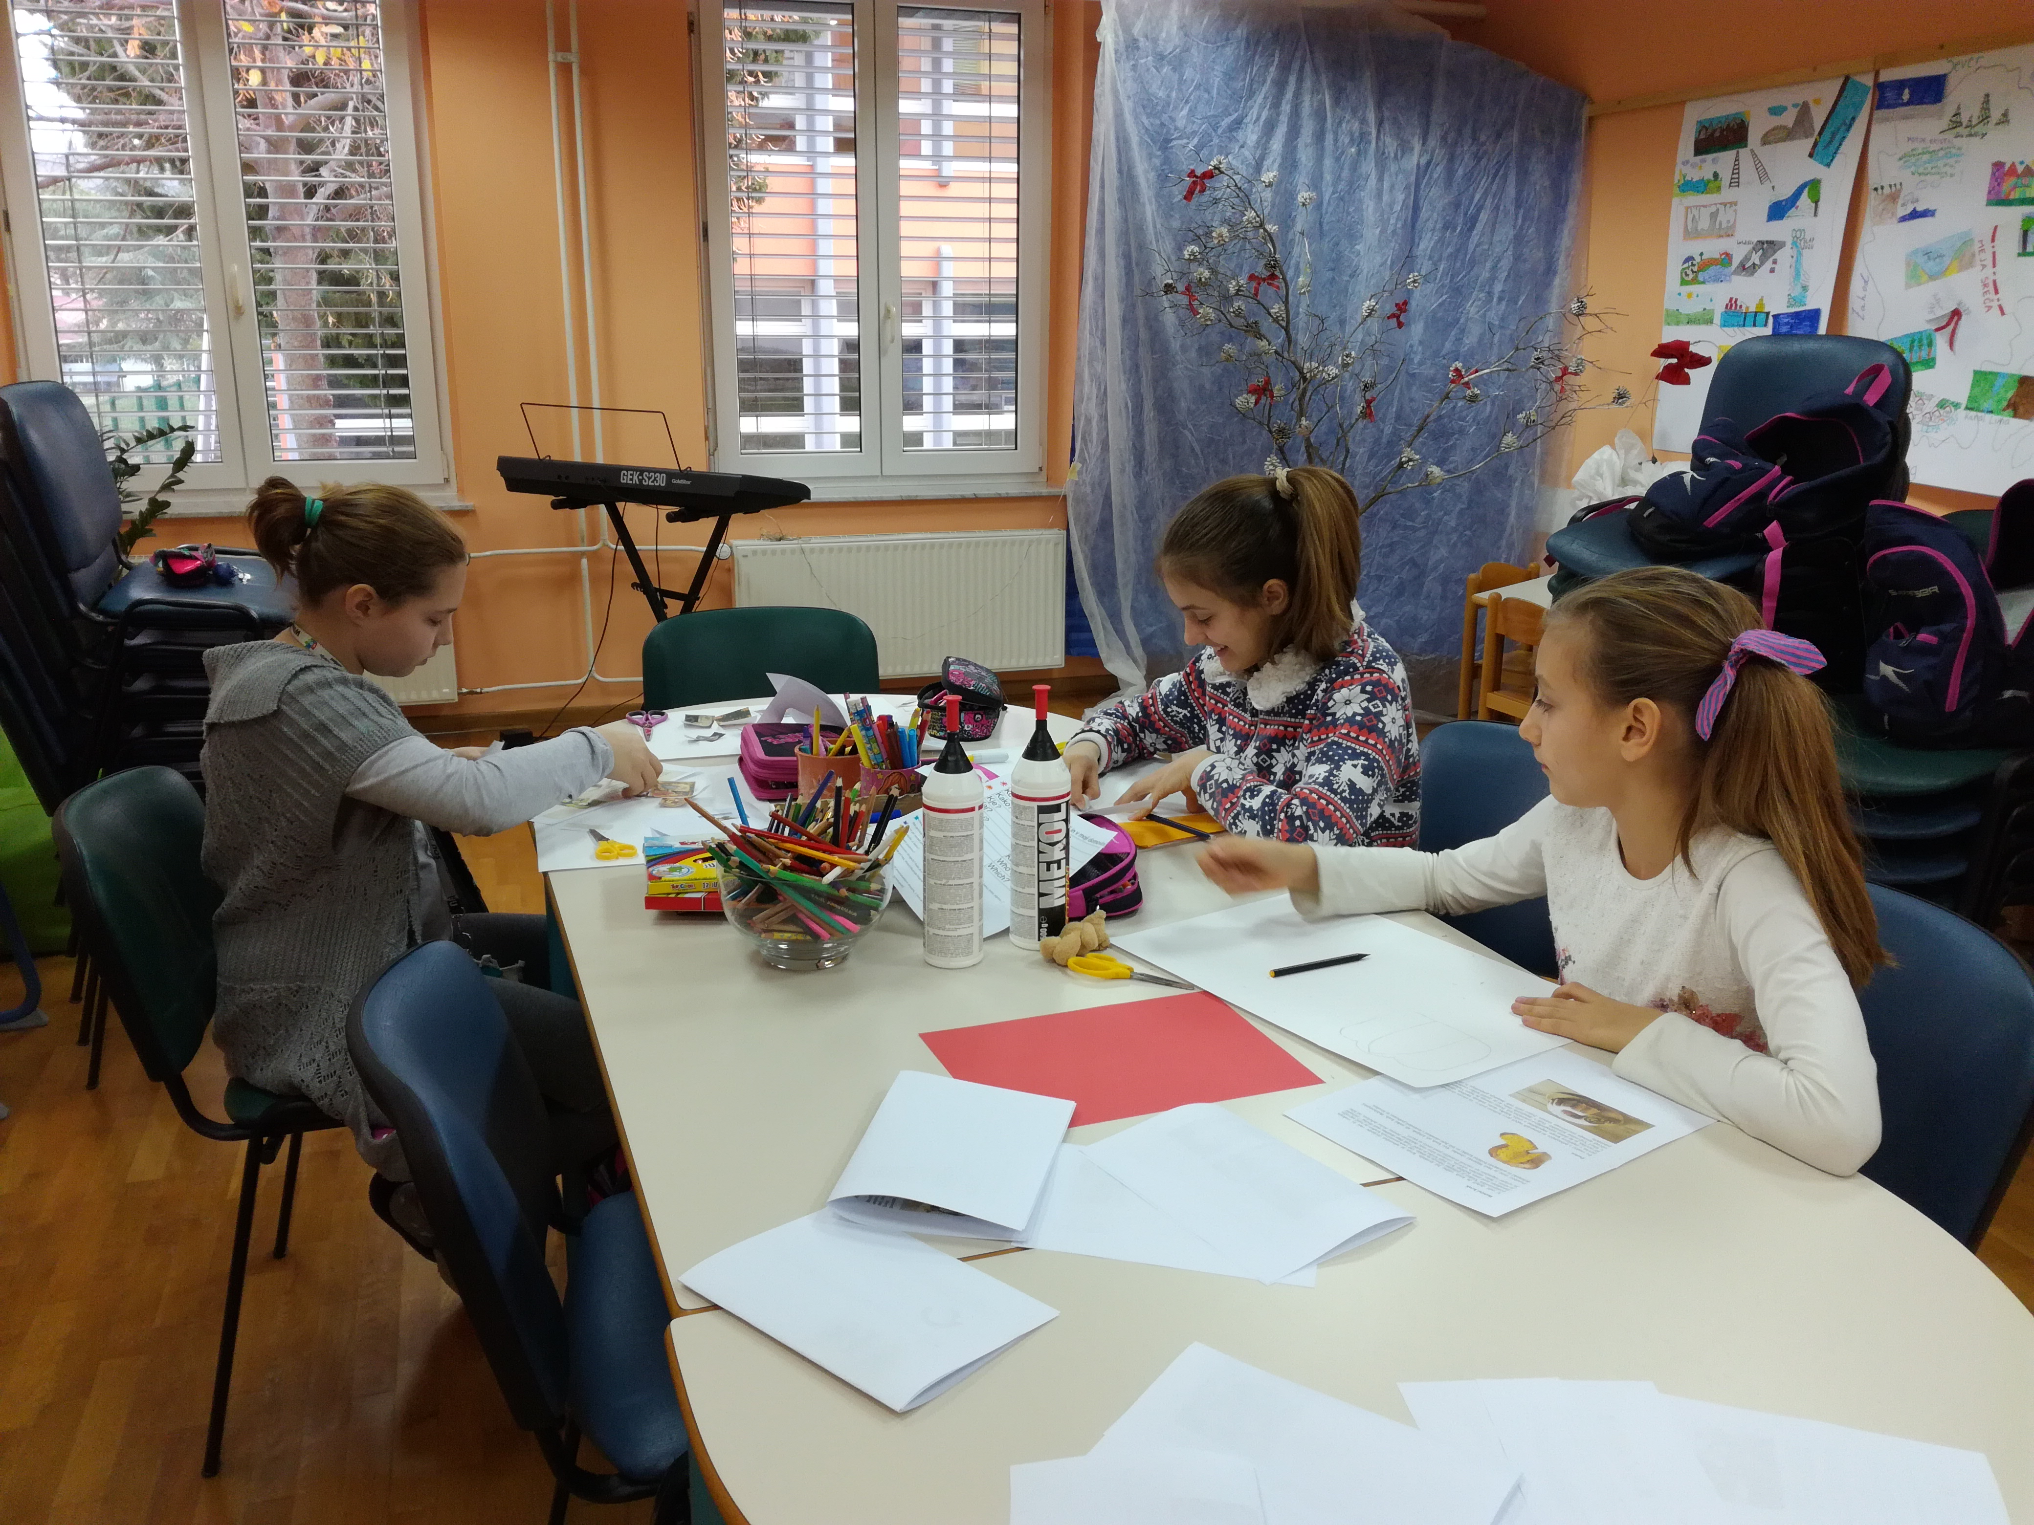 | 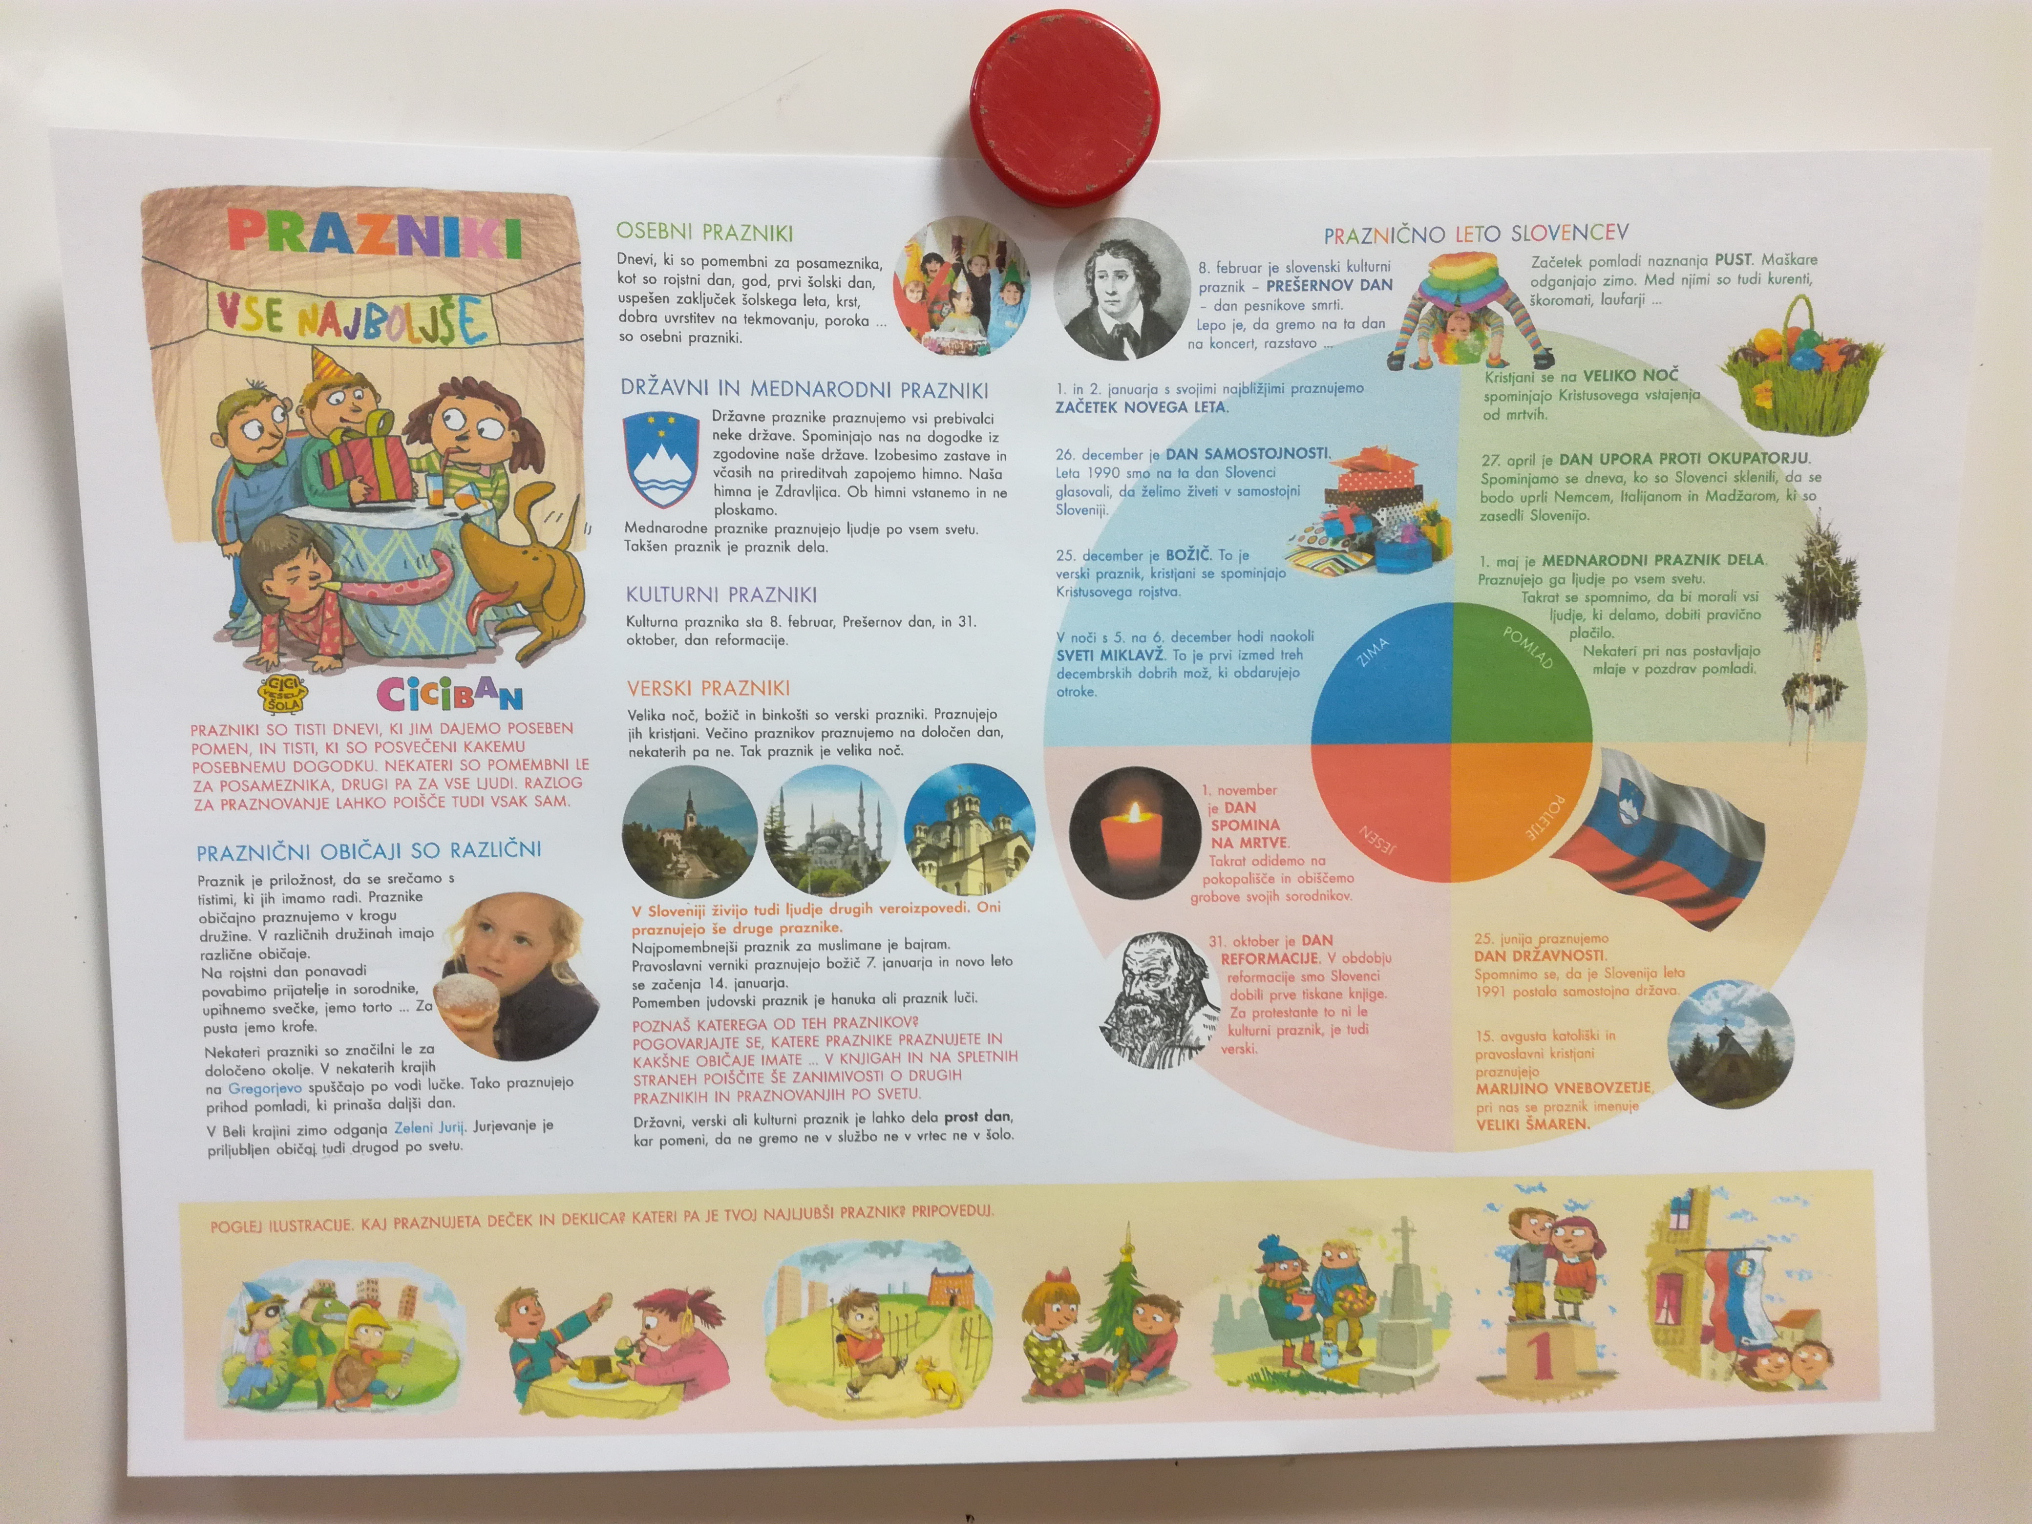 | 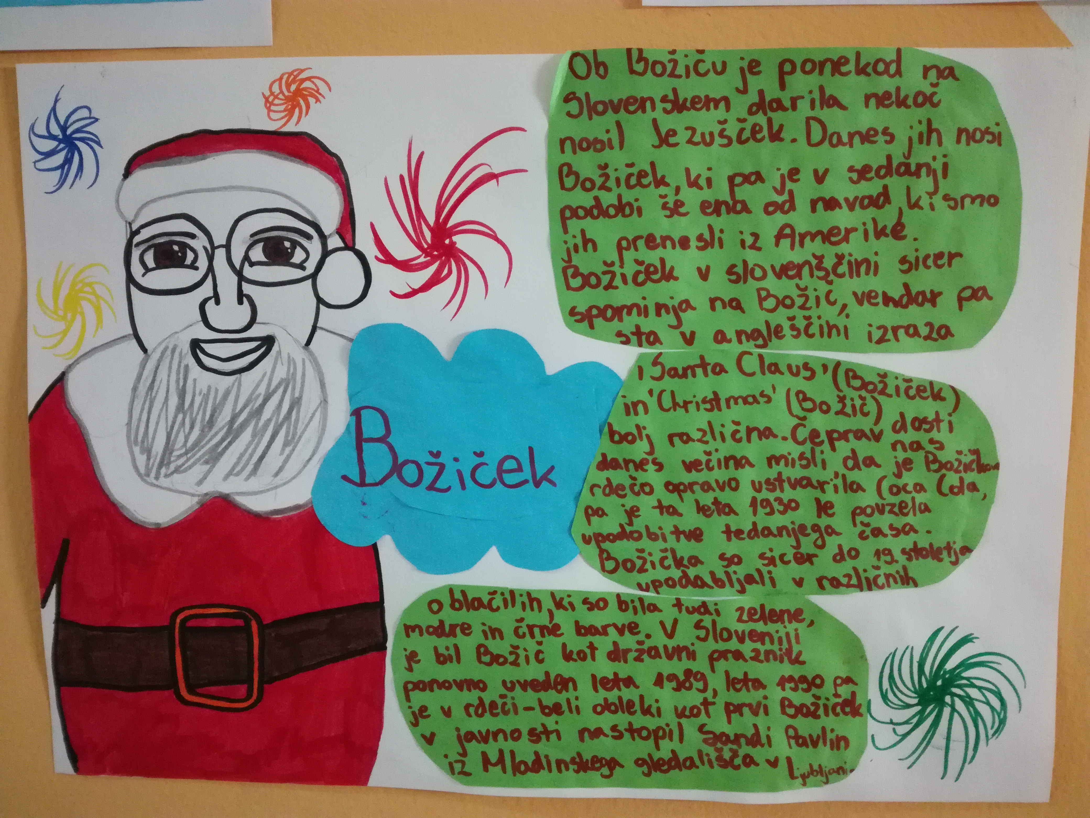
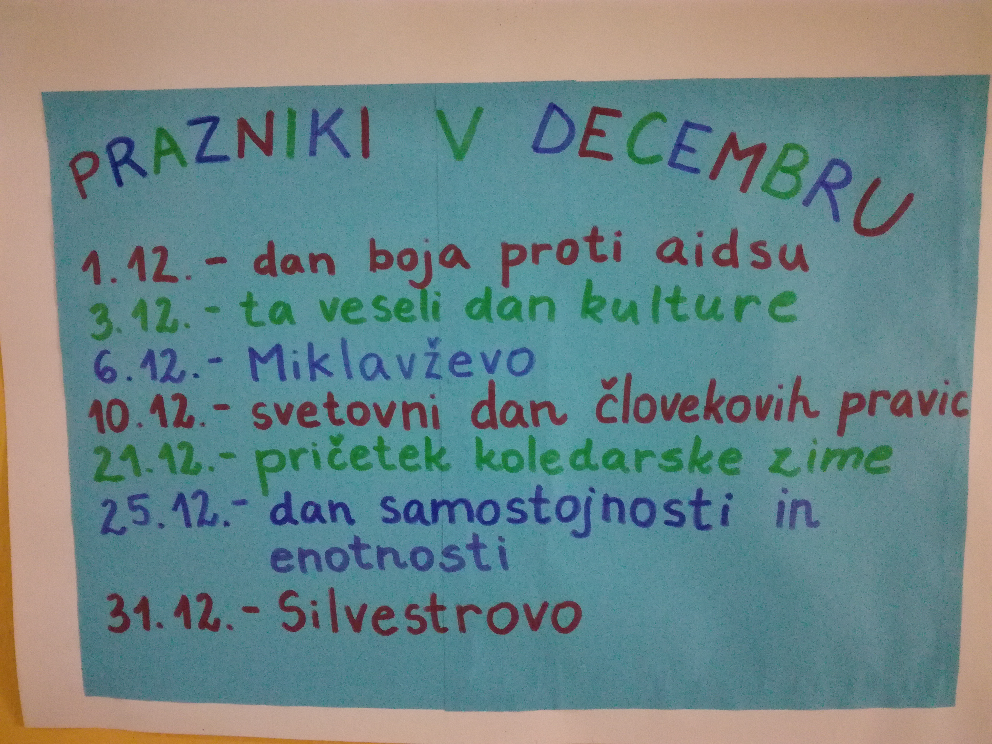 | 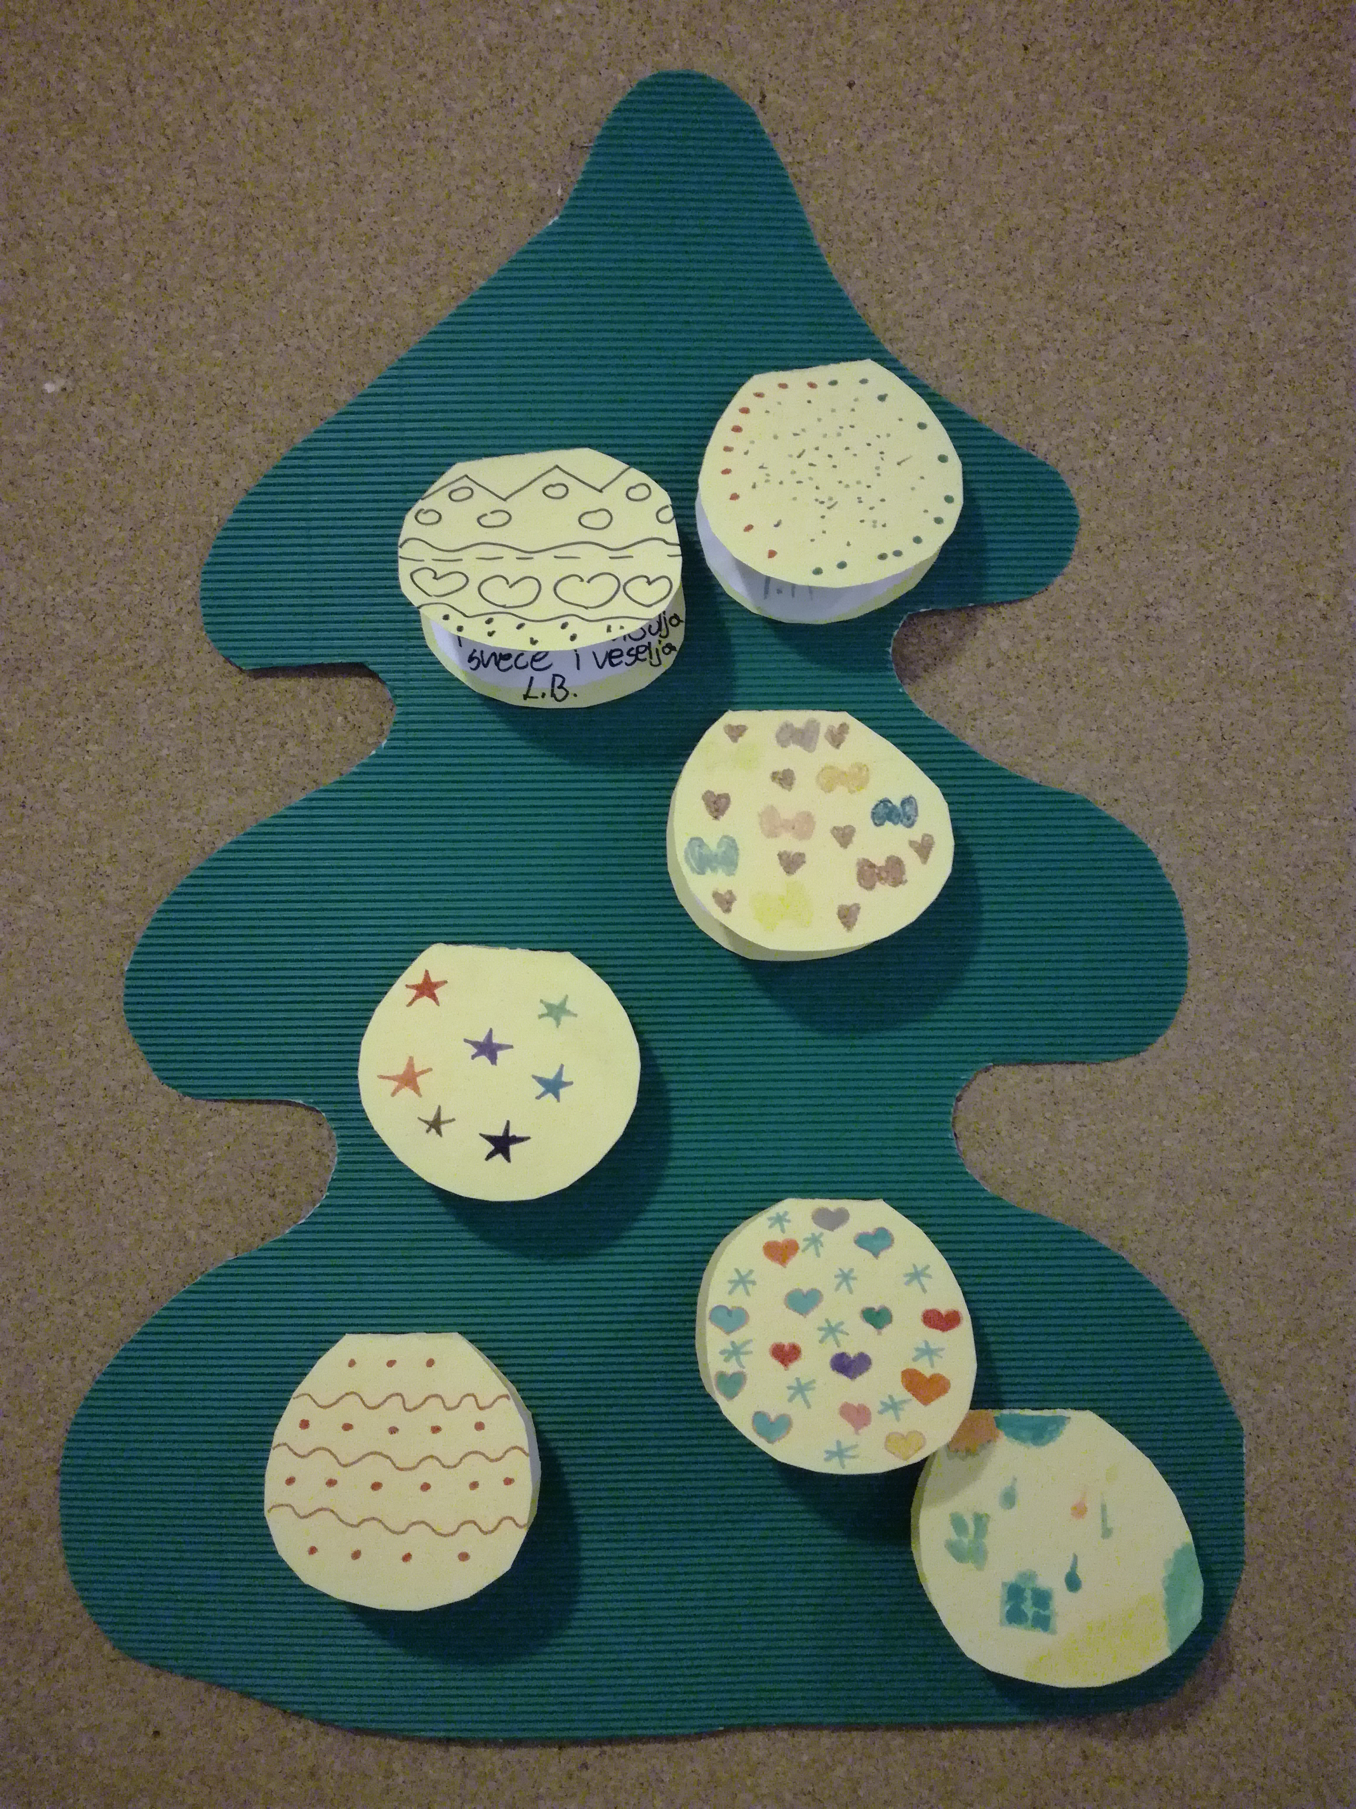 | 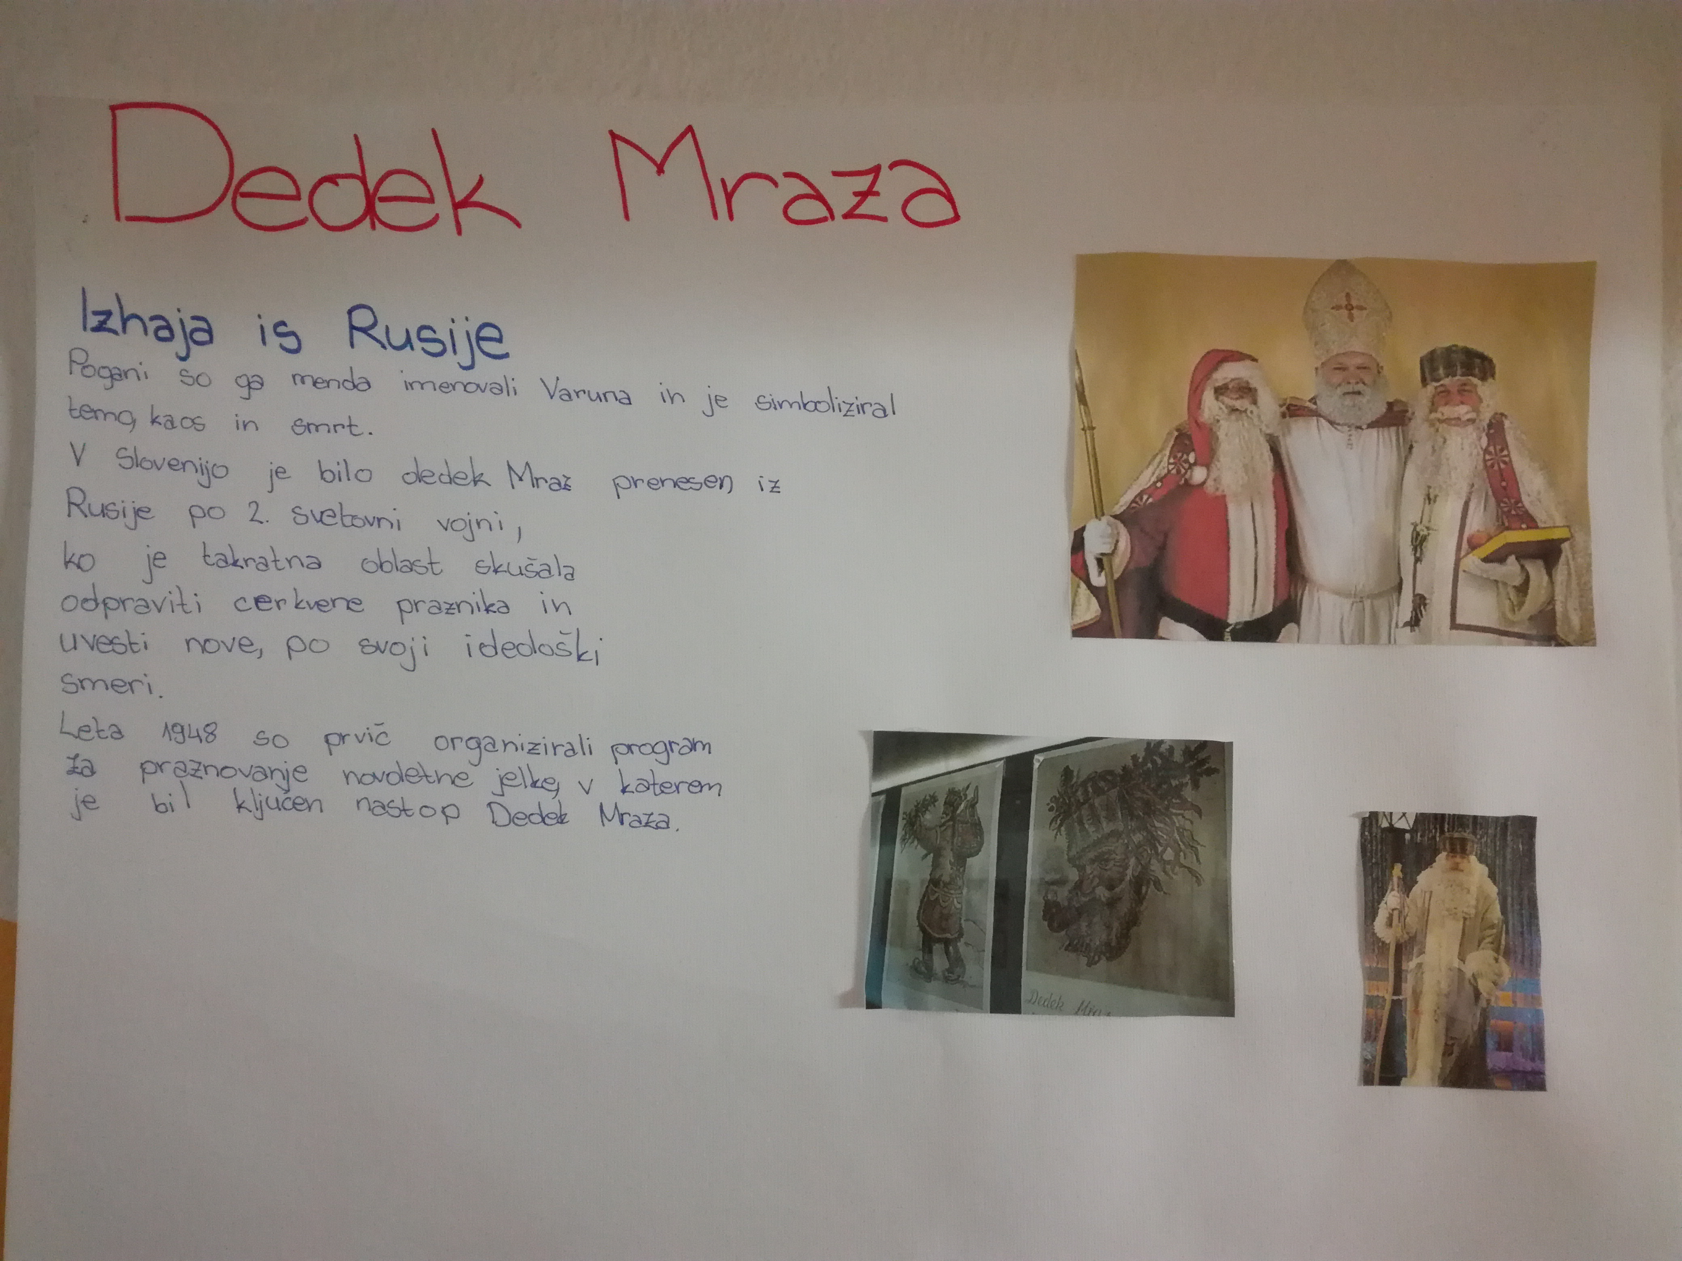
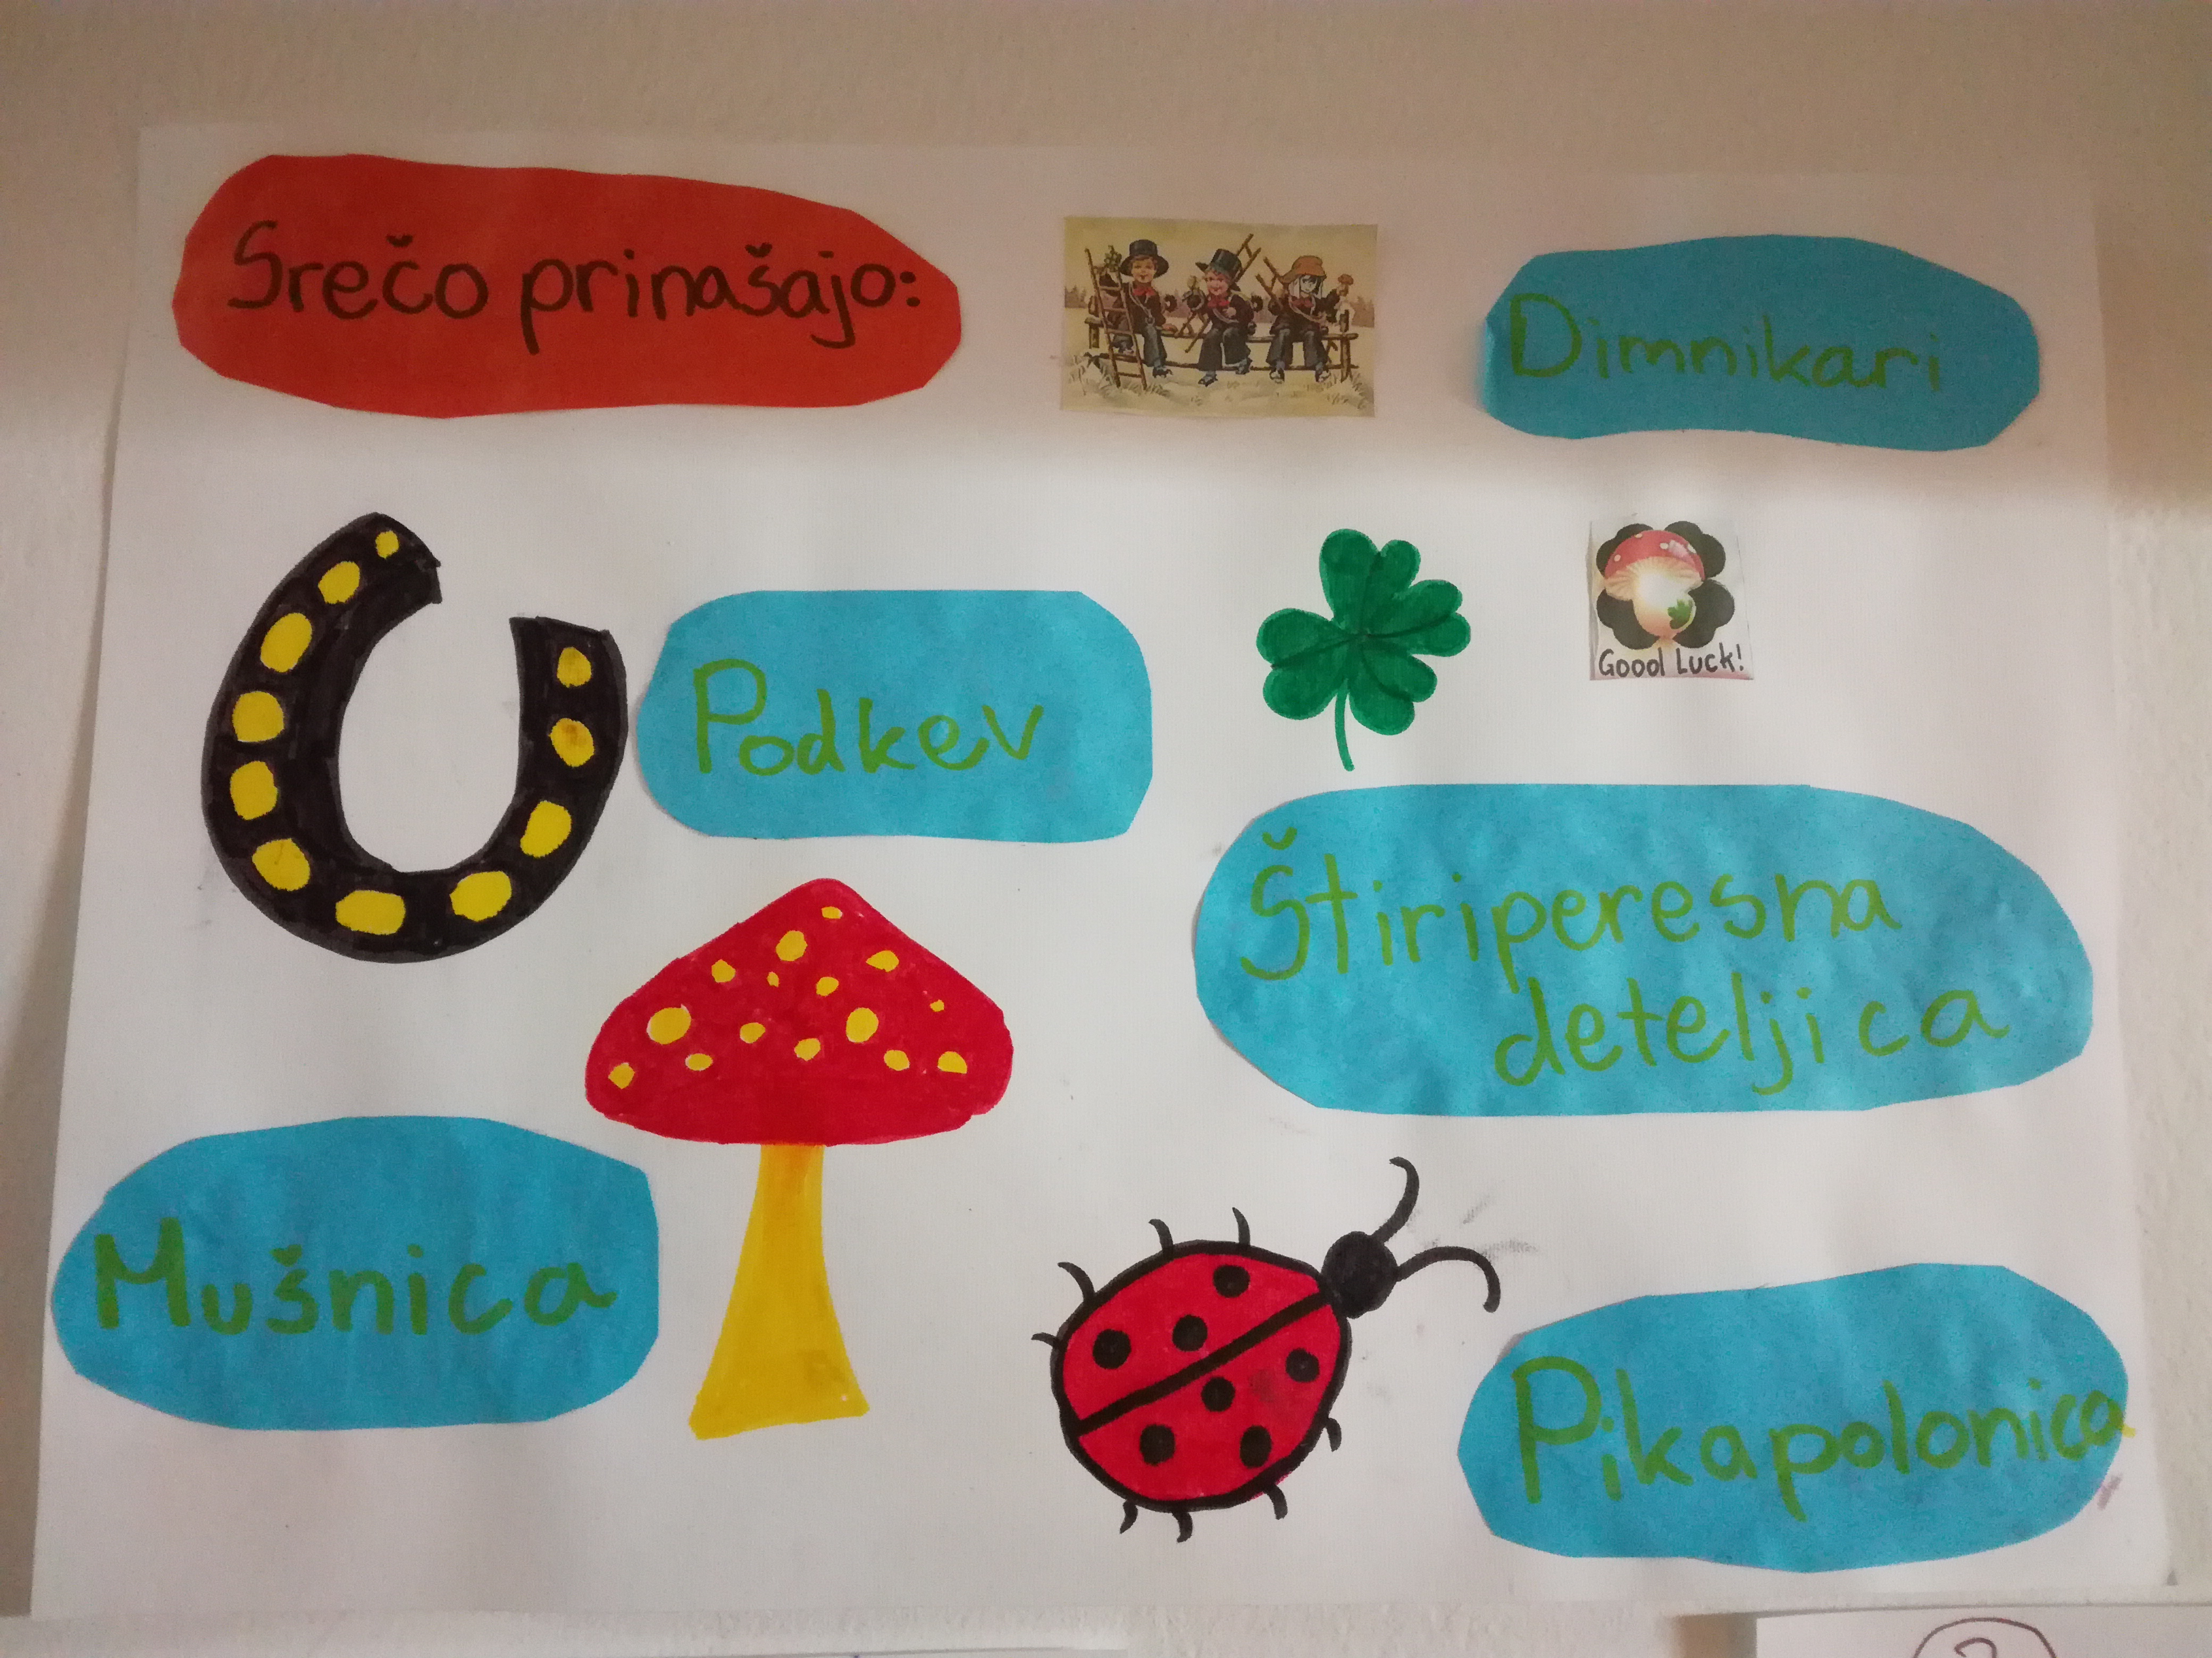 | 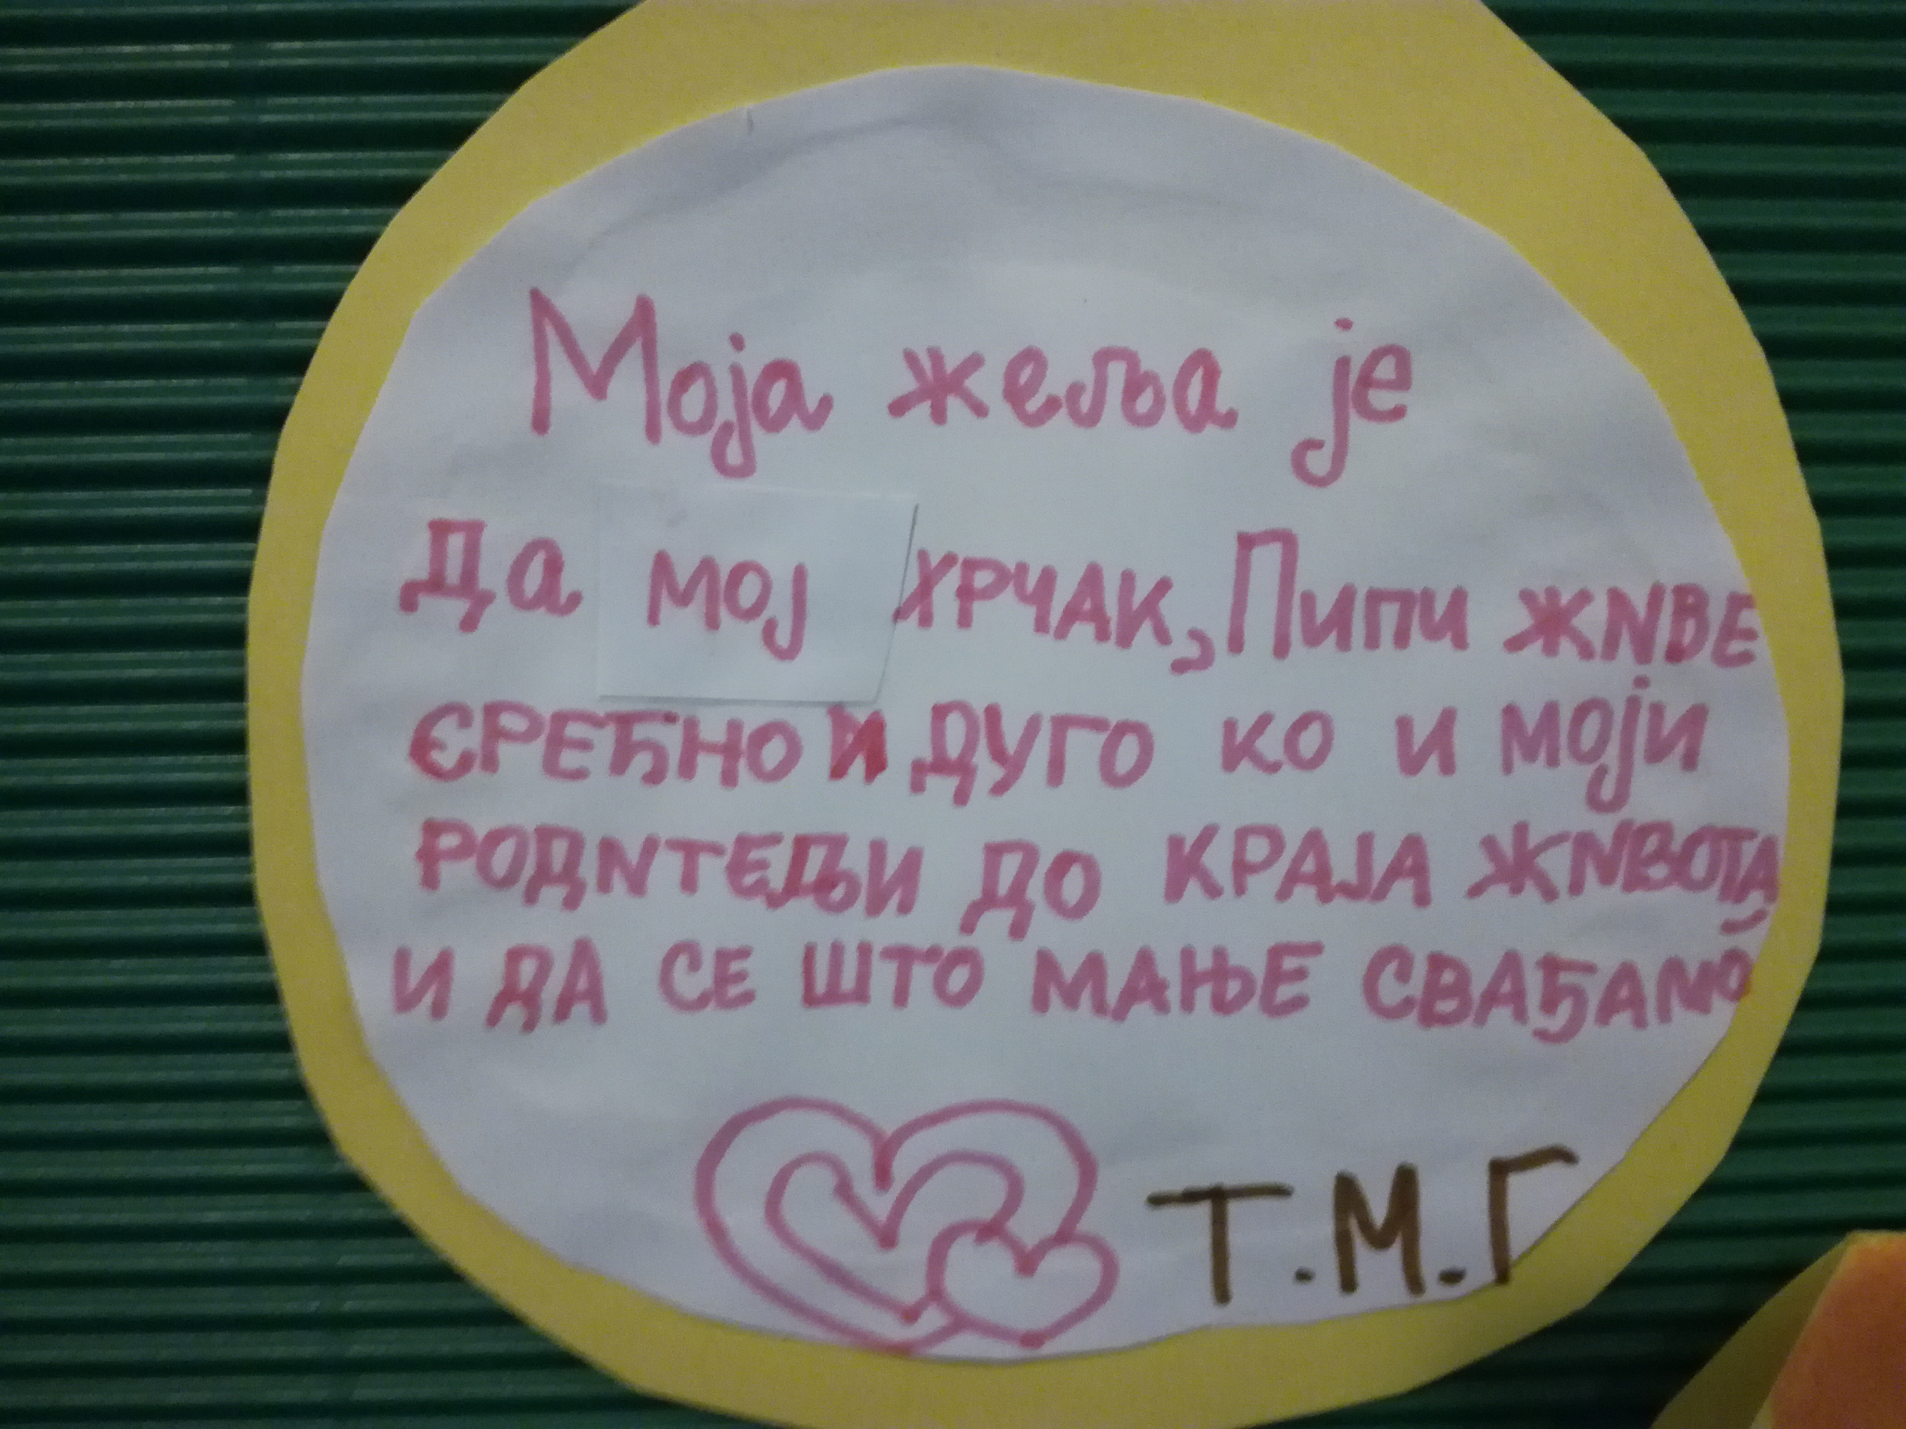 | 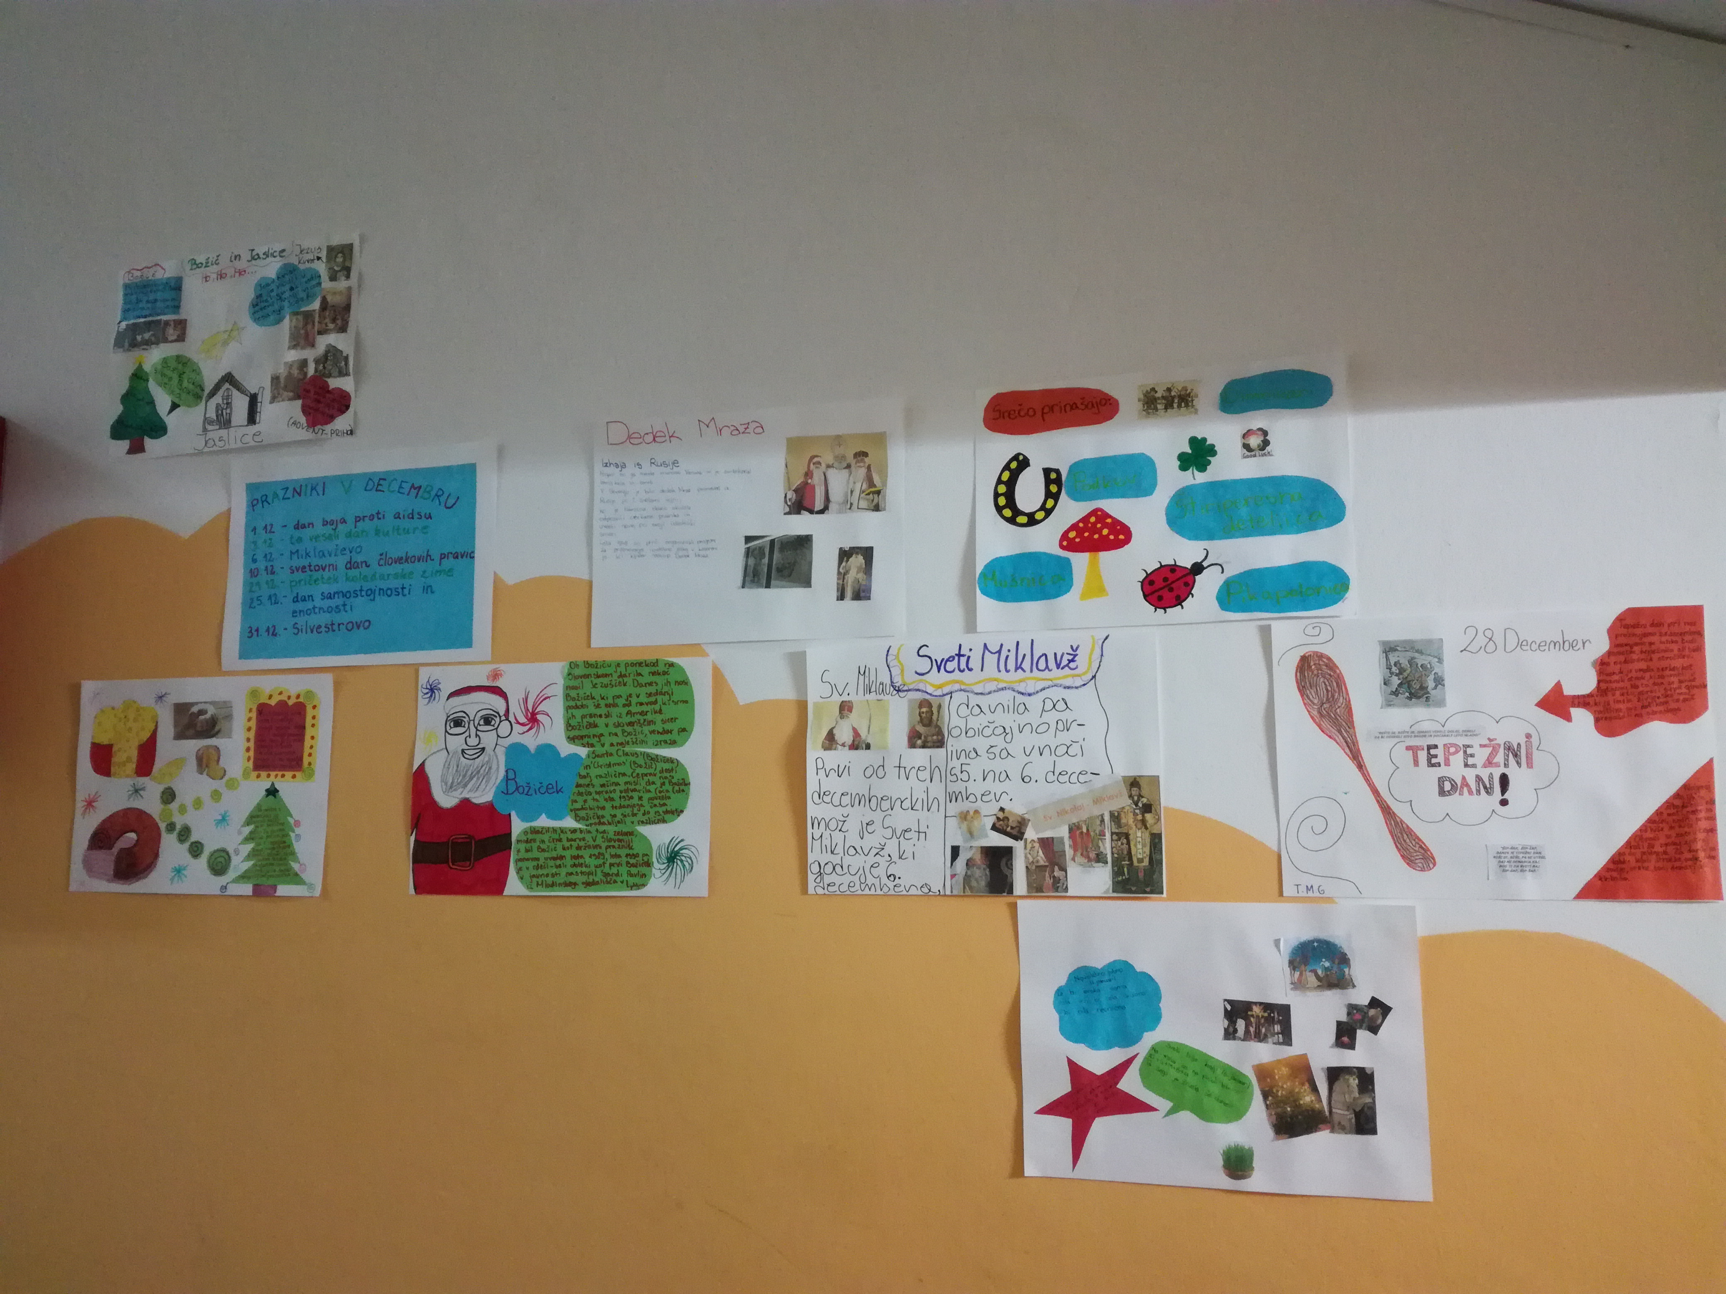
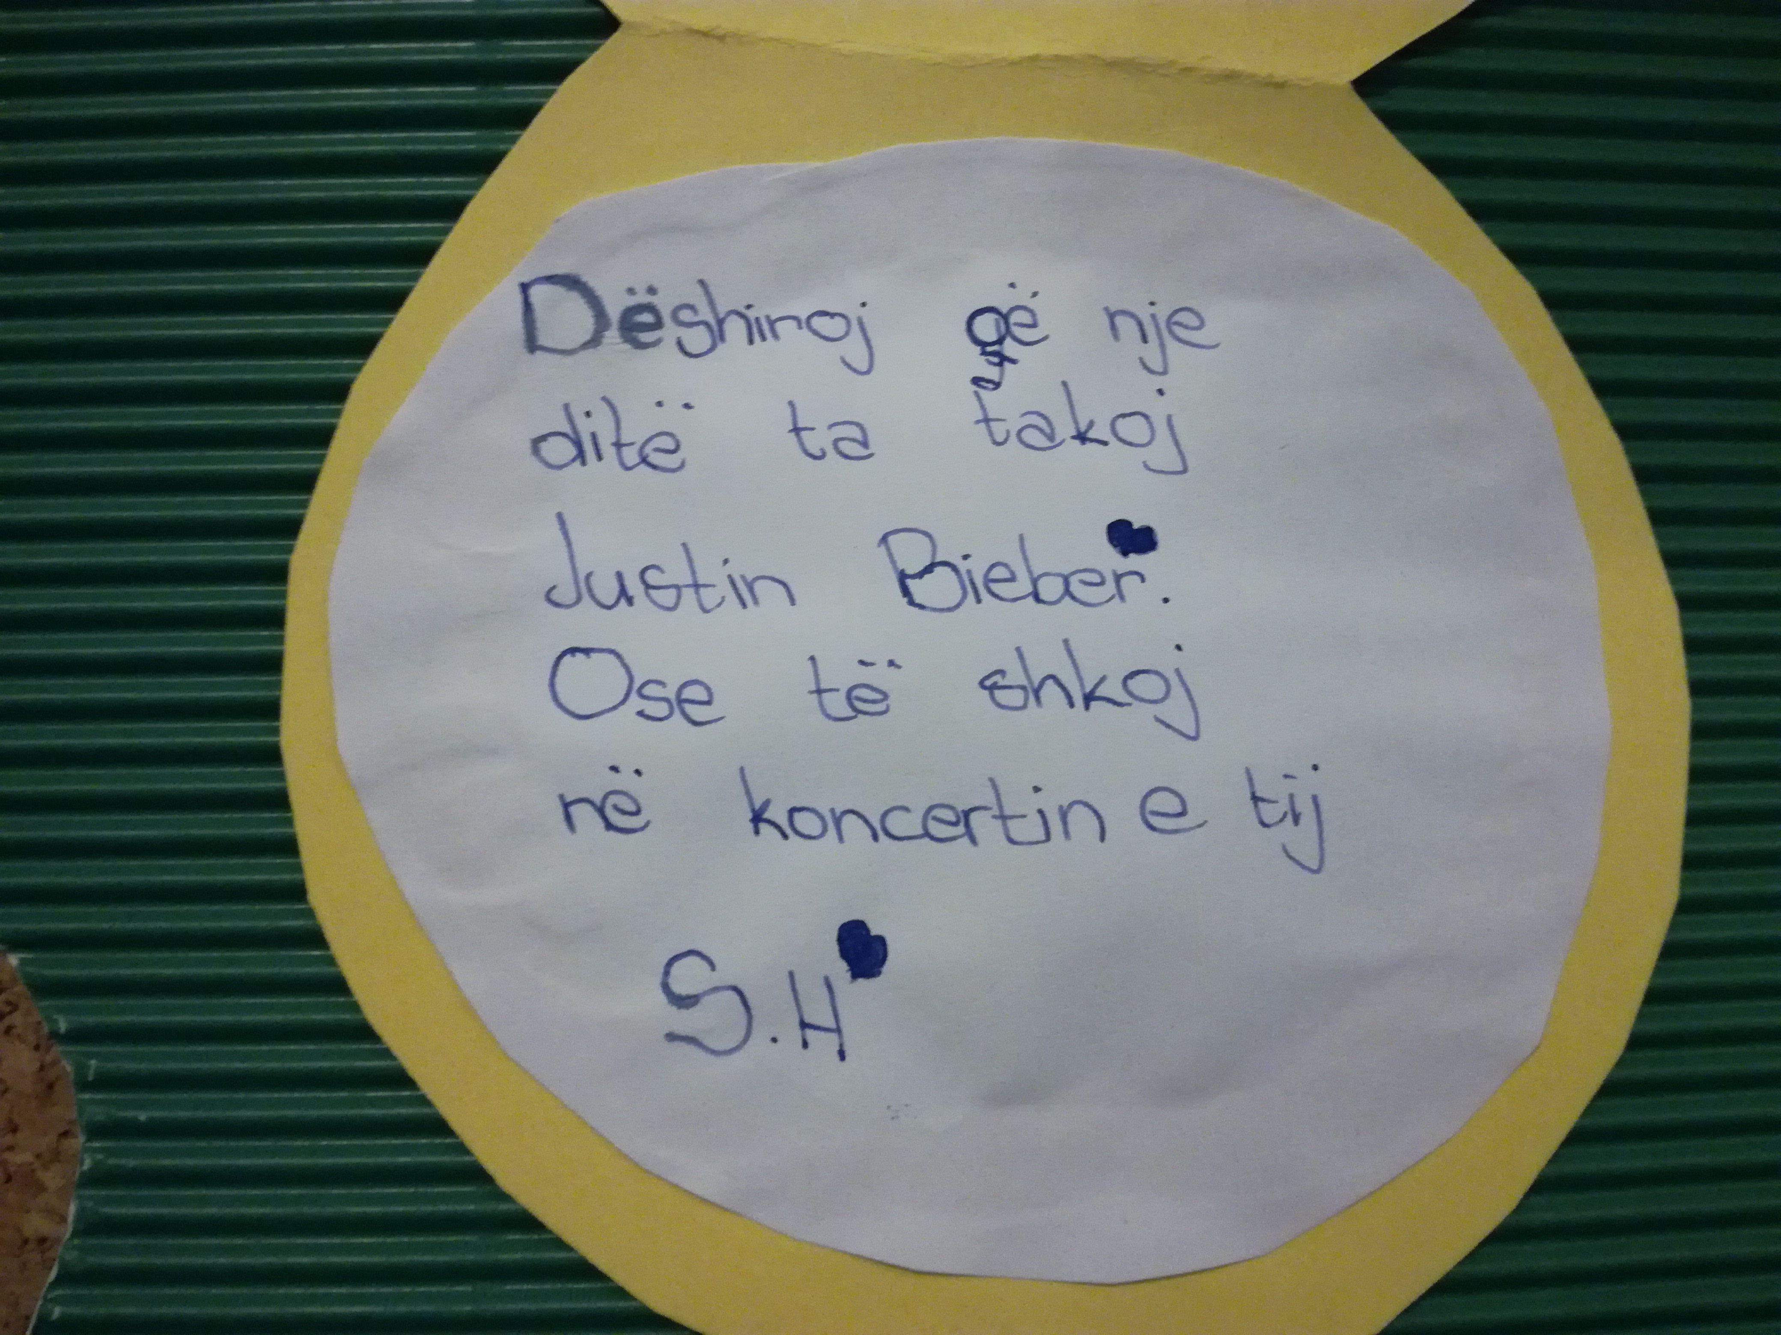 | 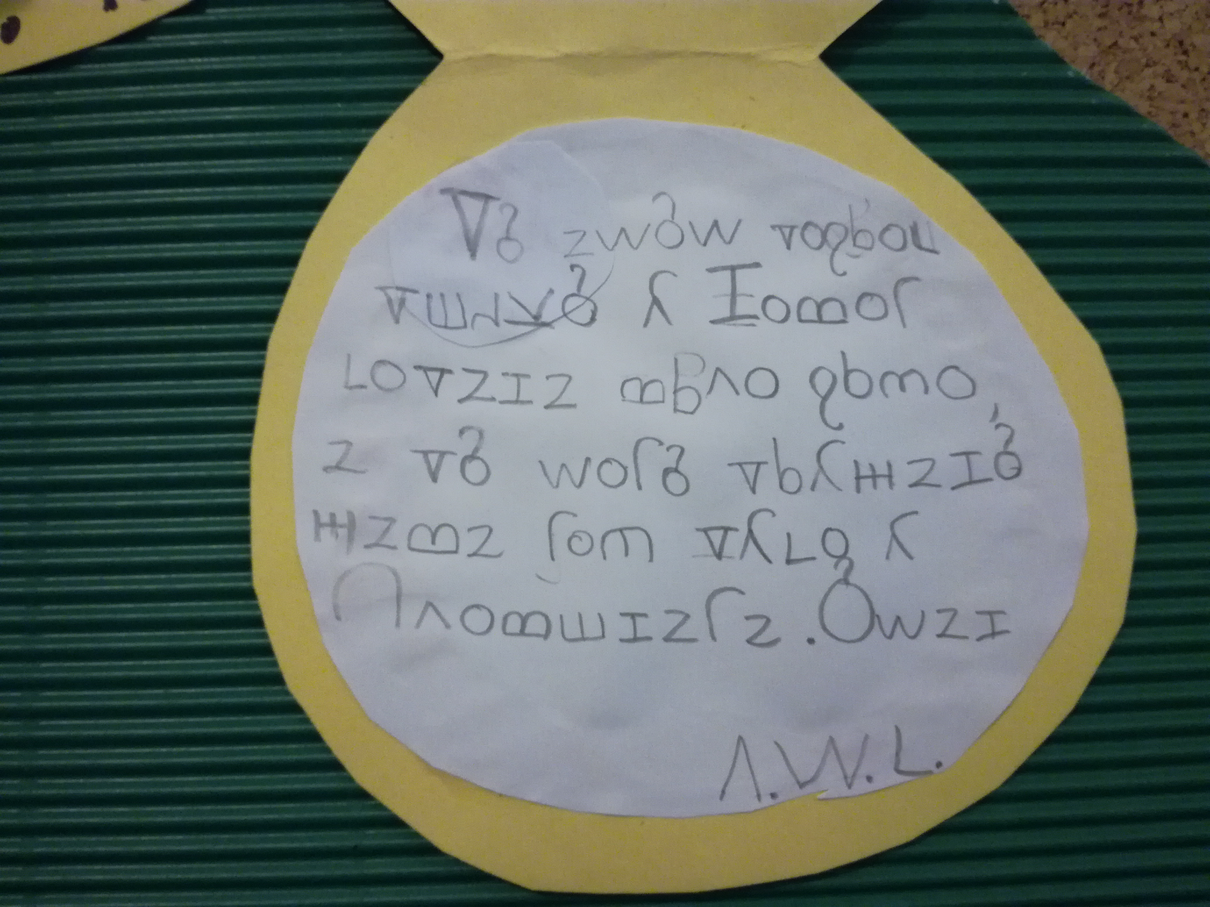 | 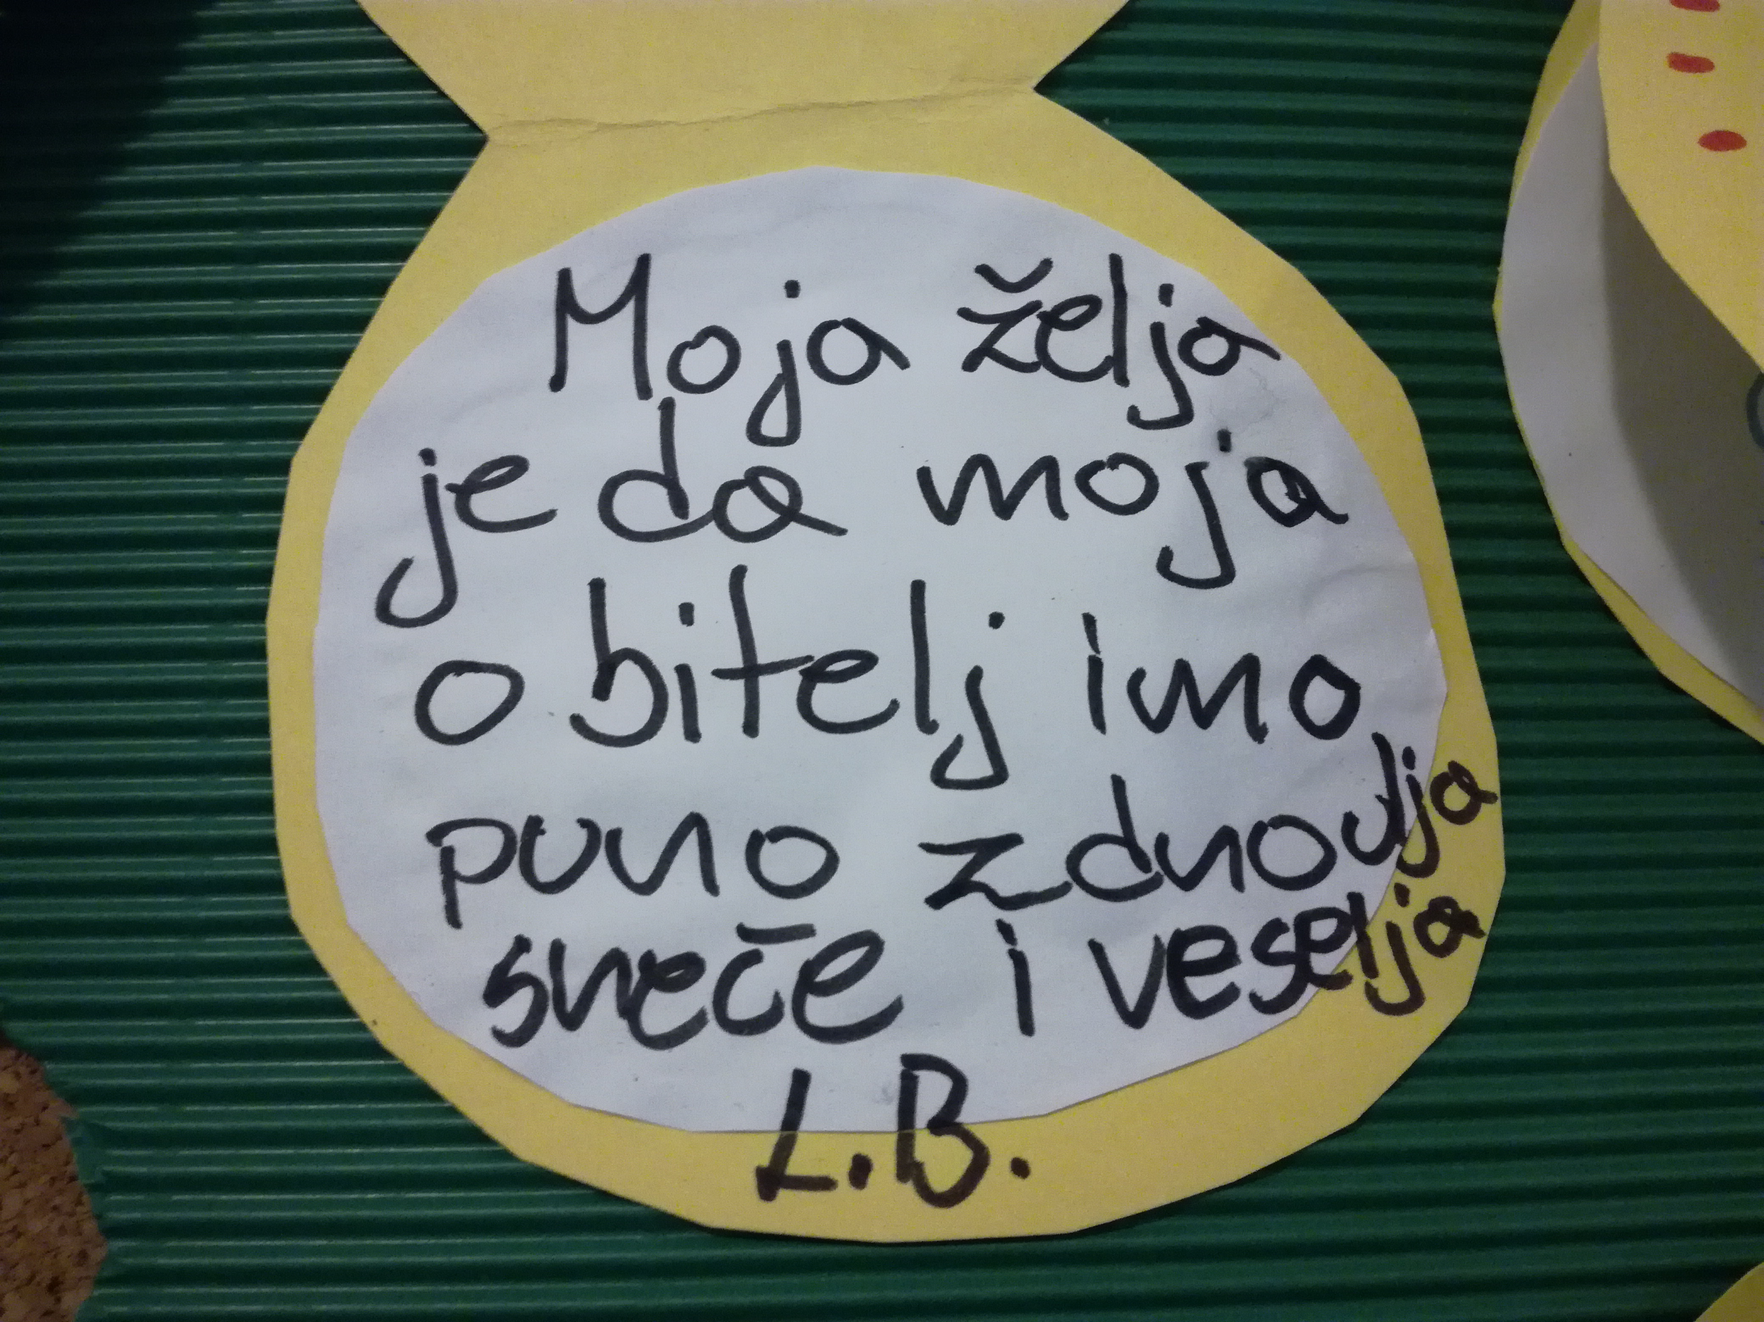
What did we talk about?  We talked about the celebrations we have in our country in December. There are quite a few of them: Birth of our great poet Prešeren, St Nicolas, Christmas, International culture day, Punishing Parents Day ( funny day when kids are allowed to punish their parents), our country's independence day, St Silvester and the New Year with Dedek Mraz.  Lots of gifts in December for good kids! | 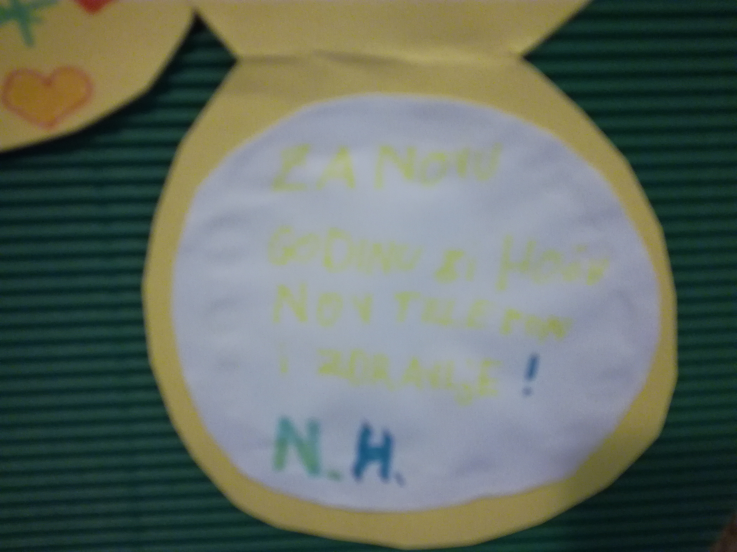 | What did the students wish?  No quarrels in the family, love in the family and health, going on Justin Bieber's concert, the girl's hamster PUPI to be alive for a long time as well as the family till the end of our lives. There were also some top secret wishes, that are not to be published anywhere!!!  They thanked the teacher for a great time they had during this activity,especially because they could write in their own mother tongues.
©
UDEL 21

