Field of diversity: | 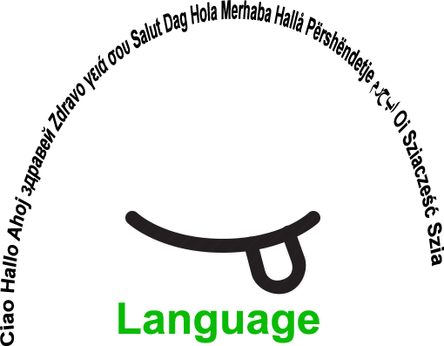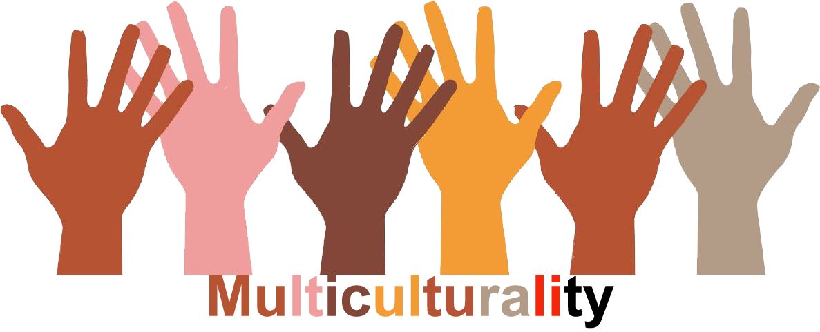 |  | L1 |  | Group size:  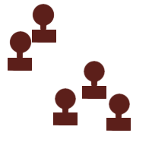
Title | Autobiographical discovers
Content | Introduce to the autobiographical activities to discover things in common and among different cultures and at the same time discover different ideas of the own culture.  Papers + post-it + colors |  |  |  |   Time: 1h
Goals (Skills/Competences) | The learners use English language to describe him/her self answering to specific questions. Through the analysis of the answer we will see how each student see himself and how he see his culture and the other that are in the same environment.  The activity is particular useful also for who has problem to interact with others, due to deficiency of language or due to shyness.  Writing allows us to:  • Focusing our thoughts  • It helps to "bring order" in our reflections  • Bring out and enhance the experience  • Keeping Memory  • Communicate with others  Expressive, social, interactive competences. Languages skills. Self-confidence
Material | Papers + post-it + colors
Procedure: | Each exercise is divided into three parts:  - A phase of the exercise description  - A phase of writing, in which everyone can write in their native language. Each participant will answer to the following questions  I tell you my name ..  The name we bear is a part of our identity, as individuals and as part of a social and family history. Then try to tell the story of your name, following the inputs that we propose, or even letting the story proceeds spontaneously as it is.  - You know how you have been given the name you bear? Often the way in which we are called is linked to cultural traditions (such as take none of the grandparents), a family history, or other special events.  - You can then tell how your name has changed over time, and then the various pet names or nicknames with which you were called by family, friends.  - Or you can tell - in general - the relationship with your name, if you have reflected and recognized in it or not, etc.  The meeting with the other ... Travel journal ...  The meeting with people from other cultures, other countries, or other "social" worlds is for each of us very important learning experience ...  Try to remember 5 events, positive or negative, related to the encounter with the other ...  The meeting with the other ...  The meeting with people from other cultures, other countries, or other "social" worlds is for each of us very important learning experience ...  Try to tell one of the experiences that you mentioned in the list we have compiled ...  What happened?  What have we learned from this experience?  How what we have learned is also useful for others  - A phase of sharing, which will be carried out in this way: each participant can read in his own language and then he/she will make a summary in English.  - Collection of the answer in post-it that will be placed in the a white board paper and commented with all the participants.  - Phase of joint reflection of shared records
Modifications
Comments
Success    factors | Continuos interaction among diverse learners and learners. with learning disabilities.  Learning by doing.  Pair learning. | Pitfalls  
The activity is flexible and depends on the local context. Feel free to adapt!
©
UDEL 21

