Field of diversity: | 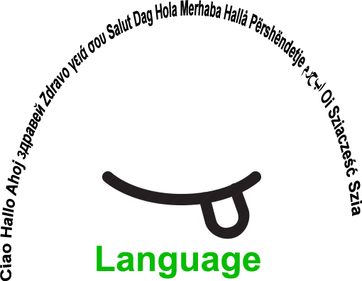 |  | L1 |  | Group size:  
Title | I LOVE MY FREE TIME
Content | Be able to work in-group, with SEN students, using foreign languages.  Coordination of responsibilities, exchange of ideas and passions. |  |  |  |   Time: 1h
Goals (Skills/Competences) | The learners use English language and enrich it in a involving situation created by themselves.  For SEN learners the cooperative work is a compensatory tool regarding relationship and participantion in group activities.  For the other learners the activity is usefull to be in touch with diversity, and take care of it.  Expressive, social, interactive competences. Languages skills.
Material | Video + Images, Interactive board
Procedure: | - The class is involved in brain storming to enrich vocabulary.  - The class watch a video or images (pictograms + text) talking about free time activities in foreign languages.  - They practice in pair asking and answering in pair.  - The teacher passes by each pair to listen and correct the pronunciation.  - Then the class is divided in groups and in each group there is a SEN student and a responsible for the work.  - Each group has to prepare a sketch about free time with different characters.  - Each group should write the text, learn and practice it.  - The teacher gives to each group a different scenario: for example the dialogue has to take place in a cinema or in a football stadium during a match.  - Each groups makes a video, which will be shown to the class in the interactive board, in a final plenary session.  - At least they have to put three questions and answers in the video about sports, leisure and hobbies.
Modifications
Comments
Success    factors | Continuos interaction among diverse learners and learners. with learning disabilities.  Learning by doing.  Pair learning | Pitfalls  
The activity is flexible and depends on the local context. Feel free to adapt!
©
UDEL 21

