Field of diversity: | 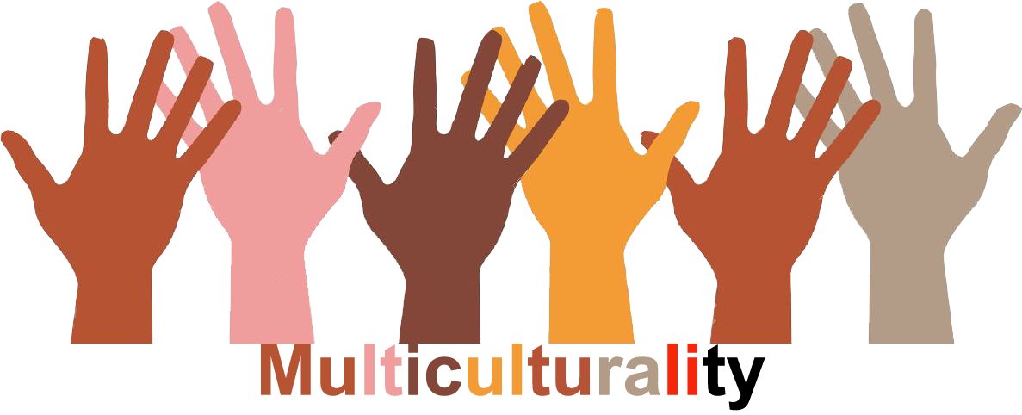 |  | L1 |  | Group size:  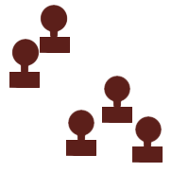
Title | Autobiographical discovers
Content | Discover the vision that we have of the other sex. No more prejudices. |  |  |  |   Time: 1h
Goals (Skills/Competences) | The workshop will help to analyze and take in consideration what we think about the other “sex”. Explore stereotypes and destroy them confronting the ideas and the thoughts of every participants. Help to better understand the needs, fears, behaviors, ways to see the world of the other “sex”. It helps to increase the respect among the students.  Expressive, social, interactive competences. Languages skills. Self-confidence.
Material | Papers + big wall + colors
Procedure: | Tape four easel pages, widely spaced, to the wall, or use a large chalkboard. Write a heading on each: Home, School, Community, Media. Divide participants into four smaller groups, one group per easel page.  Ask them to write the influences and messages in each arena that affect girls’ and boys’ notions of mathematics, science, and technology, or their general notions of what it means to be male and female in each of these areas in our society.  After a few minutes ask each group to move on to the next easel page, and continue until everyone has had an opportunity to contribute to each page and to see what others have written.  When every group wrote in each easel page put 4 new easel pages on the wall and ask to the girl to write about boys and vice versa.  At the end compare the 2 groups of pages, the first one with mixed answer and the second with answer divided per gender. We are sure you will learn a lot about fears, behaviors, visions, attitudes of the other “sex”.
Modifications
Comments
Success    factors | Continuos interaction among diverse.  Pair learning. | Pitfalls   |  | Participants must be sincere
The activity is flexible and depends on the local context. Feel free to adapt!
©
UDEL 21

