Field of diversity: | 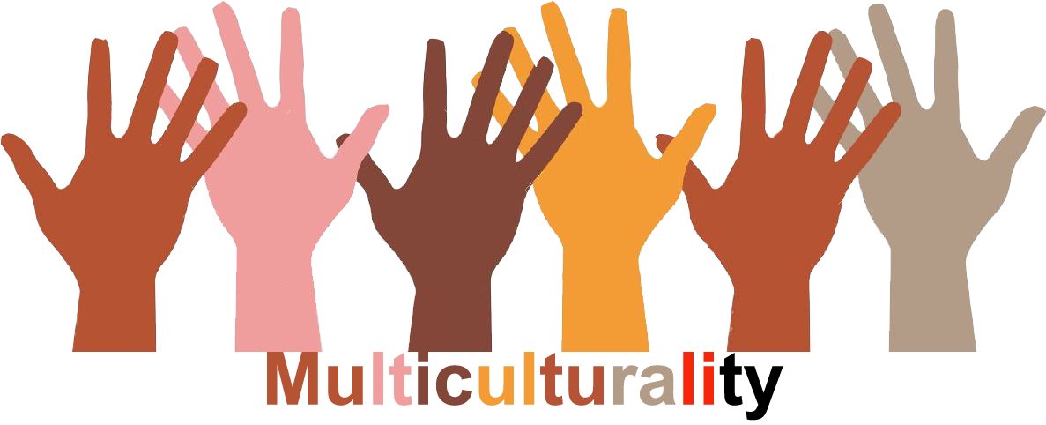 |  | L1 |  | Group size:  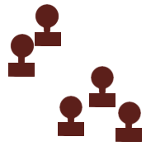
Title | Greeting rituals
Content | Get a feeling for other customs, in order to learn how to deal with different kinds of verbal and non-verbal communication and to experience the limited validity of your own habits. |  |  |  |   Time: ½ - 1UE
Goals (Skills/Competences) | - discuss different types of behaviour and cultural differences  - reflect on the validity of your own norms and values  - learn to perceive and respect other people's boundaries
Material | Role cards with symbols and text
Procedure: | - the teacher explains to the pupils that they are at a multicultural party.  - the role cards are handed out with some made-up forms of greeting.  - the pupils go round the class and greet each other in their specific way (as described on the card)  - the goal is to greet everyone in the group, as far as possible.  - The activity is followed by a group analysis using these questions:  1. Which forms of greeting were pleasant/unpleasant? Why?  2. Were any greetings interpreted differently? (e.g. as hostile, trying to make a pass, too close, too distant ...)  3. How did you feel about the unusual forms of greeting?  4. How did you act after the first greeting? (happy, scared, curious, tense, ...?)  5. how should you react to different customs? What rule should be observed? (Who should adapt to whom? Optional question)  + links: www.miteinander-ev.de/servicestelle-miteinander/integration.pdf
Modifications  Comments | - Modification of the role cards  - As a warm-up or at the end of the activity the pupils should talk in the group about their personal forms of greeting (family, friends, pets, ...)  - Proximity – distance: Pupils stand opposite each other in pairs and test when their partner gets too close.
Success    factors | Minimum of trust and openness towards the other pupils. Don't use any familiar national or cultural forms of greeting! | Pitfalls   |  | Even in funny situations the serious nature of the simulation should be maintained.
The activity is flexible and depends on the local context. Feel free to adapt!
©
UDEL 21

