Field of diversity: | 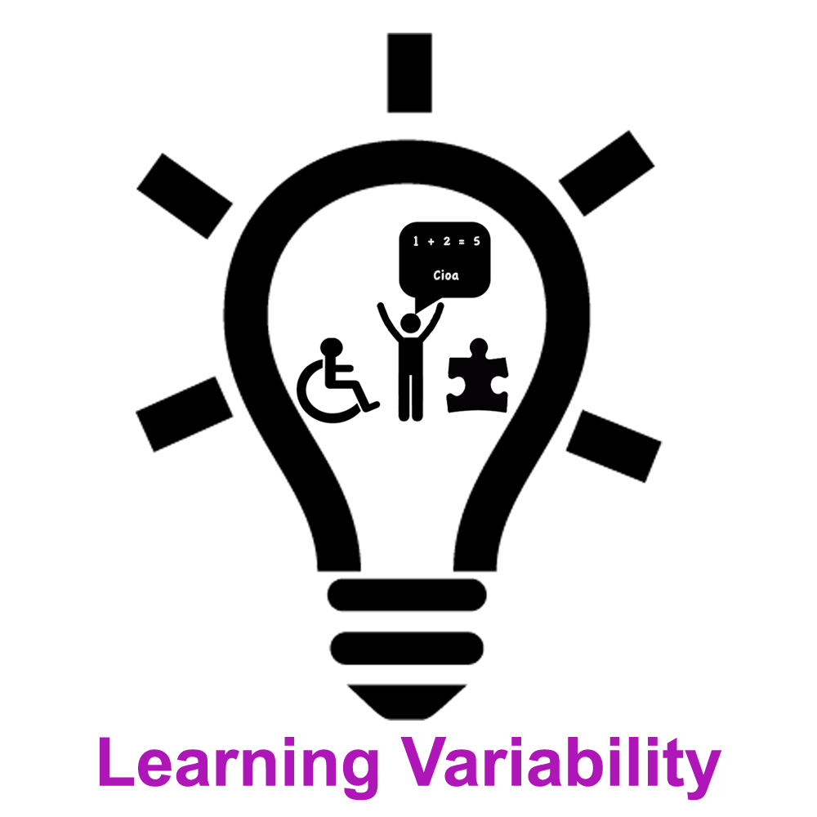 |  | LV2_CZ  L1 |  | Group size:  for students of the age of 8-10
Title | Introducing Specific Learning Dysabilities - Dysgraphia
Content | Pupils will write a short sentence with other hand they normally write with. Than teacher asks questions and presents facts about dysgraphia and forms of effective support for students with dysgraphia. |  |  |  |   Time: 45 min
Goals Skills/Competences | To help pupils to understand the needs of their classmates with dysgrafia  Social Competence, Empathy
Material | Dysgraphia Sheet 1 and 2, writing tools, whiteboard
Procedure: | - If there is a pupil with dysgraphia in the class, it is good to introduce the specific needs that these pupils have and also adjustments and aids that are provided (including adjustments in assessment that are sometimes not easily understood by other pupils and can be a possible reason for exclusion of pupil with dysgraphia from the group of peers).  - Teacher writes sentence consisting of 6 words (two of them should be of at least 6 letters) on the white/black board. Then teacher asks students to write the sentence down to their exercise book with other hand than they write with (right-handed with left hand, left-handed with right hand).  - After finishing the writing, pupils sit in the circle and put their exercise book with the writing in from of them. Short time is left for showing the writing to others and comments.  - Then teacher asks following questions (teacher can select pupils for answering concrete question, all children should have at least one response): How did you feel during the writing? What did you think during the writing? How did your hand feel compared to your normal writing? Can you imagine write like this whole page without a break? Final question is for the whole class, teacher writes down answers. If you had to write like this all the time, what do you thing that could help you at school?  - After writing down all answers, teacher introduces key facts about dysgrafia (Sheet Dysgraphia 1).  - Finally teacher presents effective forms of support for children with dysgraphia (Sheet Dysgraphia 2) and the class compares their answers with theory (sheet 2). Pupil with dysgraphia can reflect what forms of support help him/her. For homework, pupils can ask their parents if they know Agatha Christie or find other famous people who have had dysgraphia.  Source/Reference: https://www.understood.org/en/learning-attention-issues/child-learning-disabilities/dysgraphia/understanding-dysgraphia#item0
Modifications
Comments
Success    factors | This activity should be used after activities focused on understanding and accepting the fact that all people share some aspects of their identities with others (e.g. activities focused on diversity, multiple identities). | Pitfalls  
The activity is flexible and depends on the local context. Feel free to adapt!

