Field of diversity: | 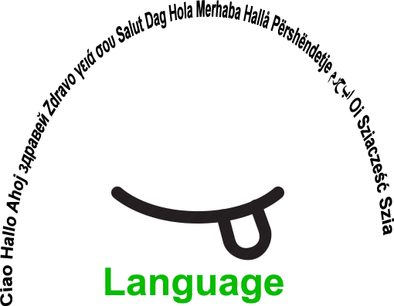 |  | L1 |  | Group size:  
Title | Working with operators – understanding instructions
Content | Workinstructions in different languages are practised with word and picture cards.  (German, English, Turkish, Albanian) |  |  |  |   Time: 1 UE
Goals (Skills/Competences) | The students should:  - get to know and experience the difficulties you face in learning working instructions in new languages.  - to strengthen and deepen the understanding of the meaning of the single instructions.  - to be able to explain an instruction (word or picture) in their own words.  - to assign pictures to the written instruction in different languages correctly.
Material | picturecards  http://li.hamburg.de/publikationen/3861104/operatoren-sprachbildung/  writtencards in German, English, Turkish, Albanian
Procedure: | - the teacher explains the word and picture cards to the students so that they know and understand the actual meaning of the instructions (acting them out)  - word and picture card-English is matched with the correct meaning on the blackboard. This way the meaning and understanding is repetated and strengthend.  - the other cards with different languages will be said out loud and explained by students who speak these languages as their mother tongue – students act as experts.  - to deepen the knowledge: game with all cards in all languages – students work in groups  - the students reflect in the class about the difficulties they had learning, writing, pronouncing and »doing« the instructions in a new language; what had helped them remembering words;....  - the students form groups and make posters with all the instructions in different languages
Modifications  Comments | - Memory: picture and words (one language - don't mix the languages)  - Memory: words and words in two different languages (German – English, German – Turkish,...)  - Use languages nobody speaks in the class  - Use anagram  - Operators/instructions are drawn by the students
Success    factors | laminate the cards  every language spoken in the class should be represented. | Pitfalls   |  | lack of language in the students' mother tongue
The activity is flexible and depends on the local context. Feel free to adapt!
©
UDEL 21

