Same same – but different

Group-discussion

1. What do you think about these situations in your culture/s? Are they okay? Are they a total no-go? Do they mean something totally different? Think about it on your own and then discuss it with your group.
2. Look at the grid and find out which 3 behaviors are not “normal” in Austria, in general.
Follow-up exercises:
2. As homework, ask your parents, grandparents, relatives or friends if they can think of some similarities or differences with Austria. You can also ask them about the list below.
3. Now ask the international students if they can think of some similarities or differences that they have encountered in Vienna so far. You can also ask them about the list below.
 | OKAY | STRANGE  ^^ | NOT  NORMAL
1. kissing in public
2. shaking hands when you greet someone
3. spitting on the street
4. standing up to answer a teacher’s question
5. arguing in public
6. to show your anger in public
7. boy and girls playing together
8. looking the teacher in her/his eyes
9. blowing your nose in public
10. smacking when you are eating
11. to pat somebody on the back
12. to talk gesticulatingly
13. to sit cross-legged
14. to cross one’s arms
15. to put an arm around somebody
16. to point with your finger
Source: Hansen/Zuber Zwischen den Kulturen
All chickens from this world
Match the chickens with the countries (1-France; 2-Italy; 3-England; 4-Japan; 5-Netherlands; 6-Germany; 7-Switzerland, 8-USA: 9-Islamic countries)

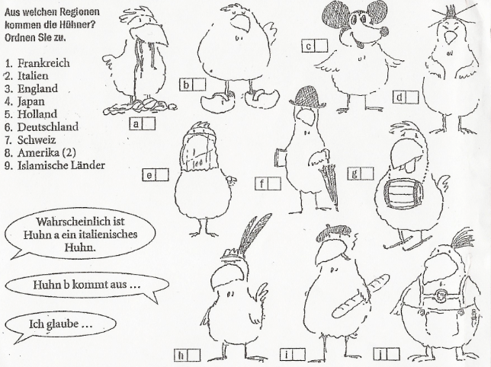
Explain your matching reasons.

Match the words with the correct nationalities
____ Lederhose ____ umbrella ____cigarette
____ bowler hat ____ Rum barrel ____ feather trimming
____ spaghetti ____ newspaper ____ Mickey Mouse
____ veil ____ clogs ____ chopsticks
____ beret ____ skis
____ baguette (French bread)
Source: Hansen/Zuber Zwischen den Kulturen

