Field of diversity: | 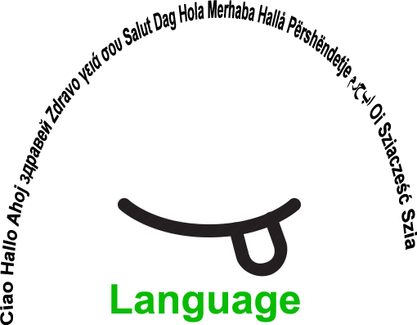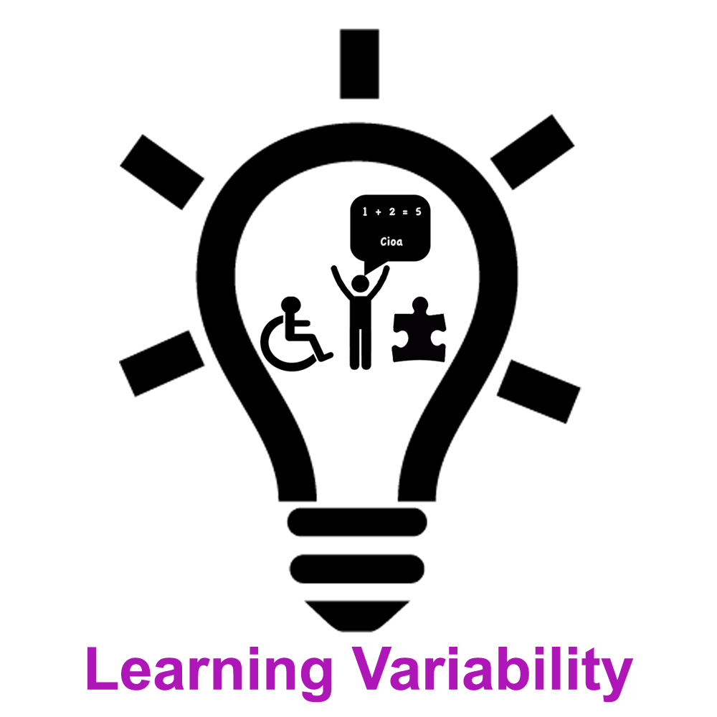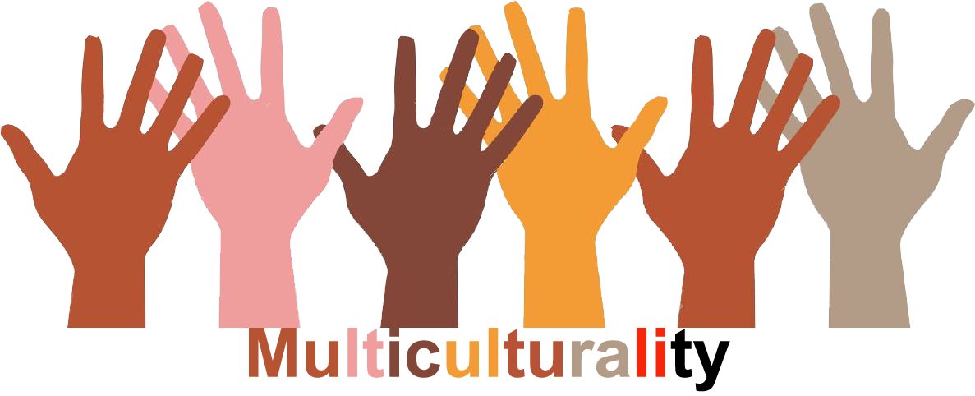 |  | L1 |  | Group size:  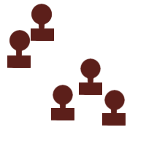
Title | Same same – but different
Content | An activity to think about your own and different cultures – the similarities and differences |  |  |  |   Time: 1-2 UE
Goals (Skills/Competences) | To reflect the similarities and differences of our own and different cultures  To understand the importance of communication and the interest in other cultures to prevent misunderstandings
Material | worksheet
Procedure: | - Optional beginning: The teachers tells a personal story about encountering cultural differences: e.g. different habits of eating in USA (putting down the knife, eating with the fork in the right hand is not common in Austria but it is totally normal in the US; using a paper tissue for several times, leaving it in a pocket, is seen very often in Austria, but confusing in the US, etc.)  1. The teacher hands out a worksheet about cultural learning. The students have a look at the grid.  - Instruction: What do you think about these situations in your culture/s? Are they okay? Are they a total no-go? Do they mean something totally different? Think about it on your own.  2. Students form groups of three and then discuss in groups what they think about the situations.  - (What do you think about these situations in your common culture? Are they okay? Are they a total no-go? Do they mean something totally different?)  3. Open discussion: Now the students can bring in their knowledge about other cultures and compare.  4. Wrap-up: The teacher asks the students why it is useful to know about the other behaviours.  - link: Handout: Hansen/Zuber: Zwischen den Kulturen
Modifications  Comments | Optional as warm-up: YouTube clips about different eating/greeting/-habits, etc.  Homework: Instruction: Ask your parents, grandparents, relatives or friends if they can think of some similarities or differences with the Austrian culture. You can also ask them about the list on the handout.  Invite parents, Native Speaker Teachers or international students from the local University of Teacher Education: Follow-up-instruction: Now ask the international guests if they can think of some similarities or differences that they have encountered  in Vienna so far. You can also ask them about the list below. (e.g. people are standing closer to each other while talking, people talk quietly on the metro, strangers do not touch babies, etc.)
Success    factors |  | Pitfalls  
The activity is flexible and depends on the local context. Feel free to adapt!
©
UDEL 21

