Field of diversity: | 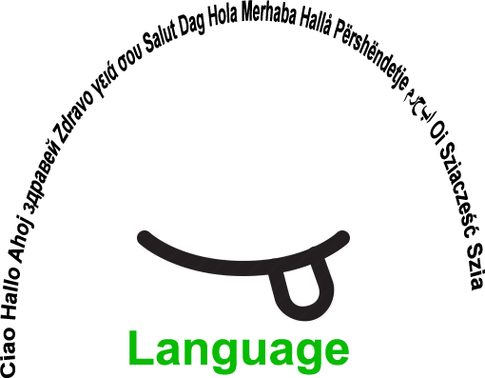 |  | L1 |  | Group size:  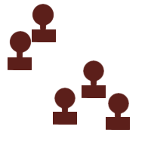
Title | I introduce myself
Content | get to know eachother  find things you have in common |  |  |  |   Time: 1 UE
Goals (Skills/Competences) | Students get to know eachother and find things they have in common  Supporting language and social skills  Selfcompetence and somebody else's competence  Mutual get to know eachother is promoted - intolerance will be reduced
Material | Worksheet
Procedure: | - Students get the worksheet and fill it in. Teacher helps if needed  - after finishing the worksheet the students form a circle  - a student reads out one sentece from his worksheet and steps into the middle of the circle. The student can choose the sentece he/she wants to read out and share with the class. Everyone who has the same sentence(ability, interest,...) joins the student in the middle. All the students in the middle repeat the sentence out loud in order to strengthen the vocabulary and then all step back from the middle  - the next student steps into the circle and reads out a new sentence and the same procedure starts again  - every student has a turn  + links
Modifications
Comments
Success    factors | Use pictures as help for students who don't speak the language as well as the others; let students help others and let them act as translaters for others | Pitfalls  
The activity is flexible and depends on the local context. Feel free to adapt!
©
UDEL 21

