Field of diversity: | 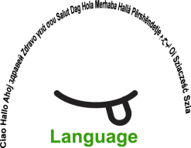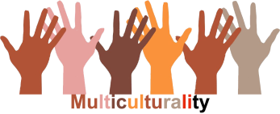 |  | L1 |  | Group size:  
Title | Experiment: Exclusion – Assimilation – Integration  (Österr. Integrationsfonds)
Content | - equip students with correct terminology  -students realize that we have to work together to help the people who have arrived in Austria/Europe - |  |  |  |   Time: mind. 50 min
Goals (Skills/Competences) | Students should be able to understand that they can contribute to a sustainable society  Students should be able to define terms like assimilation – exclusion - integration –
Material | 3 empty glasses, water (to fill each glass half), oil (to fill half a glass), salt, orange juice, spoons
Procedure: | Experiment: The teacher prepares an experiment to explain the terms "exclusion", "assimilation" and "integration".  Props: 3 glasses of water, oil, salt, juice, spoon  Teacher asks a student to put water in all the 3 glasses.  Then one student adds oil to first one, another student adds salt to the second glass, and a third student adds juice to the third glass.  They take a spoon and stir. Then the teacher asks the students to watch the results and asks them - how we could relate the glasses to integration (a term that has been introduced before). Realization: Glass 1: The water does NOT mix with the oil. --> exclusion This would be dangerous for a society, because there is a clear division in the society instead of cooperation. Glass 2: The salt in the water dissolves, is not visible anymore and doesn’t really taste good --> assimilation. This would mean that the newly arrived people had to be like Austrians. But what are Austrians like? Also each Austrian is different. And being different can be enriching for a society, if we share common values. Glass 3: The water is mixed up with the juice --> integration. Something new develops - a good mixture, so that a society can live together in harmony.  Open discussion  - What can we do to prevent the reaction of Glass 1 and Glass 2?  - Can there be something “good” in assimilation? What are the dangers?  - What can the students do to get the reaction of Glass 3? In the classroom/at school in general/at the playground/…?  - Divide class in pairs or groups of max. 4 and let them produce a recipe for the class to get the “perfect fruit juice” – how to integrate all students in the class community? The students present their “recipes” to the class and they create e.g. class rules (on a poster/flipchart which can be expanded during the year) to integrate everyone in the class community.
Modifications  Comments | You can introduce the terms «exclusion, assimilation or exclusion« or elicit them with the help of the experiment.
Success    factors |  | Pitfalls  
The activity is flexible and depends on the local context. Feel free to adapt!
©
UDEL 21

