Field of diversity: | 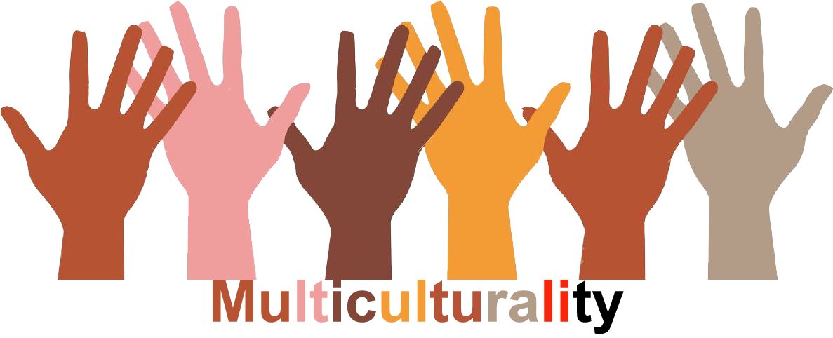 |  | L1 |  | Group size:  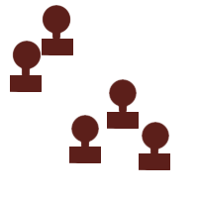
Title | The Island
Content | Simulating the creation of a new society on a LIFE island |  |  |  |   Time: 2 - 3 UE
Goals (Skills/Competences) | Discussing ideas for a fair society – encouraging social competences, for example willingness to cooperate, ability to work in a team, tolerance
Material | All kinds of pencils ... (coloured pencils, water colours, wax crayons), 4 large sheets of brown paper, sticky tape
Procedure: | - Class is divided into 4 groups  - Teacher`s instructions:  - Life on the LIFE island follows 4 principles, which should be represented in the pupils' drawings and ideas (L= Life, I= Innovation,  F= Freedom & Friendship, E= Equality).  - Introductory question: What could a good life together among the people on the island look like? What do people need so that they treat each other with respect?  - Each group is given an information sheet with rules of communication and guiding questions.  - The 4 sheets of brown paper are put on the floor next to each other (to form a square or rectangle).  - The class agrees on an outline for the island. They draw it together.  - For every »crossover« between the sectors there is at least one common element of infrastructure (a building, road, river ...)  - After that the 4 groups work on the design of their island alone.  - Each group presents their segment of the island. With each presentation the island comes closer to its completion.
Modifications
Comments
Success    factors | Allow enough time (creativity takes time), discuss rules for getting along together and working constructively, so that everyone can contribute his/her ideas. If a problem cannot be solved, work on the project may be interrupted – clarification by teacher and pupils. | Pitfalls   |  | Arguments, destructive instead of cooperative behaviour,
The activity is flexible and depends on the local context. Feel free to adapt!

