Field of diversity: | 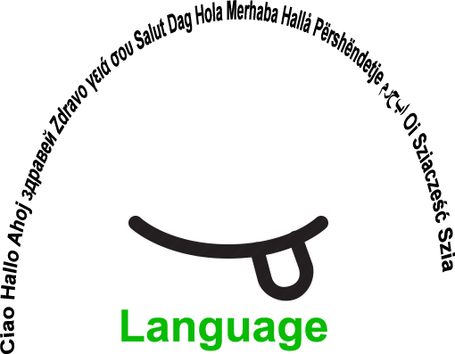 |  | L1 |  | Group size:  
Title | Anagram
Content | Key words – subject specific vocabulary (e.g. Biology – horse) |  |  |  |   Time: 5-10 Min
Goals (Skills/Competences) | Practise spelling  Writing and understanding new words about a topic
Material | Anagram card – each card is divided into two columns. On one side the letters are jumbled and on the other side there is an empty space or a line to write the word on. The columns are separated by a line.
Procedure: | - at the end of the Biology lesson, for example, the pupils are given an anagram card with the most important words from the lesson.  - the words should be written correctly on the card.  - Reward: those who have filled in their card correctly may choose a quiet activity. (optional)  + links: www.new-views.eu/resources/diversitat-und-didaktikfinal.pdf
Modifications  Comments | - can be used in all subjects with as many words as you like.  - Add a third column for explanations/definitions (possibly multiple choice). Differentiation: good pupils write their own definition.  - Word grid  - Fill in the missing letters
Success    factors | Attractive rewards for the pupils | Pitfalls   |  | You need to stick to the lesson plan because the words have to be discussed in the lesson.
The activity is flexible and depends on the local context. Feel free to adapt!
©
UDEL 21

