Field of diversity: | 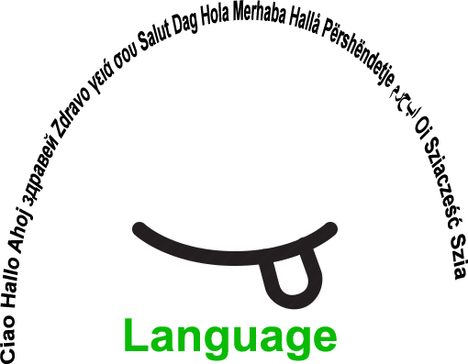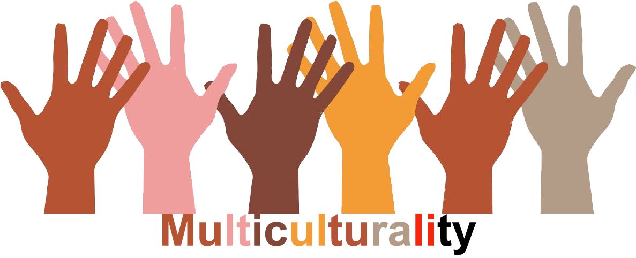 |  | L1 |  | Group size:  
Title | Ein Schritt vorwärts – One Step Forward
Content | Pupils are given role cards, invent »their« character and are sent on their »way through life«. They encounter different situations and experience how diverse conditions and opportunities affect their lives. Discrimination becomes clear and transparent. In this activity participants can see how it feels to be someone else. |  |  |  |   Time: 2UE
Goals (Skills/Competences) | - Awareness of discrimination  - Developing empathy towards others  - Awareness of unfair distribution of opportunities in society  - Critical analysis of prejudices
Material | Role cards, questions to empathize with the role, situation cards (separate Word –Dokument)
Procedure: | 1. Explain procedure.  2. Hand out role cards: one card per person; the cards should not be shown to the others. Cards may be allocated or adapted, depending on the class.  3. Ask the pupils to sit and read the cards.  4. Now the pupils should start to get into their „role“ and fill in the profile. They can ask the teacher if they have questions.  5. Ask the pupils to stand up quietly and get into a row next to each other, preferably on one side of the room.  6. Explain that you are going to read out a list of different situations. Every time the pupils can respond to a statement with „yes“, they should take one big step forward. Otherwise they should stay where they are without moving.  7. Now read out the situations one after the other. Pause after each situation so that the pupils have time to think before they take a step forward (or not).  8. Finally ask them to look how far they have got, also compared to the others. Now they should take it in turns to tell the others which role they had and how they felt during the activity. What feelings did each of them have for the people in front of them and behind them? Were there any statements that provoked a particular reaction?  9. After that there is a short break to get out of the role (physical exercises like „Shaking off“ or „Taking off“ the role are suitable.)  10. Debriefing and transfer to pupils‘ own lives (in a circle): What similarities to our own lives have we noticed?  - Is there anyone who has had similar experiences?  - What do we think about that? Is it okay or do we find it unfair?  - What could disadvantaged/privileged people do to change things? What can we do as a society? What can you do as an individual?  - What should politicians or other decision-makers do?
Modifications  Comments | http://www.schulpartnerschaften.at/images/doku/broschuere_ich_du_wir_web.pdf  Possible specifications: Age of invented character  Name of invented character
Success    factors | - Create a calm, relaxed atmosphere  - Pupils in the group must know each other and be open  - Teacher should explain questions/situations adequately  - Allow for enough time according to the group  - Possibly have a second teacher as support  - Age group: from 13  - Good guidance by a strong teacher | Pitfalls   |  | Individuals/group refuse to get into the role(s)  Ill-considered role assignment  Inappropriate language level
The activity is flexible and depends on the local context. Feel free to adapt!
©
UDEL 21

