Field of diversity: | 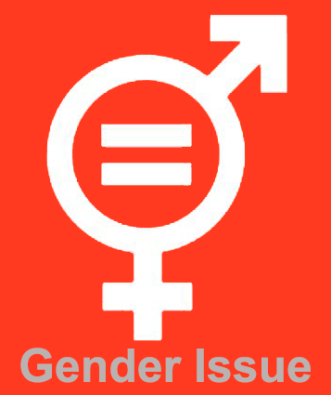 |  | G1_CZ  L1 |  | Group size:    from the age of 10
Title | Girls and boys
Content | Students create a list of various personality traits and abilities and in groups discuss which of them are more feminine or masculine |  |  |  |   Time: 30 min
Goals Skills/Competences | Be aware of gender difference is natural and we can learn from it.  Skill: To compare, synthetise, explore and avoid myths on gender.
Material | whiteboard
Procedure: | 1.Writing the list with various personality traits and abilities (e.g. sense of humour, responsibility, need to feel safe etc.)  2. Write the list on the board (in frontal form)  3. Discussion In small groups: Which of them are more feminine or masculine ones?  4. Summary – agreements and disagreements - either with exchanging group results or in frontal form  5. Possibility to transfer the most contraversial results into role play  Reflection: Why did you divide abilities this way? When you discussed it, could you notice feminine and masculine abilities in your group? Which men and women abilities and personality traits are profitable and which are risky?
Modifications
Comments
Success    factors |  | Pitfalls  
The activity is flexible and depends on the local context. Feel free to adapt!

