Field of diversity: | 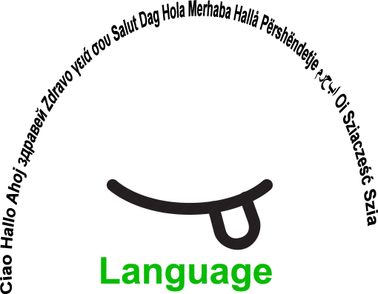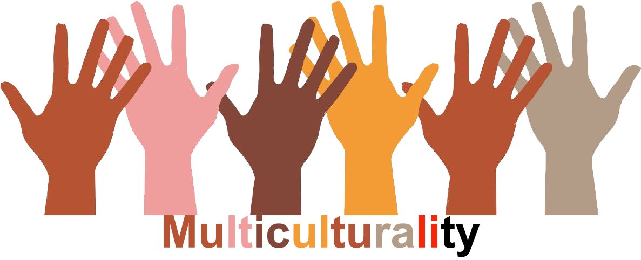 |  | GLLVM3_CZ  L1 |  | Group size:    For students from the age of 14 upwards
Title | My heroes
Content | Students write/tell about who were/are their heroes and explain why. |  |  |  |   Time: 25 min
Goals Skills/Competences | To eplore identity construction, compare various aspects of identification.  Skills: to value backgrounds of others
Material
Procedure: | Complete the answers in the chart  Who are my heroes?  (five information for both columns)  Sharing information in small groups, finding consent, difference and their context  Groups of 2-4  Source: Johnson, D.W., Johnson, R.T. Human relations: valuing Diversity. Edina: IBC, 1999.
  People I identified with as a Child | People I identify with now
Modifications
Comments
Success    factors | reflection of the activity is crutial. How our heroes have changed? Which values were important for us in childhood, which are important now? | Pitfalls  
The activity is flexible and depends on the local context. Feel free to adapt!

