Field of diversity: | 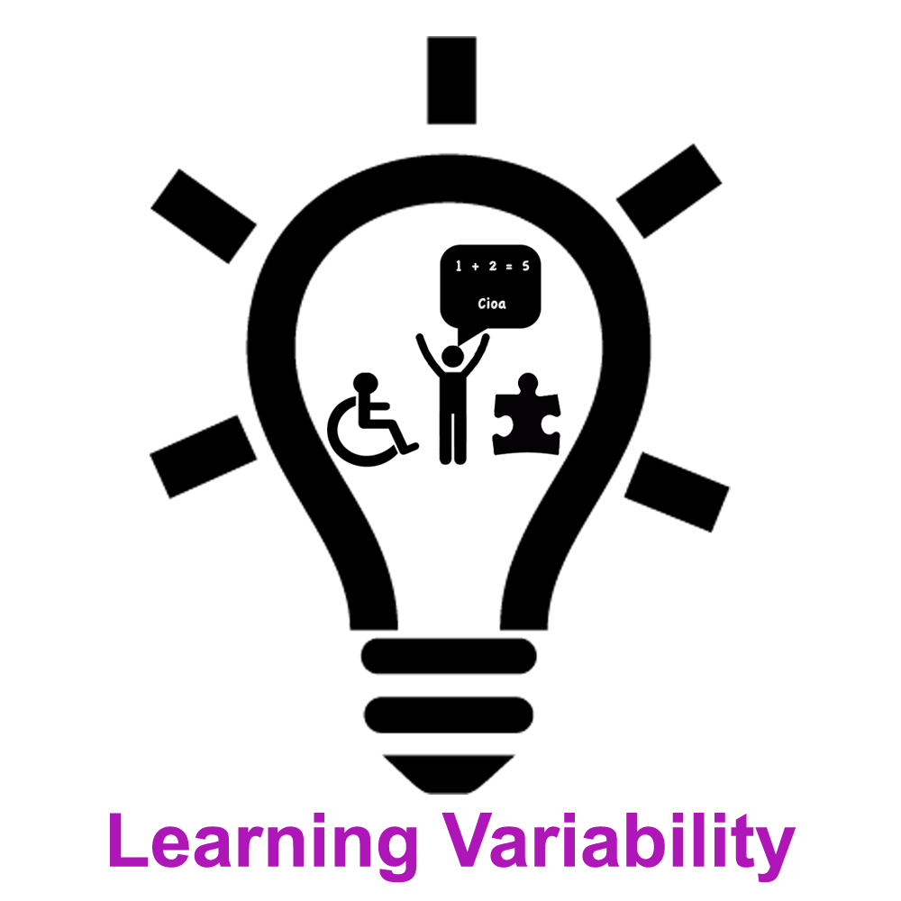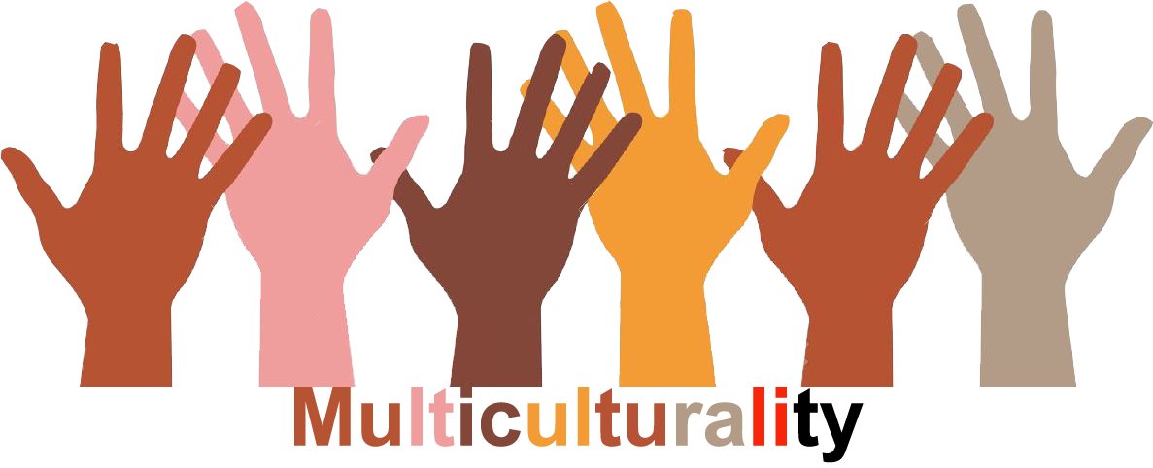 |  |  | GLLVM1_CZ  L1 | Group size:  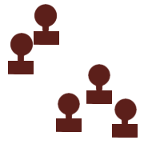  from the age of 10
Title | The machine of rhythms
Content | Students one by one join in rhythms, movements and sounds -together they create one »machine«. |  |  |  |   Time: 10-15 min
Goals Skills/Competences | Be aware of power of diversity in a process of bulding complexity, integration which works. Participate in forming the new entity, learn to be a part of the whole by active using bodies and sounds, coordination.
Material | -
Procedure: | A participant goes into the middle and imagines that he (she) is a moving part in a complex machine. He (she) starts doing a movement with his (her) body, a mechanical, rhythmic movement, and vocalising a sound to go with it. Everyone else watches and listens in the circle around the machine. Another person goes up and adds another part (his/her own body) to this mechanical apparatus, with another movement and another sound. A third, watching the first two, goes in and does the same, so that eventually all participants are integrated into this one machine, which is a synchronised multiple machine.  When everyone is part of the machine, the leader asks the first person to accelerate the rythm – everyone else must follow this modification, since the machine is one entity. When the machine is near to explosion, the leader asks the first person to ease up, gradually to slow down, till in their own time the whole group ends together.  Variation: The same thing, with the region of a single country from which the participants originate (Southern Italy, Nothern Italy, Prague machine etc.) Variation: The machine of whatever themes we are currently working on: sexism, racism, etc.  Source: Boal, A. . Games for actors and non-actors./ theatre and drama pedagogy  movie link?
Modifications
Comments
Success    factors | Play the internal rythm, not external aspects  kids must be prepared/experienced in such this kind of activities  adequate space | Pitfalls   | if people are shy to epress themselves by movement and sounds
The activity is flexible and depends on the local context. Feel free to adapt!

