Field of diversity: | 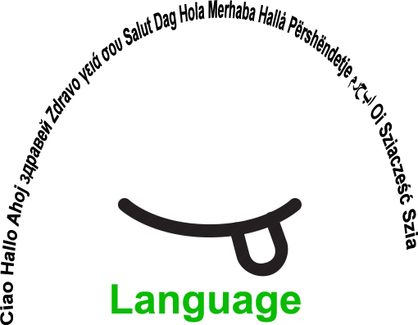 |  |  | L2_CZ  L1 | Group size:    for students of the age of 9-19
Title | Key Visuals
Content | Teacher prepares for students a table with illustrative visual representations of key terms of the topic of the lesson with definitions in language of instruction and with space for definition in native language of each student. |  |  |  |   Time: -
Goals Skills/Competences | To help pupils with different native language to understand important terms and definitions in language of instruction.  Comprehension of educational content in different language of instruction.
Material | Table with illustrative visual representations of key terms (photos, pictures, graphics, diagrams etc.)
Procedure: | For each topic, teacher selects key terms that are essential for its understanding. Teacher selects illustrative visual representations of key terms (photos, pictures, graphics, diagrams etc.) and prepares table with visual representation of the key term, term in language of instruction and its simple but accurate definition in language of instruction. Empty column is left for pupil to fill in the term in native language (if he/she wants to). The key visuals (and also key terms and key definitions) are than used as much as possible in presentations, handouts, mind-maps etc. This tool is effective for pupils without previous (or very limited) experience with language of instruction, however any pupil that could possibly benefit from the tool (e.g. pupils with intellectual disability) can use it (empty column can be used for notes). Example of table is presented in attachment.  Source: Equality, Babington Community College, UK
Modifications
Comments
Success    factors | Selection of illustrative visuals and simple definitions of selected terms and their frequent use in lessons.  The number of the key terms should be limited (e.g. max. 15 per unit). | Pitfalls   | Too complicated definitions with too many words or less frequent words. Preparation of the visuals is time consuming - involves more teachers or students in searching key visuals and definitions on the Internet.
The activity is flexible and depends on the local context. Feel free to adapt!

