Field of diversity: | 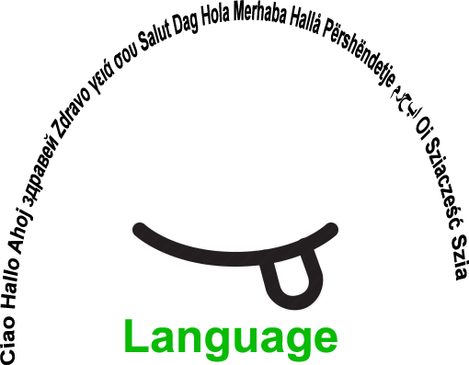 |  | L1_CZ  L1 |  | Group size:   for students of the age of 12-19
Title | Group Feedback in New Topic
Content | Through students´answers (in different ways) of a questionnaire about new educational topic the teacher receives immediate information about the level of students ´comprehension. |  |  |  |   Time: 2-3 min
Goals Skills/Competences | Comprehension raising in selected area of skills or knowledge.  Children reflect the level of comprehension to new topic in science subjects.
Material | Questionnaire, flashcards, blackboard, interactive whiteboard, data projector screen etc.
Procedure: | - Before presenting a new topic of the lesson (especially useful for science and related subjects) the teacher divides the information content to smaller logical units and prepares multiple choice questions with 2 to 4 answers regarding each unit. Each answer is marked with different number of letter (e.g. a, b, c,) and only one of the answers is correct. True of false statements can be also used.  - Each pupil will receive flashcards with letters or numbers representing the answers. After finishing presentation or activity regarding the information unit, teacher visualizes the question and choice of answers including one correct answer (on the blackboard, interactive whiteboard, data projector screen etc.) and also reads them for pupils. Pupils get short time to select the correct answer without touching the cards. Then teacher counts to three and all pupils show the card with sign representing selected answer at the same time (so they do not have time to select the answer according to others).  - The teacher has immediate information on the level of comprehension each pupil has regarding the unit topic. If there are more pupils who selected wrong answer, teacher knows that he/she has to return back and give more time and effort to this information unit.  Teacher can also use statements when pupils have to decide if the statement is true or not. Teacher can ask pupils who think that the statement is true to go to the left side of the class room and those who think that it is false to the right side of classroom. If there are pupils on both sides, teacher can ask one or two pupils from each group to explain their opinion. Using motion is useful for pupils with ADHD. Alternatively the pupils can remain seated and teacher asks them to raise hand if they think that the statement is true with their eyes closed (so they cannot look at choices of others).  The activity is useful in classes with high number of pupils with different language background for more complex topics integrating more information together.  Source: Babington Community College, UK
Modifications
Comments
Success    factors |  | Pitfalls  
The activity is flexible and depends on the local context. Feel free to adapt!

