Field of diversity: | 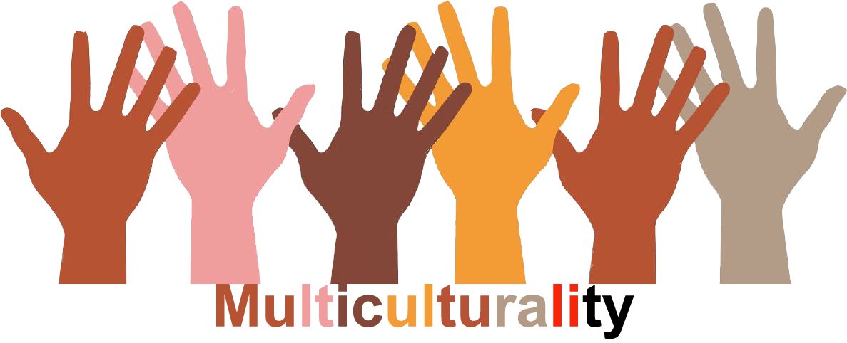 |  | M3_CZ  L1 |  | Group size:   for students of the age of 8-12
Title | Flower of My Identity
Content | Pupils create flower of their identity than they discuss and compare flowers in groups |  |  |  |   Time: 30-45 min (depends on number of children)
Goals Skills/Competences | Awareness raising on multiple identity.  Children understand that identity has different elements, they understand that diversity is important characteristic of every society.
Material | Drawing tools
Procedure: | - In a class discussion teacher first explains the concept of multiple identity. It means that we all identify with certain groups based on some of the identity elements (such as gender, race, nationality, disability, employment, free time activities etc.). It is important to stress, that everybody has some elements of identity that are shared with others in the class (e.g. they are all pupils of certain school), some of them are shared by part of the members of the group (e.g. some of them are boys) and some elements are unique in the class (e.g. only one pupil is Asian, piano player etc.).  - Children draw a flower (daisy). To each part of the blossom children write one element of their identity (e.g. European, Czech, boy, son, brother, pupil, football player, scout). Parts of blossom are added according to the number of identity elements child selects.  - After finishing their flower of identity children in group of 4 – 5 discuss what all of them have in common and if there are any elements that are specific only for one of them.  - Member of each group finally present what elements of identity are shared by all members and what was unique in the group.  References/Sources: www.inkluze.upol.cz (information available only in Czech), http://czechkid.eu/index.html
Modifications
Comments
Success    factors | Knowledge of theoretical background of the topic of identity and diversity. | Pitfalls  
The activity is flexible and depends on the local context. Feel free to adapt!

