Field of diversity: | 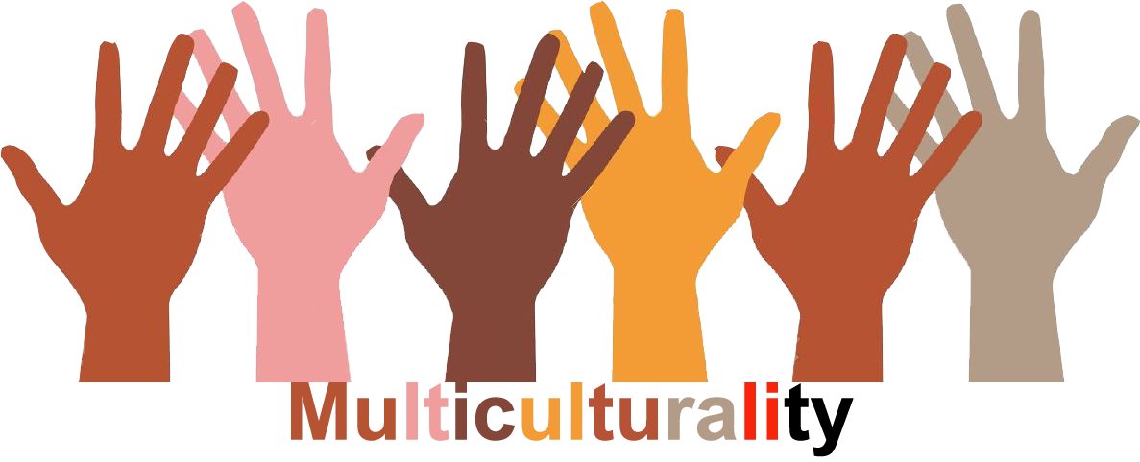 |  | GM2_CZ  L1 |  | Group size:    for students of the age of 13-19
Title | Prejudice2
Content | Discussion about statements reflecting some prejudices |  |  |  |   Time: 20 min
Goals Skills/Competences | To reflect prejudices and to become aware of them
Material | Written/electronicaly presented statements
Procedure: | - At the beginning teacher presents to students the following statements. Students will be asked to read them quietly.  - Immigrants take our jobs  - Who has dreadlocks, he or she takes drugs  - Young people listen to terrible music  - Romas shoplift  - Women are bad drivers  - Ukrainians are mafiosos  - Muslims are terrorists  - Boys do not cry  - Politicians are corrupted  - All who have short hair are skinheads  - Give students time to read the statements. Ask questions: Do you see any relationships between the statements? Whom they concern? How they probably originated? Can all members of the group have the same qualities? Is it possible to assess the group of people on the basis of one negative experience with one of its members? Have you heard such statements? Where? Do you think they are true? How would you argue against the statements? The statements could be discussed one by one. We ask for students´ opinions.  Source: NESEHNUTI, http://multikulti-challenge.cz/workshopy/
Modifications
Comments
Success    factors | When there is a member of any of the groups mentioned under a), b), d), f) or g) we exclude particular statement/s. | Pitfalls  
The activity is flexible and depends on the local context. Feel free to adapt!

