Field of diversity: | 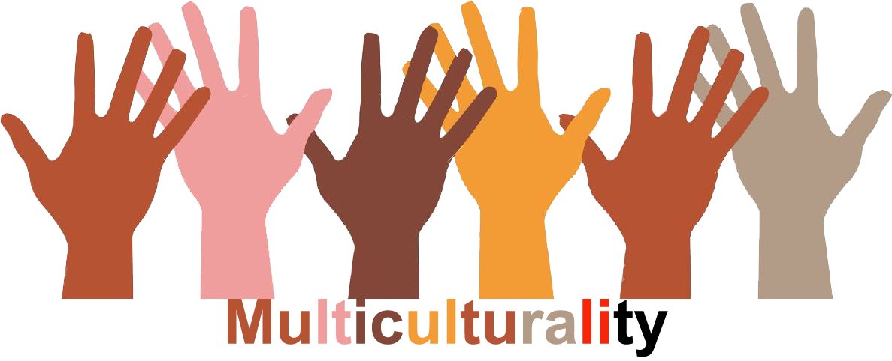 |  | GM1_CZ  L1 |  | Group size:   for students of the age of 13-19
Title | Prejudice 1
Content | By trying to assign statements to the right people students can experience how easy we can judge people from the first sight. Discussion follows. |  |  |  |   Time: 20 min
Goals Skills/Competences | To reflect prejudices.  To become aware of prejudices
Material | Written statements
Procedure: | - Two teachers/lecturers prepare 3 statements about themselves. Each statement will be written at a separate paper. The statements should relate to judging people from the first sight when we rely on our first impression (habits, hobbies, origin,…), for example „I like sports“, „I am a bad driver“ etc. The teachers clip the statements one by one on the board. If there is only one teacher/lecturer 3 statements will be correct and 3 incorrect.  - Students are asked to assign individual characteristics to individual persons.  - The teachers divide the statements into two columns according to the reality. They can ask students if they were surprised by the assignment of any statement or if anyone guessed all the statements.  - The discussion reflects our habit to judge people from the first impression. If we have an opportunity to get to know people better they very often exhibit qualities very different from those we saw on the first sight. Let´s try to reflect this next time when we meet someone for the first time.  - The students answer the question: Does it sometimes happen to you that someone evaluated you according to your appearance?  Source: NESEHNUTI, http://multikulti-challenge.cz/workshopy/
Modifications
Comments
Success    factors |  | Pitfalls  
The activity is flexible and depends on the local context. Feel free to adapt!

