1.  I’m ready to receive the information and I’m planning to do something with it.   | 2.  I take the information and put it in my head.    I watch in order to …  I listen in order to …  I touch in order to …
3.  I think about the information I got.  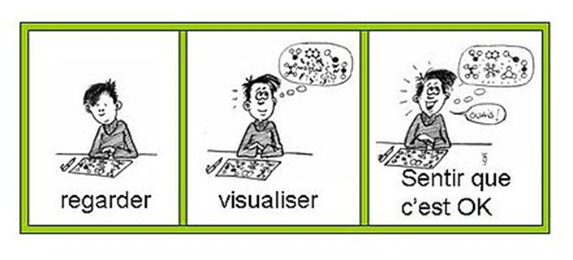 | 4.  I check if what I have in my head is what I wanted to get.  INGT/INDJ © D. Migeot
Mental management - annex

