Field of diversity: | 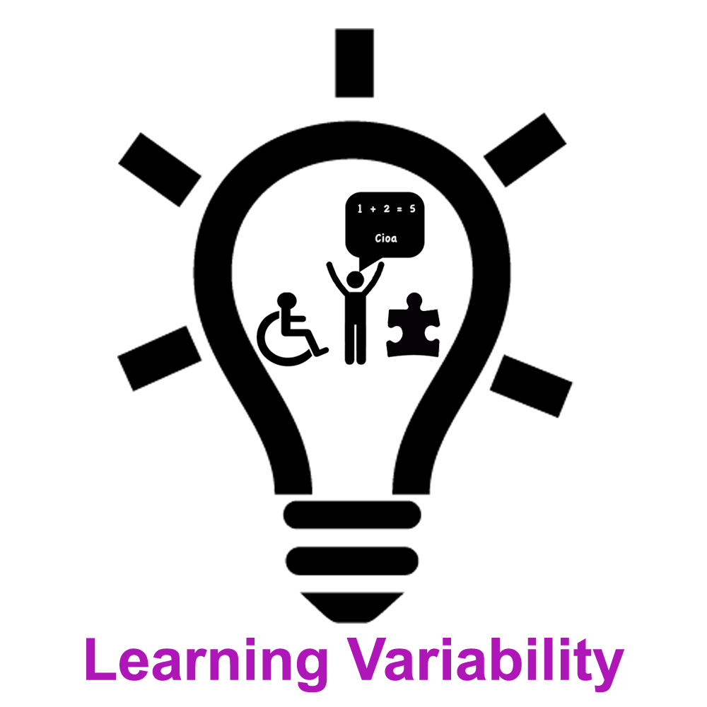 |  |  |  | Group size:  
Title | SUM UP !
Content | To be able to summarize a text with the help of a Mind Map proposed by the teacher (cf enclosed card – in French) |  |  |  |   Time: variable
Goals (Skills/Competences) | To be able to summarize a text pointing the main elements/ideas  To improve the comprehension of the text  Prepare the memorisation
Material | The Mind Map created by the teacher (cf enclosed card in French), dictionnary, paper, colour pens, slat...  Text to sum up
Procedure: | - Active reading of the text (f.i. underline the verbs, encircle the subjects…)  - Read the text again pointing out/highlighting in colours the different ideas  - Structure the ideas in paragraphs  - Work on the sentences structure/syntax  - Use linking words to structure the paragraphs  Whenever you want use the methodological Mind Map to be sure that you respected all the steps
Modifications
Comments
Success    factors |  | Pitfalls  
The activity is flexible and depends on the local context. Feel free to adapt!
©
UDEL 21

