Field of diversity: | 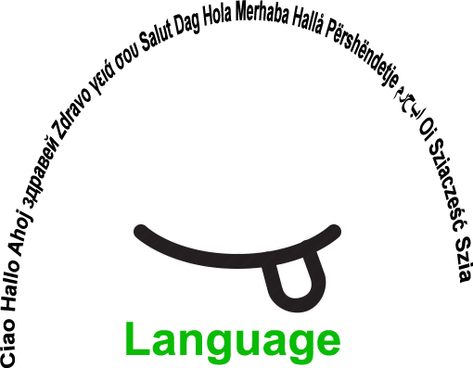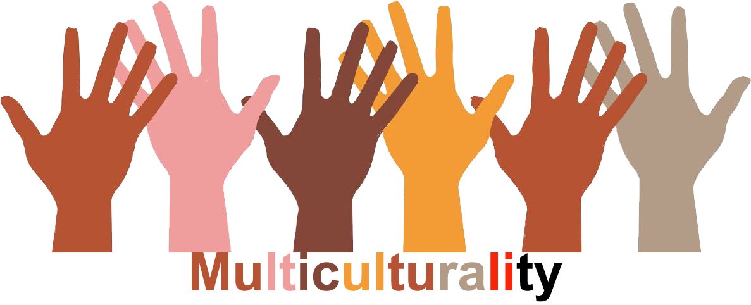 |  | L1 |  | Group size:  
Title | Oral exchange between schools in Europe
Content | Speaking in a foreign language with a class from another European country. Promoting and setting up linguistic exchanges between schools. |  |  |  |   Time: regularly 50‘
Goals (Skills/Competences) | Getting the opportunity to speak in a foreign language  Realizing that mistakes are allowed  Awareness of European citizenship
Material | Via Skype
Procedure: | - the teacher has already found a class in a school located in another European country, thanks, f.i., to e-Twinning, and determined which language will be used for the exchanges  - the students from both schools introduce themselves (short videos, (e)mails, portraits, treasure boxes…) so that pairs can be formed  - the students choose their twin  - Skype appointments are determined by the teachers, during which the students will exchange on different subjects/topics  f.i. my country and its traditions/habits and customs, my town/village, my school, a typical school-day, my courses, my family, my hobbies, my tastes... The appointments do not necessarily take place during the lessons: they can also be at lunchtime or at home.  Other option: this activity can be used for any course to exploit the linguistic diversity.  f.i. if you have a young Syrian, find another school with young Syrians and ask them to prepare an activity in their own language. Then they present it in the learning language to their respective class  eTwinning can also be a positive way to install the exchange regularly
Modifications
Comments
Success    factors | The students should be the same age  NB It can also be part of the project: students from a nursery section twinning with primary pupils to read stories f.i. | Pitfalls   |  | the students choose their twin... which can be dangerous if pupils are not chosen
The activity is flexible and depends on the local context. Feel free to adapt!
©
UDEL 21

